The MYOB Advanced Processes that you need to Know in a nutshell

Purchasing

Setting up a Supplier

Purchase Orders

Purchase Receipts

Landed Cost Purchase / Receipt

Back Orders

Generating a Bill

Paying the Bill

Returning Goods and Processing a Debit Adjustment

Setting up Supplier Pricing

Sales

Setting up a Customer

Sales Orders

Sales Shipping

Back Orders

Invoicing

Receiving Payment

Generating a Credit

Setting up Customer Pricing
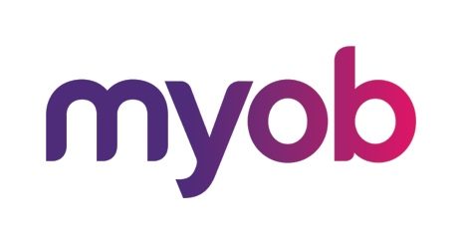
MYOB Advanced
AU-004 – Sales Orders
July 2018
MYOB Technology Pty Ltd
Website: myob.com.au/myob.co.nz
ABN 13 086 760 198
Disclaimer
MYOB has carefully prepared this material but excludes (to the extent allowed by legislation) any direct or indirect liability arising from errors or omissions or from its use. Any case studies (including the application of particular accounting standards or legislation) are representative examples only, and will not directly apply to the user's own circumstances. They are not a substitute for professional advice. Users must check that third party materials, for example from the IRD and the ATO, are current at the time they are used.
Trademarks
MYOB®, MYOB Accountants Office®, MYOB AccountEdge®, MYOB AccountEdge® Network Edition, MYOB AccountRight™, MYOB AccountRight Standard™, MYOB AccountRight Plus™, MYOB AccountRight Premier™, MYOB AccountRight Enterprise™, MYOB Accounting™, MYOB Accounting Plus™, MYOB BusinessBasics™, MYOB CashBasics™, MYOB ClientConnect™, MYOB FirstEdge®, MYOB M-Powered®, MYOB M-Powered Services™, MYOB M-Powered Bank Statements™, MYOB M-Powered Invoices™, MYOB M-Powered MoneyController™, MYOB M-Powered Payments™, MYOB ODBC DeveloperPack™, MYOB ODBC Direct™, MYOB PowerPay®, MYOB Premier®, MYOB Premier Enterprise®, RetailManager®, Accountants Office®, AccountEdge®, Accounting Plus™, BusinessBasics™, ClientConnect™, FirstEdge®, M-Powered®, M-Powered Superannuation™, ODBC DeveloperPack™, ODBC Direct™, PowerPay® and Premier® are registered trademarks or trademarks of MYOB Technology Pty Ltd and their use is prohibited without prior consent. Ceedata, Solution 6 MAS and Xlon are registered trademarks or trademarks of Solution 6 Holdings Limited, a member of the MYOB group.
Adobe®, Acrobat®, Acrobat Reader®, Adobe Reader®, PDF™, and PostScript® are trademarks or registered trademarks of Adobe Systems Incorporated.
AddressBook, Apple®, iCal®, Macintosh®, and QuickTime® and the QuickTime logo are registered trademarks of Apple Inc. Mac and the Mac logo are trademarks of Apple Inc., used under licence. MobileMeSM is a service mark of Apple Inc.
Microsoft, Access, Excel, Internet Explorer, .Net Framework, Office, Outlook, Smart Tags, Windows and Word are registered trademarks or trademarks of Microsoft Corporation in the United States or other countries. Quicken® and QuickBooks® are registered trademarks of Intuit Inc. 4D Tools® is a registered trademark of 4D S.A. Bpay® is a registered trademark of Bpay Pty Ltd, ABN 69 079 137 518. CaseWare® is a registered trademark of CaseWare International Inc. FlexNet Connect® is a registered trademark of Flexera Software™ Inc. Google Maps™ card links included with permission. HandiLedger® is a registered trademark of HandiSoft Software Pty Ltd. POSTbillpay® is a registered trademark of the Australian Postal Corporation. SM2DGraphView Copyright 2002-2008 Snowmint Creative Solutions LLC snowmintcs.com/. Sentry Spelling Checker Engine for Windows, copyright Wintertree Software Inc. Brio Intelligence and Hyperion Intelligence are trademarks or registered trademarks of Hyperion Solutions Corporation. Crystal Reports® is a registered trademark of Crystal Decisions, Inc. in the United States or other countries. MasterCard® is a registered trademark of MasterCard International Inc. VISA® is a registered trademark of Visa International Service Association.
RightNow CX® is a registered trademark of RightNow Technologies Inc
Other products mentioned may be service marks, trademarks or registered trademarks of their respective owners.
© MYOB Technology Pty Ltd 2018. All rights reserved.
This material is intended only for MYOB Enterprise Solutions Business Partners and their customers. No part of this publication may be copied, reproduced, utilised, transmitted, or distributed in any form by any means—including photocopying, recording, mechanical, electronic or otherwise—by any other party without the prior written authorisation of MYOB Technology Pty Ltd.
Version 2018.1

Introduction to the MYOB Advanced User Interface 4
Completing the Training in the Modern UI 4
Navigating to Forms: Tips 8
Completing the Training in the Classic UI 10
Product Features 12
MYOB Advanced Business – Edition Comparison Chart 12
Sales Orders 12
Selling to my Customers 13
What do I need to know? 14
Sales Order Preferences 15
Activity 1 – Sales Order Preferences 15
Other Preferences 16
FOB Points 16
Shipping Terms 16
Shipping Zones 16
Ship Via Codes 16
Boxes 16
Receivables Preferences 18
Activity 2 – Accounts Receivable Preferences 18
Activity 3 – New Customer 19
Selling Cycle 24
Quotes and Sales Order Process 26
Order Type QT (Quotes) 26
Activity 4 26
Sales Order Processing 29
Back Orders 32
Activity 5 32
Credit Memo Order Type 38
Activity 6 38
Return for Credit 40
Activity 7 40
Invoice Order 42
Activity 8 42
Sales Prices 45
Activity 9 45
Discounts 48
Activity 10 49

Introduction to the MYOB Advanced User Interface
MYOB Advanced now offers two user interfaces:
- Modern, introduced in 2018.01, which is now used by default
- Classic, which is the user interface used in previous MYOB Advanced versions
The following sections describe the main aspects of working with MYOB Advanced user interface when you complete this course:
- Completing the Training in the Modern UI
- Completing the Training in the Classic UI
- Navigating to Forms: Tips

Completing the Training in the Modern UI
For completing the training, we recommend that you use the modern user interface, which provides an enhanced new look and easy navigation in the system. The following sections provide an overview of the modern UI and explain how to navigate in the system during the completion of the training.

To Navigate to a Form from a Quick Menu
Forms in the modern UI are grouped by workspaces, which are shown on the main menu on the left side of the screen. When you select a workspace, the system shows its Quick Menu, which has links to the most commonly used forms and reports of the workspace (see the screenshot below), listed under categories to further organise them. You can click a form name to navigate to it.
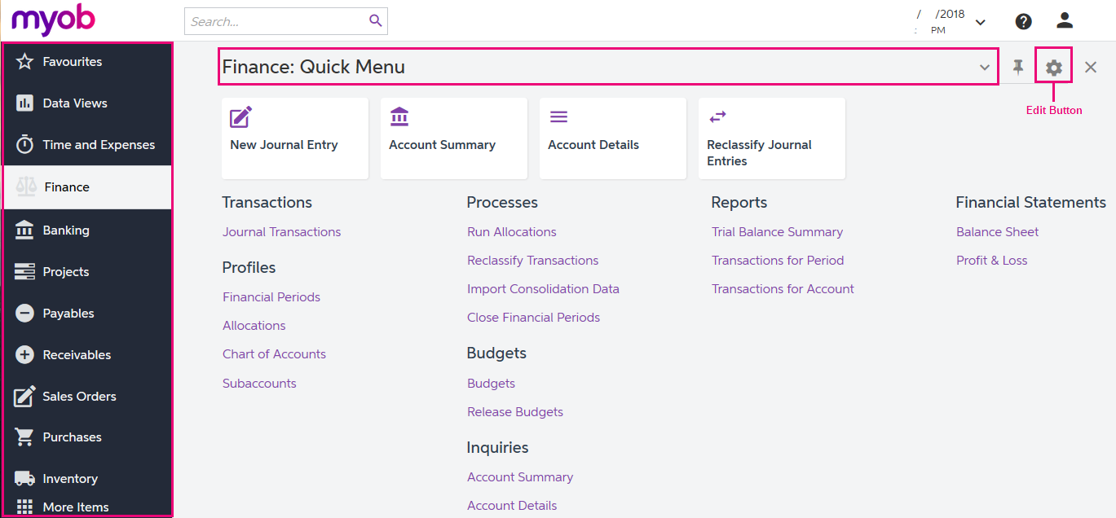
Figure: Navigating to a form from a Quick Menu

To View All Forms in a Workspace
To find any form of a workspace that is not shown on the Quick Menu, you can click the Quick Menu title bar to switch to All Items mode. In this mode, you can see the links to all forms that are included in the selected workspace (see the screenshot below).
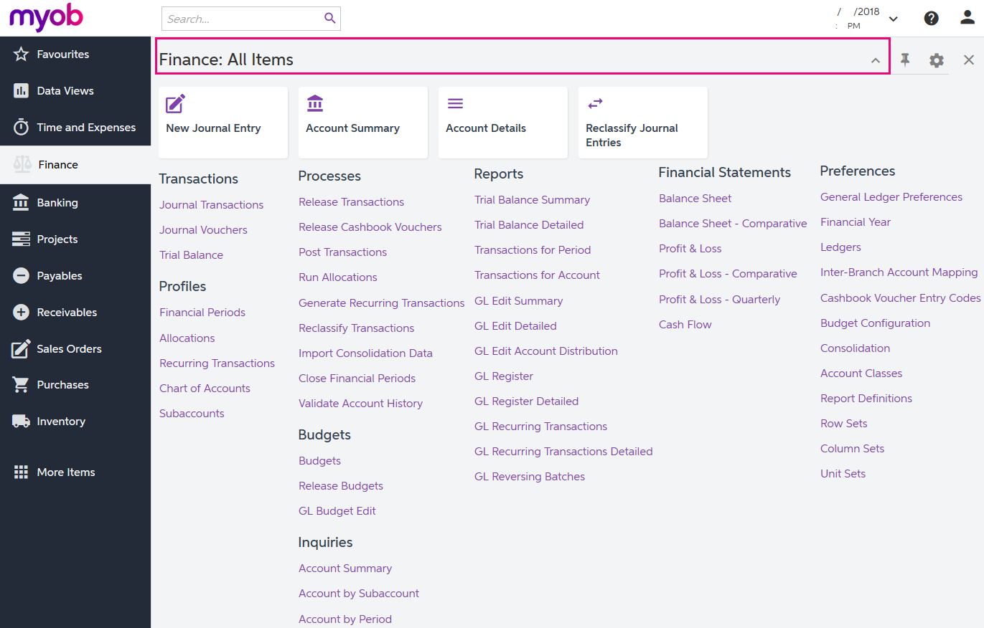
Figure: Displaying all items of the Finance workspace

To Add Forms to a Quick Menu
To add a form that currently is not shown on a Quick Menu of a workspace, open the needed workspace, and on the workspace title bar, click the Edit button (see the previous screenshot). In Configuration mode, select the check boxes next to the needed forms, and then click Exit to apply your changes and exit Configuration mode.
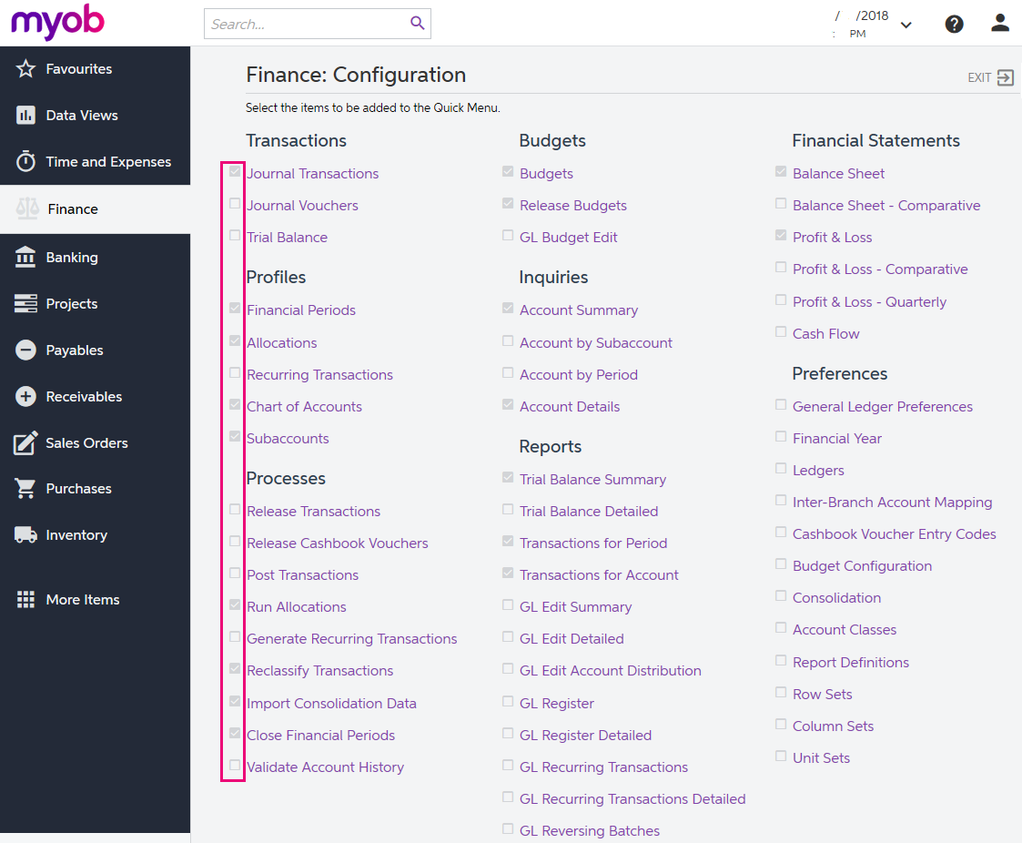
Figure: Adding forms to a Quick Menu
The full list of forms used during the completion of this training is provided below in this topic. We recommend that you be sure all these forms have been added to the applicable quick menus, to simplify navigation during the completion of the training.

To Review and Open Documents on Search Forms
Search forms provide a quick and easy way to review the list of records created on the applicable data entry forms. A search form is a generic inquiry that shows the summary information on the records entered on the entry form. Search forms are initially brought up instead of the corresponding entry forms when a user navigates to these forms in the Quick Menu.
For example, if you click Journal Transactions (under the Transactions category) on the Quick Menu of the Finance workspace, the system opens the Journal Transactions search form (GL3010PL), which shows the list of all transactions in the system (see the screenshot below). The search form may show tabs that filter the documents by their type or status.
To open the Journal Transactions entry form (GL301000) for entering a new batch of transactions from the Journal Transactions search form (GL3010PL), you need to click Add New Record button on the form toolbar.
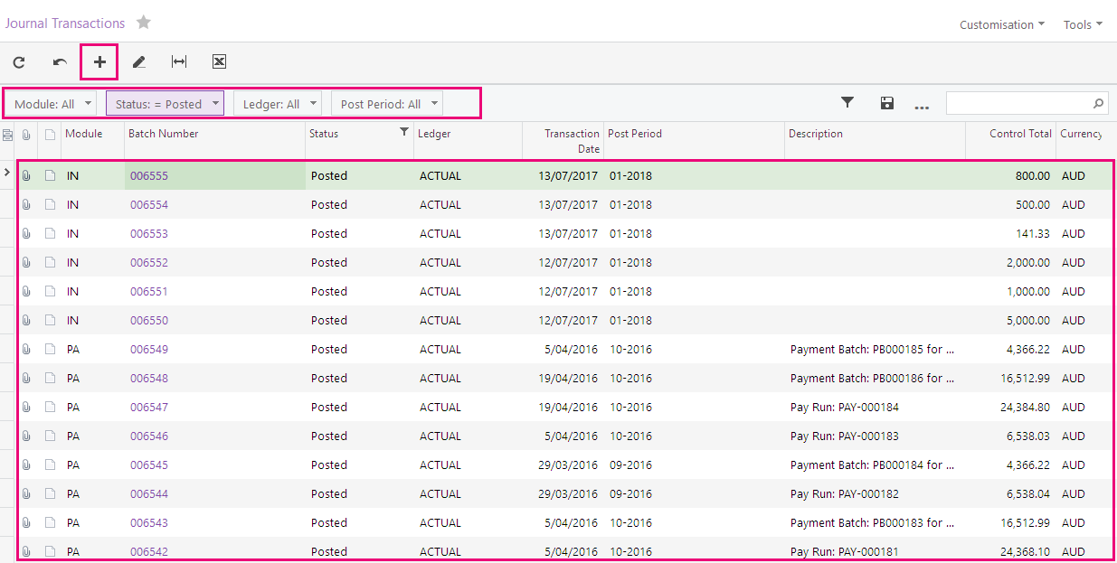
Figure: Viewing the Journal Transactions search form
If the training instructions ask you to open a document (such as a batch, a Payables bill, or a Receivables invoice), you can find this document on the appropriate search form and then click its reference number link to open this document on the data entry form. Alternatively, you can open the data entry form itself, select the module or document type (depending on the form), and in the Reference Nbr. box, click the selector icon and select the document by its reference number (see the screenshot below).
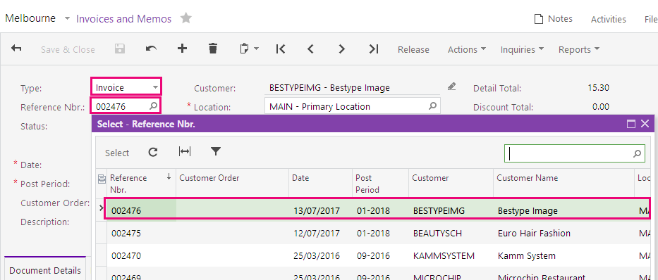
Figure: Opening a document by its reference number

Navigating to Forms: Tips
The following tips apply to the modern and classic user interfaces and will help you to quickly find and open any form.

How To Search for a Form by Its Title or ID
At any time, you can quickly search for a form by typing its title or ID in the Search box:
- In the modern UI, type the text in the Search box on the top of the screen (see the following screenshot). The system shows the search results in the Search window, which opens when you start typing the text in the Search box. Then on the Menu Items tab of the Search window, you click the link to open the needed form.
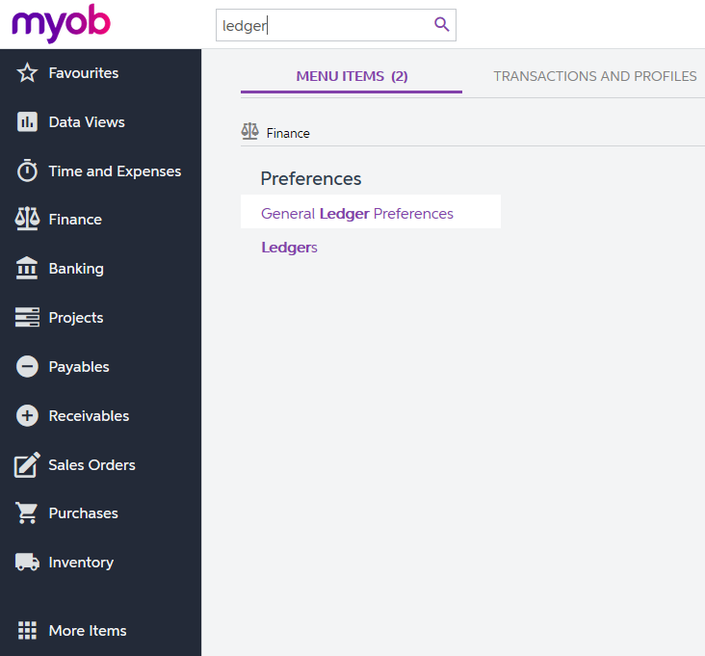
Figure: Searching for a form by title in the modern UI
- In the classic UI, type the text in the Search box at the top of the navigation pane (see the following screenshot). To navigate to the needed form, click it in the drop-down list with the search results.
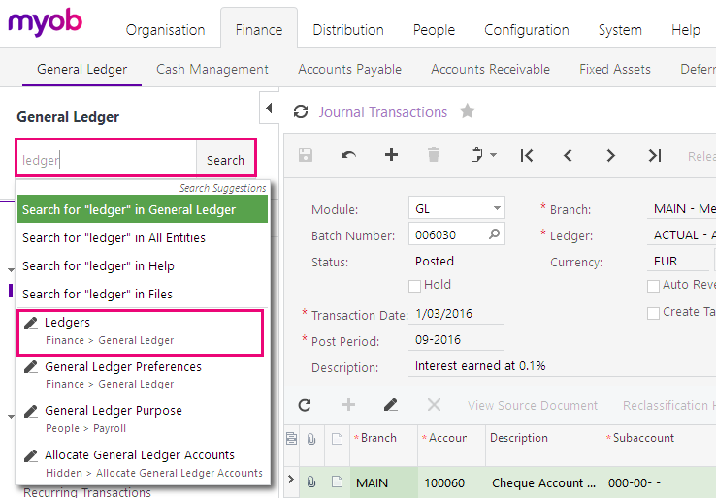
Figure: Searching for a form by its title in the classic UI

How To Navigate to Forms by Using the Form ID
In the training guide, each form is referred to by its ID. If you are not sure in which area a form is located, instead of searching for the form, you can simply open it by using its form ID. You can do this in both the modern UI and the classic UI as follows:
- In the browser's address bar, change the form ID of the currently opened form to the form ID of the needed form (see the screenshot below).
Figure: Entering the form ID
- Press Enter. The system navigates to the form.

Completing the Training in the Classic UI
The following sections provide a quick overview of the classic UI and explain how to navigate in the system during the completion of the training.

To Switch Back to the Classic UI
When you have created a new company and signed in to it, the modern user interface is enabled by default. If you need to switch back to the classic UI, do the following:
- In the top right corner, click the name of the current user, and click My Profile, as shown in the following screenshot.
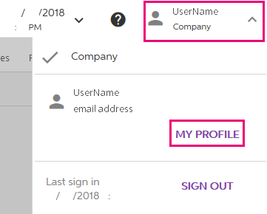
Figure: Opening the user profile
- On the User Profile form (SM203010), which opens, select the Show Classic UI by Default check box, and save your changes.
To switch back to the modern UI, again click the name of the current user in the top right corner and click Switch to Modern UI in the menu (see the screenshot below)
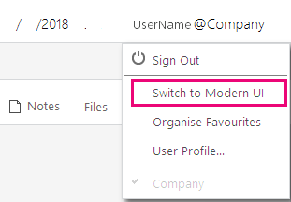
Figure: Switching to the modern UI

To Navigate to Forms in the Classic UI
To help learners to search for forms during the training completion in the classic UI, the paths to forms in this training guide are based on the classic UI. The main menu, at the top of the screen, shows suites and the modules of the selected suite. The navigation pane, located on the left side of the screen, shows the forms of the modules grouped by their functions. The path to a form is specified as follows in the training:
Form Title (Form ID; Suite > Module > Tab > Node)
For example, the form with the following path is shown in the screenshot below:
General Ledger Preferences form (GL102000; Finance > General Ledger > Configuration > Setup)
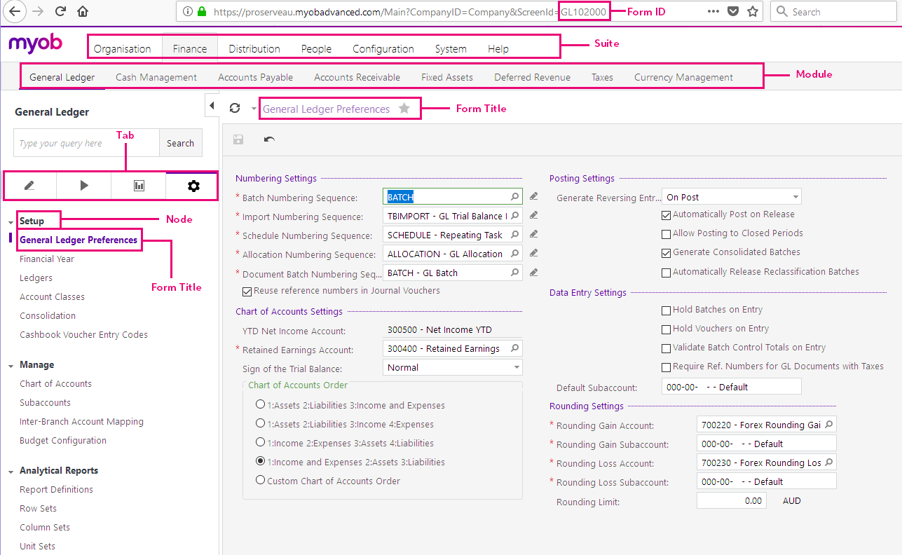
Figure: General Ledger Preferences form in the classic UI

Product Features
Not all features are available in all MYOB Advanced Business Editions, for example as you can see from the following comparison chart, Custom Sales Order types are only available in Enterprise Edition.
Contact your Business Partner for more information on the different Editions or if you want to add more features to Advanced Business.

MYOB Advanced Business – Edition Comparison Chart

Sales Orders
Product Features | MYOB Advanced Business Edition
 | Standard | Plus | Enterprise
Sales Order Entry |  |  | 
Shipments and Backorder Processing |  |  | 
Customer Returns |  |  | 
Discounts, Promotional and Special Pricing |  |  | 
Purchase Orders Directly from a Sales Order |  |  | 
Custom Sales Order Types |  |  | 

Selling to my Customers
We are in business to provide goods and/or services to our customers. By using the Sales Orders module, you can easily setup sales order processing to fit your sales workflows. MYOB Advanced provides order types, and in the Enterprise edition you can create custom types of orders with special processing. The Sales Orders module provides flexible pricing and discounting policies. With MYOB Advanced, your company can deliver orders accurately, consistently, and efficiently.
Let’s look at how we manage sales and sales orders in MYOB Advanced.
When we sell goods or services to our customers, a sales order is usually raised; we then pick the goods and ship them depending on the customer’s instructions. The customer may receive the invoice with the goods or we may send the invoice later. The customer then pays the invoice based on the terms we have agreed.
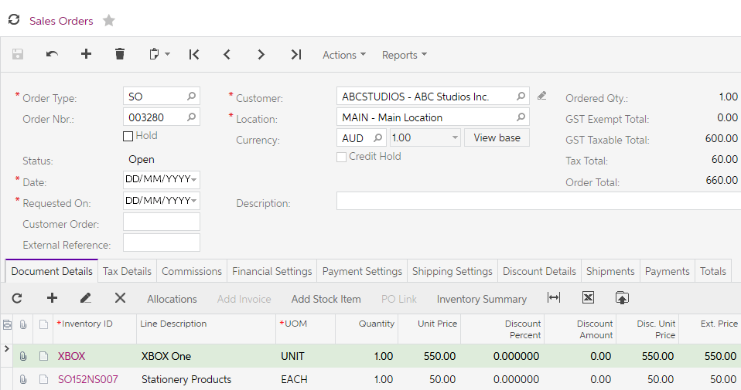
Figure: Sales Order showing Stock and Non-stock items
In your training today, we will go over the sales order module. Receiving payment for customer invoices will be covered in the Accounts Receivable module of the Finance suite.
As MYOB Advanced is highly configurable, the features and processes may differ for your business. Please refer to your Business Partner for details on any customisations they may have included in your implementation.

The Sales Orders module supports the following sales order types in the Enterprise edition of MYOB Advanced:
- CM (Credit Memo)
- CR (Cash Returns)
- CS (Cash Sale)
- IN (Invoice)
- QT (Quote)
- RC (Return for Credit)
- RR (Return with Replacement
- RM (Generic Authorised Return)
- SA (Sales Order with Allocation)
- SO (Sales Order)
- TR (Transfer)
In the Enterprise Edition, you can also create new Order Types.
Your MYOB Advanced will be implemented by a consultant who is Certified to Implement MYOB Advanced Business. As mentioned previously, MYOB Advanced is highly configurable, this training covers the basic business processes you need to know when selling to your customers.

What do I need to know?
When businesses sell goods and/or services they usually raise a sales order, sometimes the sales order is created after a quote has been raised. We will cover the basic sales cycle in MYOB Advanced, should you want to know any additional information, please see the help pages of MYOB Advanced or ask your Business Partner.

Sales Order Preferences
After review of your company’s needs, your implementing partner will go through and set up the preferences for the Sales Orders module. Preferences include numbering sequences for customer documents, validation requirements for sales orders and shipments, approval and mailing settings, and the default freight expense account and subaccount. These are set up in the Sales Order Preferences form (SO101000).
You should only make changes to any settings in Preferences after talking to your Business Partner.

Activity 1 – Sales Order Preferences
- Go to the Sales Order Preferences form (SO101000; Sales Orders > Preferences (Full Menu)).
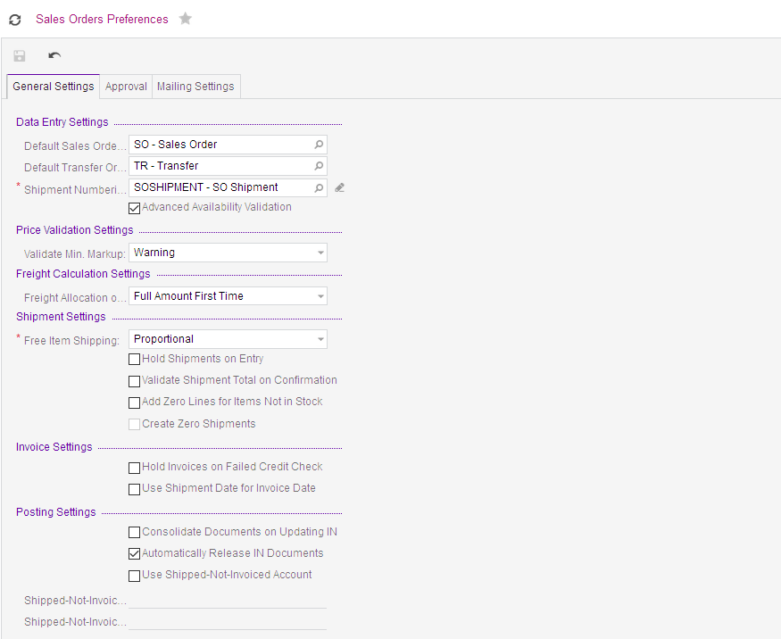
Figure: Sales Order Preferences
The General Settings tab holds the default settings of the Sales Order module.
The Validate Shipment Total on Confirmation in the Shipment Settings checkbox allows you to choose whether a Control Quantity: field is displayed on the shipment. The Shipped Quantity and Control Quantity fields must be the same before you can save the document.
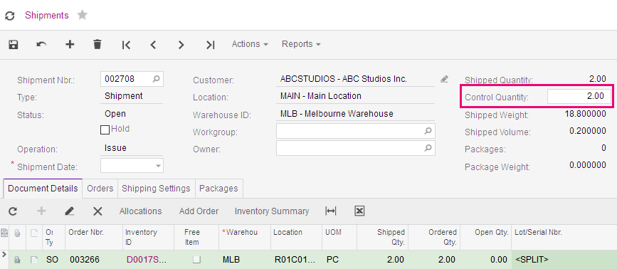
Figure: Sales Order with Control Quantity

Approval
Outside the scope of this course.
The Approval tab is shown when the Approval Workflow feature is enabled. If you would like this feature for your business contact your Business Partner.
The Mailing Settings tab is where you can list the predefined mailings used for sending documents by email.

Other Preferences

FOB Points
Outside the scope of this course.
At FOB Points, the supplier delivers the goods and pays for the freight to that point. The freight and other expenses for the goods from that point are paid by the customer.

Shipping Terms
Outside the scope of this course.
Shipping terms are used to define the shipping, packaging, and handling costs, depending on the shipment amount.

Shipping Zones
Outside the scope of this course.
Shipping zones used to calculate freight charges when your company ships goods to customers.

Ship Via Codes
Outside the scope of this course.
A ship via code denotes a possible method your company uses to ship goods to customers.

Boxes
Outside the scope of this course.
You use this form to create and maintain the list of boxes used by your company for shipping goods. Settings such as box dimensions, weight, and maximum weight capacity are used for freight calculation for shipments.

Receivables Preferences
We are now going to move away from the Sales Order module to the Receivables module.
As part of your implementation, your Business Partner will configure MYOB Advanced to your needs and import master records, such as Customers. Once you are working with MYOB Advanced, you will need to be able to add to these records when you need to add a new Customer.
The Receivables module is defined on this form Accounts Receivable Preferences (AR101000). You can specify the default customer class associated with the Receivables module, to provide some settings when a new customer is added.
We will go over the Receivables module during our Finance training, for now we will look at this module’s role with the Sales Orders module.

Activity 2 – Accounts Receivable Preferences
- Go to the Accounts Receivable Preferences form (AR101000; Receivables > Preferences (Full Menu)) and review the settings.
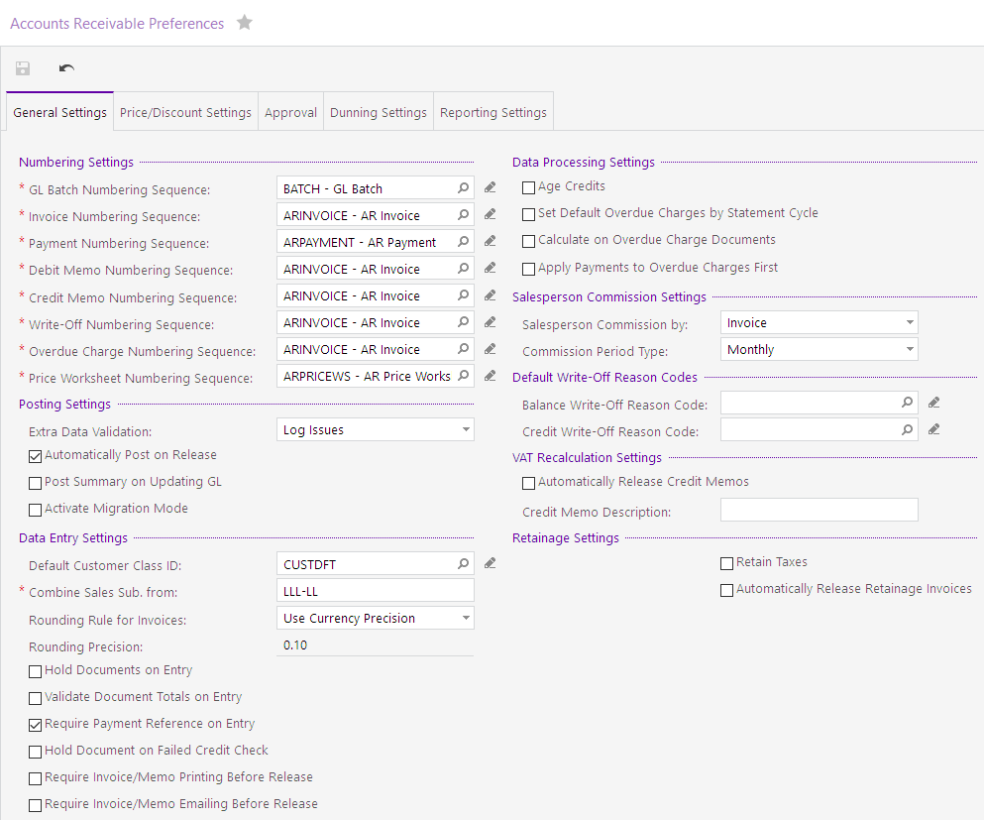
Figure: Accounts Receivable Preferences – General Settings tab
To raise a quote or a sales order, a customer must already be in the Receivables module.

Activity 3 – New Customer
- On the Receivables Menu, add a new customer by clicking on the tile New Customer. This will open the Customers form (AR303000; Receivables > Profiles) and add a new customer with the following details.
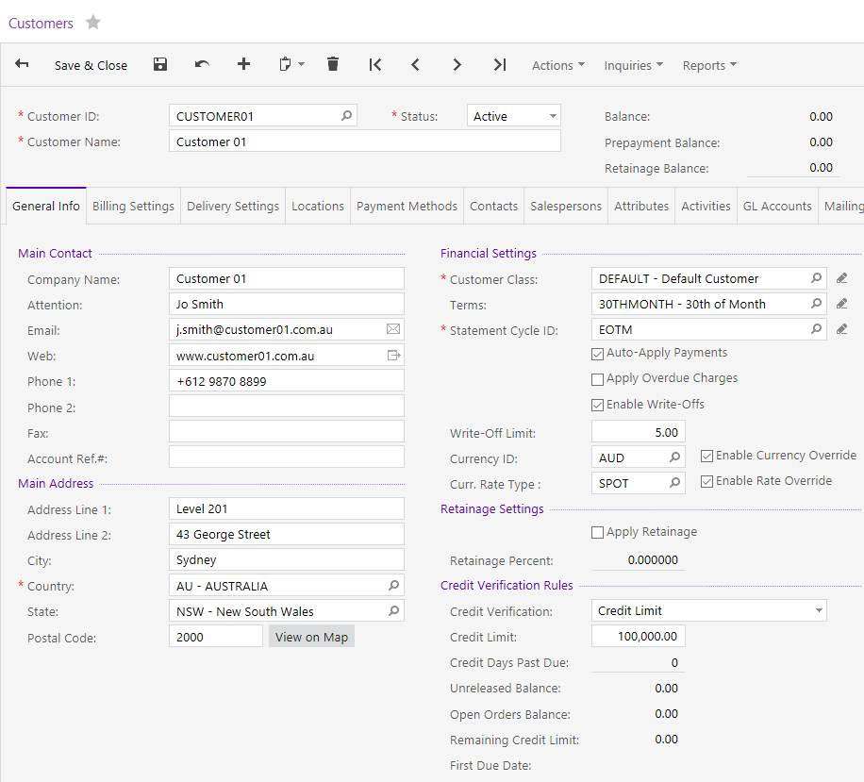
Figure: Customer General Info tab

- On the Delivery Settings tab enter the following information and then save .
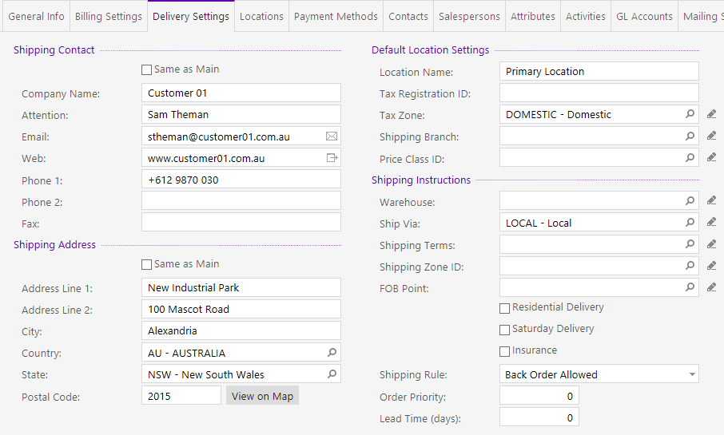
Figure: Customer Delivery Settings tab
- From the Contacts tab, add 2 new contacts with the following information then save .
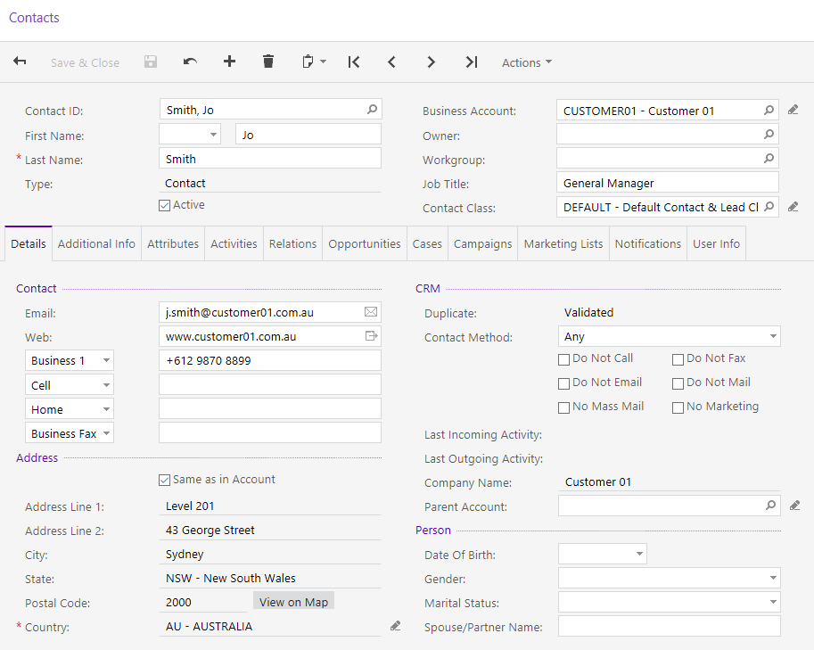
Figure: Contact 1
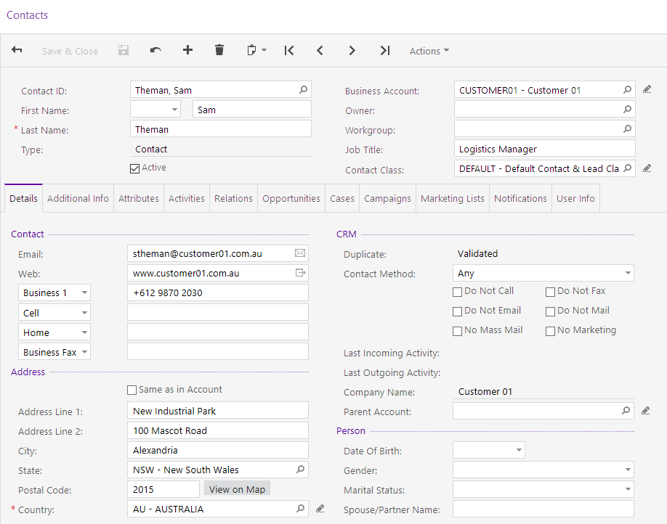
Figure: Contact 2
We let the Customer Class, DEFAULT update the record, except for the credit limit of $100,000.00.
Some of the defaults that came from the customer class include:
- Terms
- Statement Cycle
- Payment Method
- Country
- Tax Zone
- Default General Ledger Accounts
- Default Mailing Settings

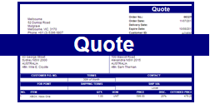
Selling Cycle

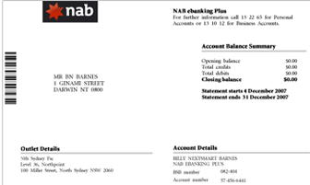
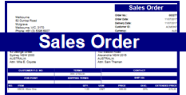

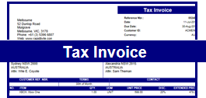

Shipment

Figure: Selling Cycle
The Sales Orders module helps you organise and control the selling process, manage quotes for customers who purchase your goods and services.
In our training we will be going through the selling cycle, covering all the above steps except for the Receivables Payment which is covered in the Finance topic.
As mentioned previously, MYOB Advanced is highly configurable, and not all functions are available in all MYOB Advanced Business editions; for example, Custom Order Types are only available in the Enterprise Edition.

In MYOB Advanced there are a few steps from Quote to final Invoice. Although you will be working through all these steps, just take a moment to review who would be entering or processing the documents in your company. Each step may be done by different people or a combination of people in your company.

Quotes and Sales Order Process
We enter Quotes on the Sales Order form. The transaction behaviour on this form is controlled by the Order Type. In our training, we are going to enter the following Order Types.
- QT – Quote
- SO – Sales Order
- CM – Credit Memo
- RC – Return for Credit
- IN – Invoice Order
There are other Order Types available. For more information on these types please refer to the Help or ask your certified consultant.

Order Type QT (Quotes)

Activity 4
Our new customer would like a quote for a Wireless Solar Keyboard. They need the quote because of their purchasing rules.
- On the Sales Orders Menu, add a new quote by clicking on the tile New Quote. This will open the Sales Order form (SO301000; Sales Orders > Transactions) and add a new quote with the following details and save .
A Quote uses the Sales Order form with the Order Type: QT:
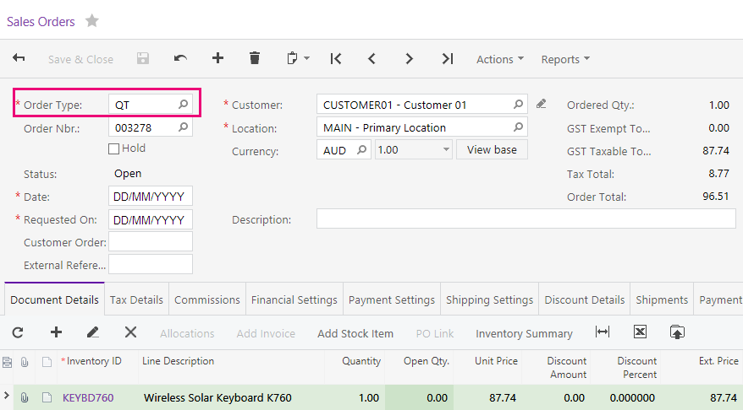
Figure: Quote Type QT Sales Order
- The quote has been accepted, copy the order from the Actions dropdown list on the form toolbar,
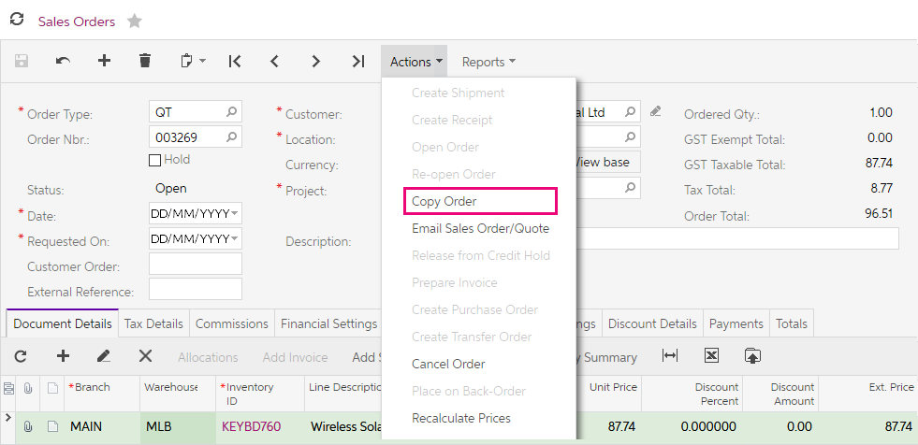
Figure: Copy Order feature under Actions dropdown
- Choose the Order Type: SO and save
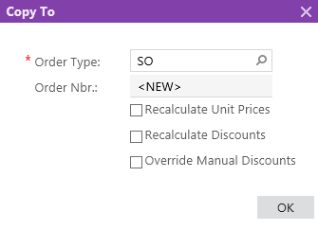
Figure: Copy To dialogue box
The sales order will appear on the screen. We can then email the sales order to the customer, also from the Actions dropdown list.
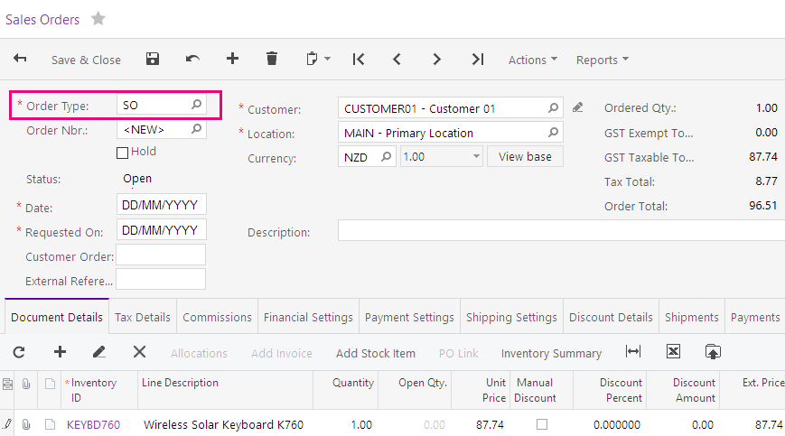
Figure: Sales Order created from quote.

Sales Order Processing
The good will be shipped to the client after the sales order is converted to a Shipment. Follow the steps below to ship the goods to the client and email and release the invoice.
- From the Actions dropdown list on the form toolbar select Create Shipment
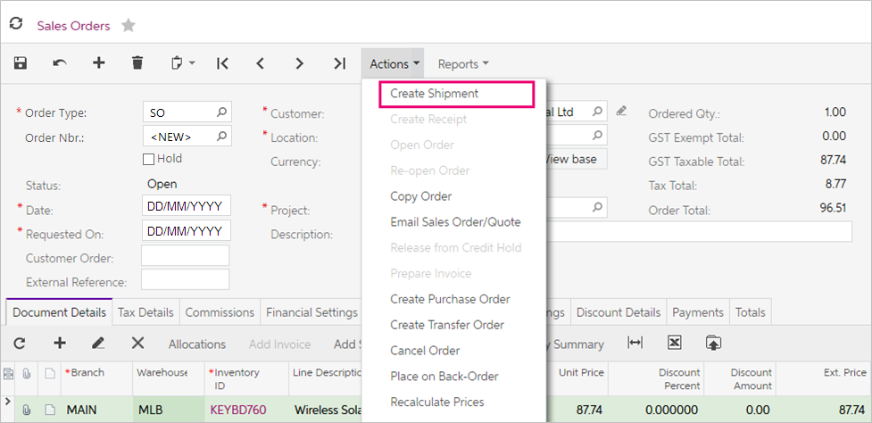
Figure: Create Shipment feature under Actions dropdown
- A dialogue box will appear for you to Specify Shipment Parameters. Accept the defaults displayed and OK.
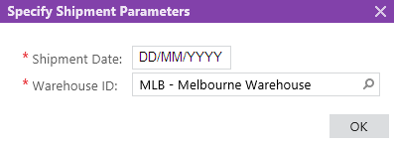
You will be taken to the Shipments form (SO302000).
- From the Actions dropdown list on the form toolbar select Confirm Shipment, you can then print the pick list so the goods can be ready for delivery.
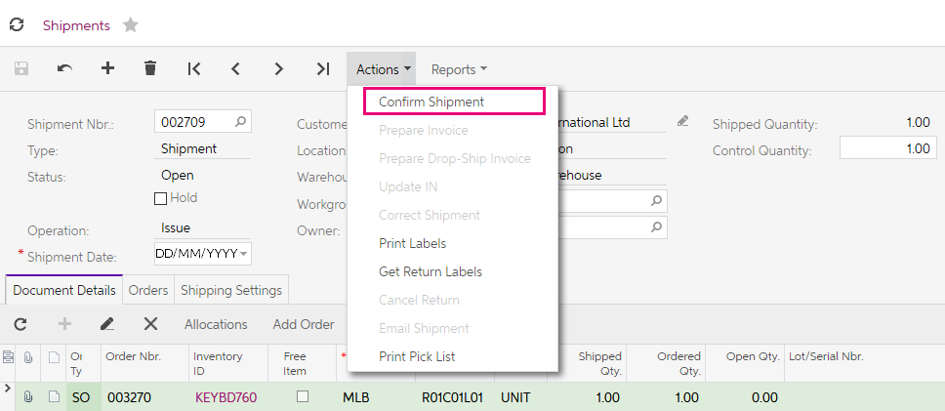
Figure: Confirm Shipment feature under the Actions dropdown
- From the Actions dropdown list on the form toolbar select Prepare Invoice.
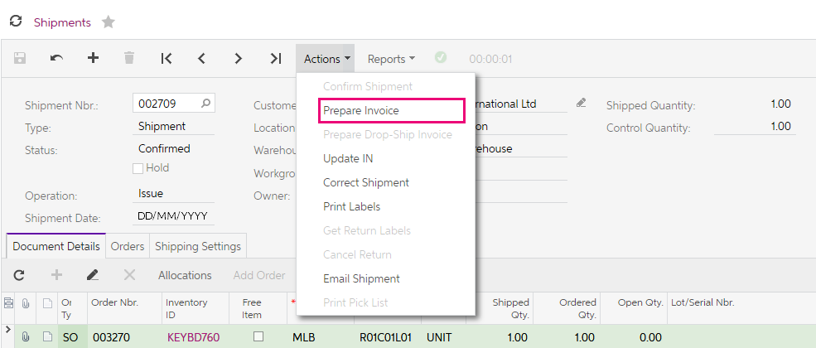
Figure: Prepare Invoice feature under the Actions dropdown
You will be taken to the Invoice form (SO303000)
- On the Invoice form from the Actions dropdown list on the form toolbar select Release this will post the transactions to the general ledger, you can now email the invoice to the customer.
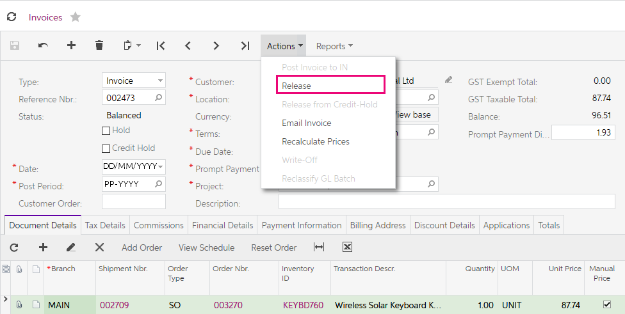
Figure: Release feature on the Actions dropdown on Invoice form

Back Orders
Our customers Euro Hair Fashion and Elevation Computers both want the 4.2GHz as5 Processor, Euro Hair Fashion has ordered 10 and Elevation Computers 20 units. We want to order enough stock to fill the orders.

Activity 5
- On the Sales Orders Menu, add a new sales order by clicking on the tile New Sales Order. This will open the Sales Order form (SO301000; Sales Orders > Transactions) and add a new sales order with the following details and save .
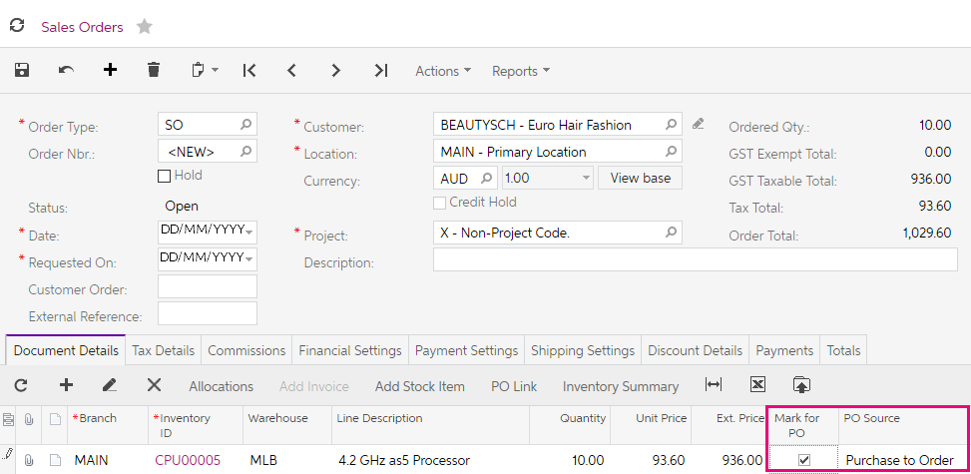
Figure: Sales order marked for Purchase to Order
- Create another Sales Order with the following details and Save your changes with the Status of Open:
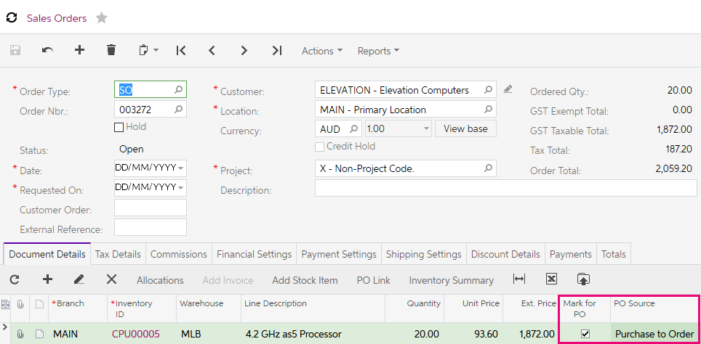
Figure: Sales order marked for Purchase to Order

Now we have saved the two sales orders, and marked them for PO, we can generate a purchase order.
- Open the Create Purchase Orders form (PO505000; Purchases > Process) and select the two SO to Purchase created earlier in the form grid.
- Then enter the Supplier for the orders, Shenzhen Jackren Technology Co. Ltd if they are not already showing, then Process the SO to Purchase orders.
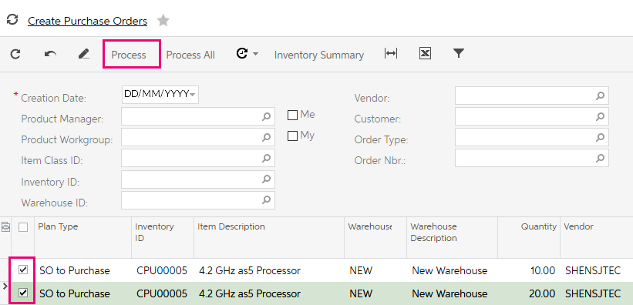
Figure: Two purchase orders selected for processing with supplier added.
- A Purchase Order combining the two SO to Purchase is created.
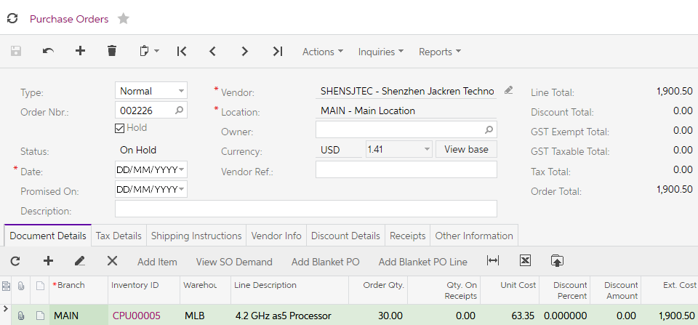
Figure: Purchase Order created
- Take the order off Hold.
- From the form toolbar select Email Purchase Order from the Actions dropdown list.
You will be able to see the sales orders that belong to this purchase orders by selecting View SO Demand on the grid toolbar.
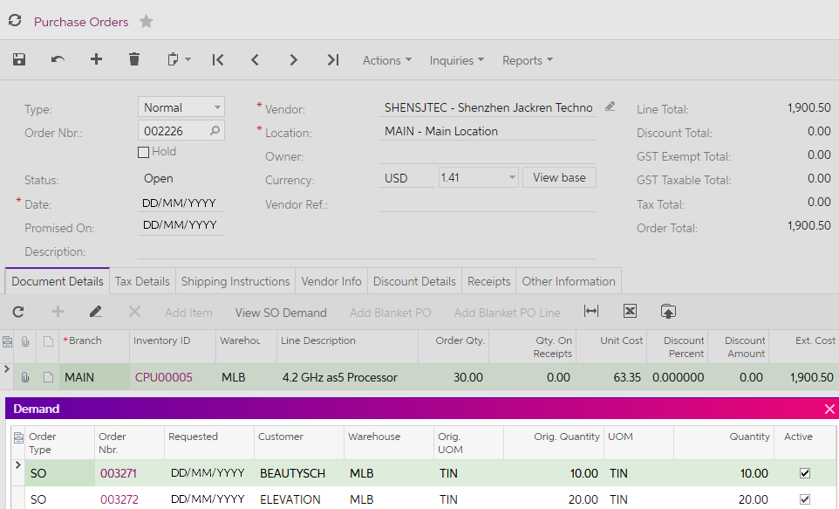
Figure: View SO Demand dialogue box
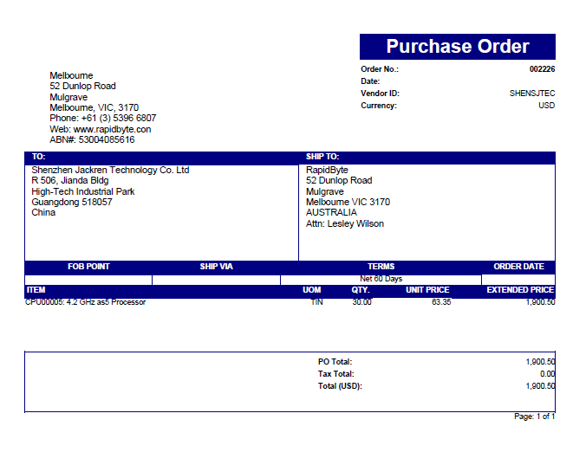
Figure: Purchase Order attached to email sent to supplier
- In a few days, the CPU00005 – 4.2 GHz as5 Processors are received. Find the purchase order to Shenzhen Jackren Technology Co. Ltd and from the Actions dropdown list select; Enter PO Receipt, enter the Supplier Ref.: 99898. To put the goods in stock so you can ship them to your customer, Release the generated receipt.
Now it’s time to ship the orders to our customers.
- Go to the Process Orders form (SO501000); Distribution > Sales Orders > Processes > Daily and select the two purchase orders from the previous activities. Process these Sales Orders with the Action: Create Shipment.
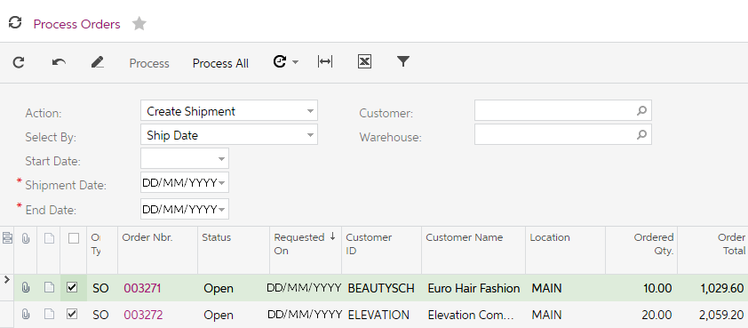
Figure: Process Orders with sales order ready to be shipped.
- We now need to confirm the shipment and then invoice the customers. Go to the Process Shipments form (SO503000); Distribution > Sales Orders > Processes > Daily and select the two sales orders. Process the Shipments with the Action: Confirm Shipment.
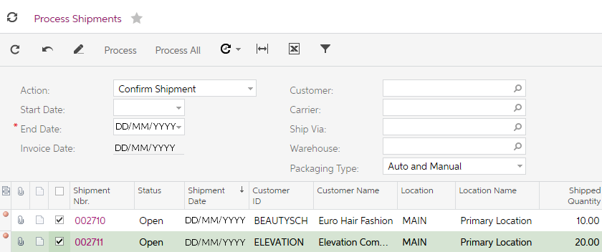
Figure: Process Shipments form
You should get an error when trying to process the shipments. When the Sales Order preferences were setup, it was decided that all shipments need to be validated before they can be confirmed. The feature Validate Shipment Total on Confirmation is ticked on the Sales Order Preferences.
This means you must go into each of the Shipments and update the Control Quantity to the Shipped Quantity on each of the shipments.
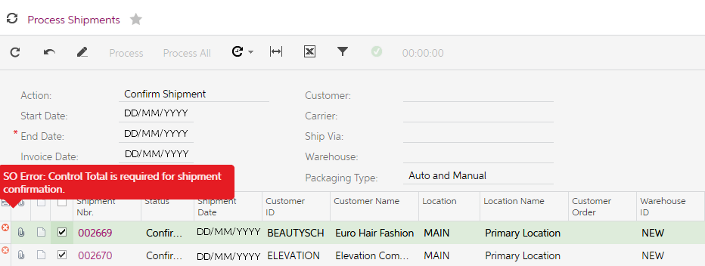
Figure: Error on process of Confirm Shipment
- Find the shipment for the CPU00005 for Elevation Computers. Enter 20 in the Control Quantity as shown below.
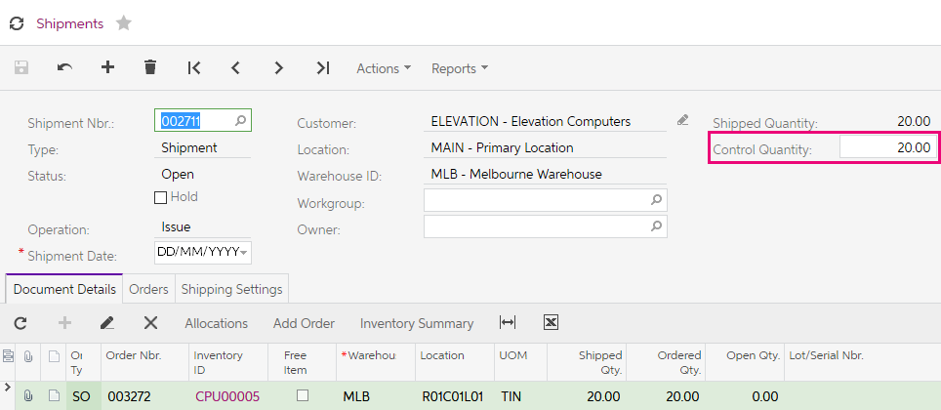
Figure: Control Quantity updated to allow the shipment to be confirmed.
- Now you can select Confirm Shipment from the Actions dropdown list on the form toolbar.
- Find the shipment for Euro Hair Fashion for the CPU00005 and repeat the two steps above but enter 10 as the Control Quantity.
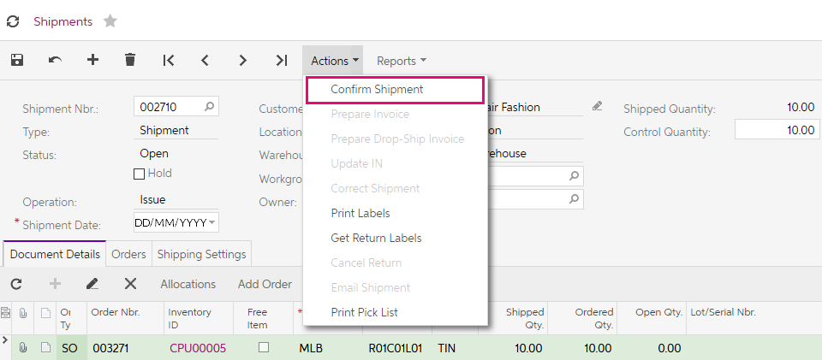
Figure: Confirm Shipment action item.
Our final task to complete the sale to our customers is to now prepare the invoices.
- From the Actions dropdown list on the form toolbar of both shipments, select Prepare Invoice.
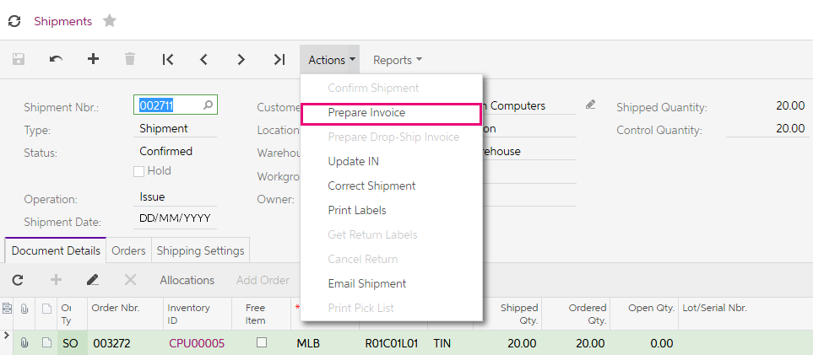
Figure: Prepare Invoice action item.
- You will be taken to the Invoices form where you can Release both Invoices from the Actions dropdown list on the form toolbar.

We are now going to enter two sales orders; a Credit Memo and a Return for Credit. These are created when customers reject or return goods to us.

Credit Memo Order Type
Elevation Computers wants to return 1 UNIT of inventory CPU00005 from the order just created.

Activity 6
- Open the Sales Order search form (SO3010PL; Sales Orders > Transactions).
- Go to the Sales Order raised in the previous activity for Elevation Computers and on the form toolbar select Copy Order from the Actions dropdown list.
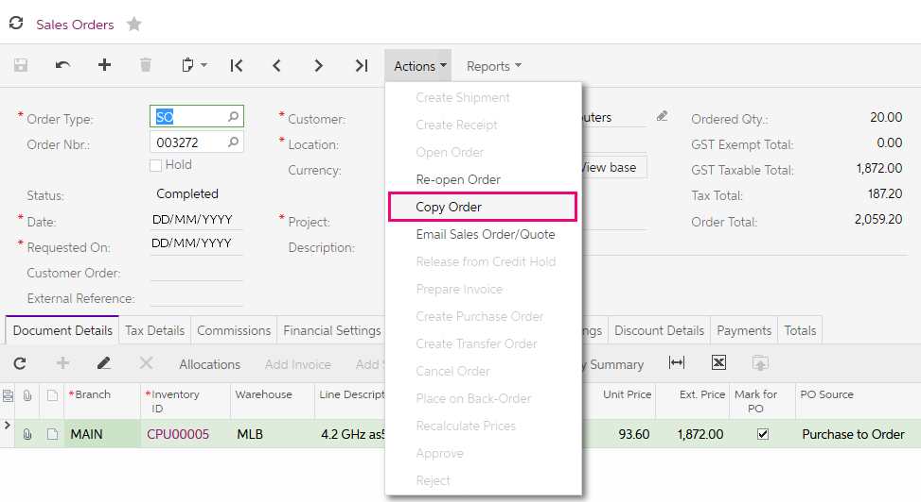
- In the pop up, select the Order Type: CM.
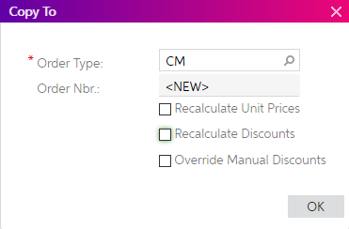
- On selecting OK, a Credit Memo Order Type will be created based on the previous order.
- Change the Quantity to 1, take the CM order off Hold and Save.
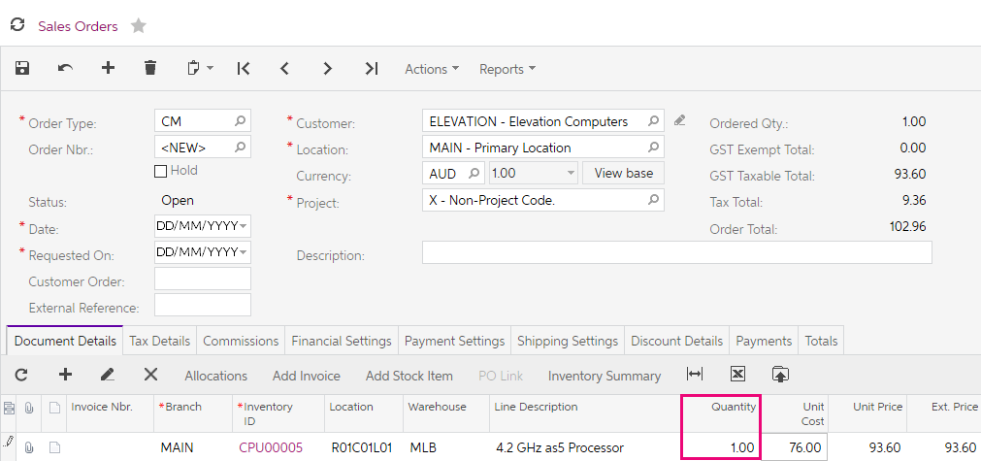
- From the Action: dropdown list, select Prepare Invoice and then Release the Credit Memo.
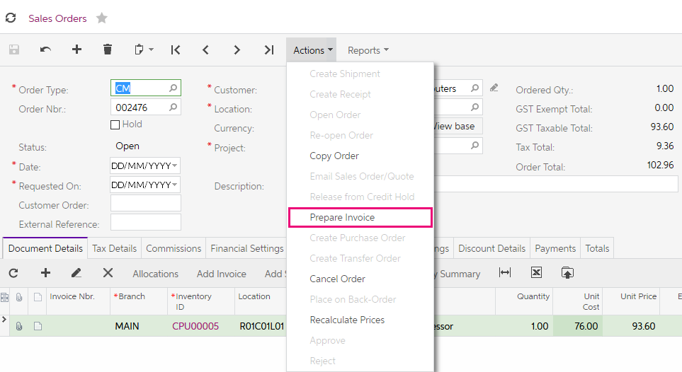

Return for Credit
In this activity, you will search out an existing order and receive the goods back from and issue a credit.

Activity 7
- Open the Sales Order search form (SO3010PL; Sales Orders > Transactions), then search for the Sales Order for Euro Hair Fashion for 10 4.2GHz as5 Processors and bring this sales order to the screen. On the form toolbar select Copy Order from the Actions dropdown list.
- In the pop up, select the Order Type: RC
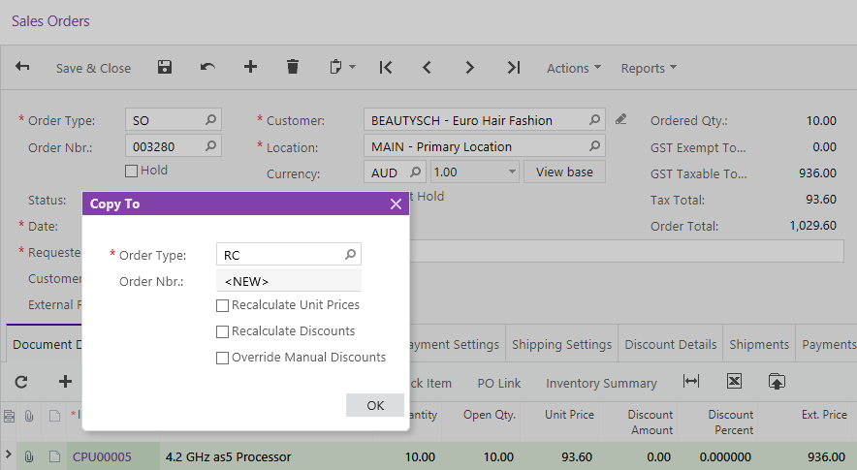
Figure: Sales Order Copy
On selecting OK, a Return for Credit Order Type will be created based on the previous order
- Change the Quantity to 1 and from the Actions dropdown list, select Create Receipt.
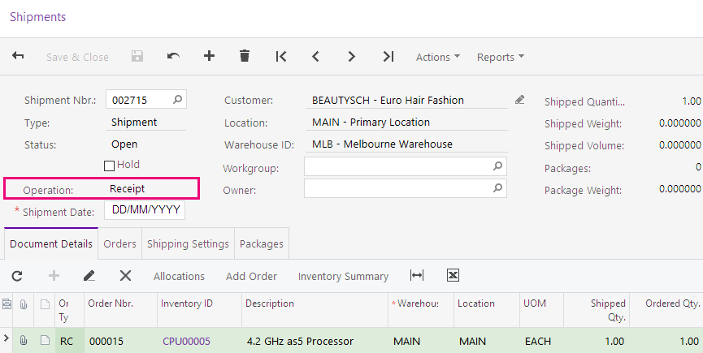
- From the Actions dropdown list, select Prepare Invoice. This will create the Credit Memo.
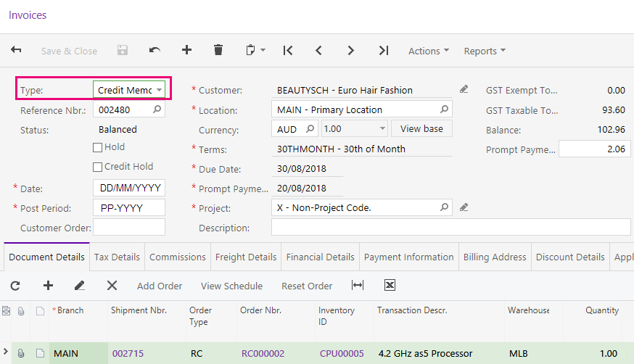
- Again, from the Actions dropdown list, select Release. This will complete the transaction.

Invoice Order
Sometimes you might want to directly invoice your customer without raising a sales order or creating a shipment. An IN type of sales order is the preferred way of doing this.

Activity 8
- On the Sales Orders Menu, add a new sales order by clicking on the tile New Sales Order. This will open the Sales Order form (SO301000; Sales Orders > Transactions).
- In the Order Type field select the IN Invoice and update with the following details;
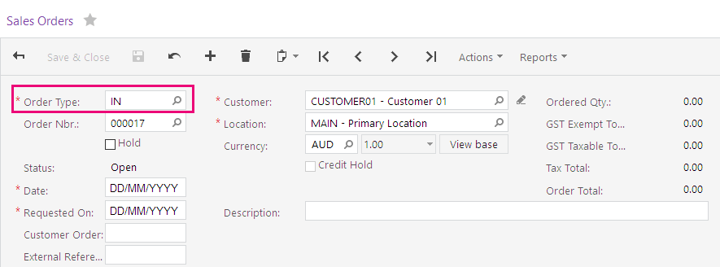
Figure: New IN type sales order
- You want to check the stock levels in the different warehouses for the stock items starting with CPU. Click on the from the grid toolbar.
- In the Inventory Lookup dialogue box that appears enter CPU in the Inventory field, you will see the quantities available for the items across the different warehouses. Select 10 of the CPU00005 and 5 of the CPU00006V both from the MLB warehouse.
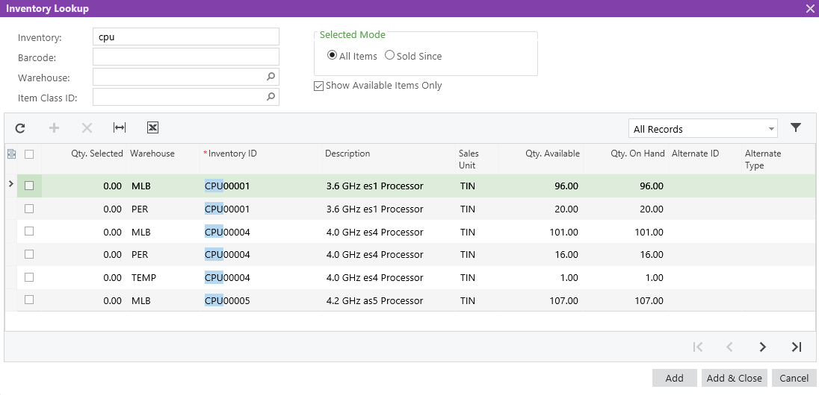
Figure: Inventory Lookup
- From the Actions dropdown on the form toolbar, Prepare Invoice
- Go to Shipments and click on the Invoice Nbr. Hyperlink. The Invoice you just prepared will show on the screen. From the Actions dropdown, Release the invoice.
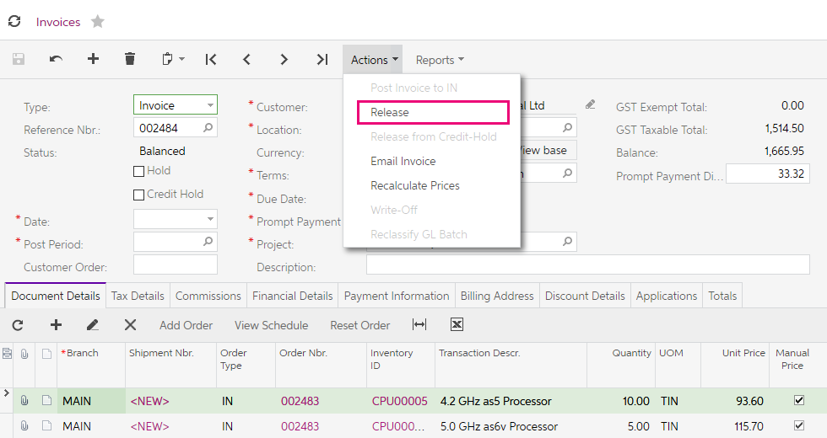
Figure: Invoice from IN order.
As mentioned, by using the IN order type, we do not need to process the sales order or create and confirm the shipment.
- To see the general ledger journal that was created when we released the invoice, go to the Financial Details tab and click on the Batch Nbr. hyperlink.
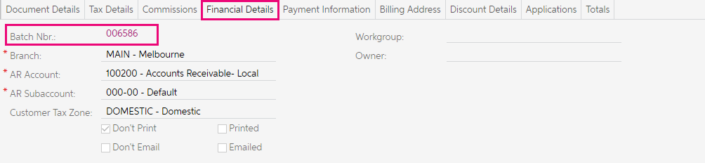
Figure: Financial Details tab of released invoice
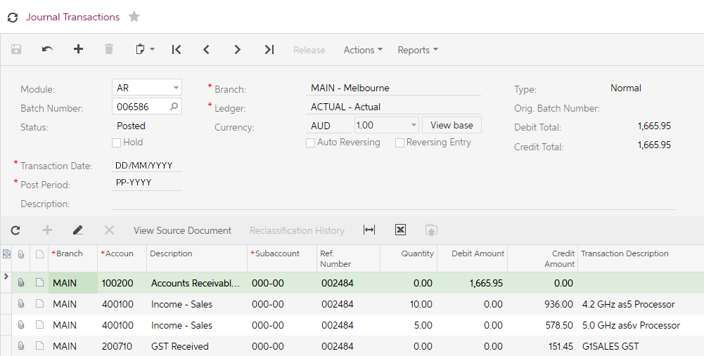
Figure: Journal transaction from released invoice.

Sales Prices
MYOB Advanced provides the following ways to maintain sales prices:
- Default prices: You define and maintain a price for each individual item. The default price is used for sales. You can use discounts with these prices. There is no history of price changes when using Default pricing only.
- Price lists: You can setup different pricing strategies by defining a base price list, price lists that apply to a group of customers and a customer, promotional price lists, and prices that depend on the quantity of the product.
To show how both ways work, you will now add a new stock item and sell this to a customer using both default prices and a price list.

Activity 9
- Open the XRL-120 Laptop in the Stock Items form (IN202500); and review the Price/Cost Info tab note the Default Price.
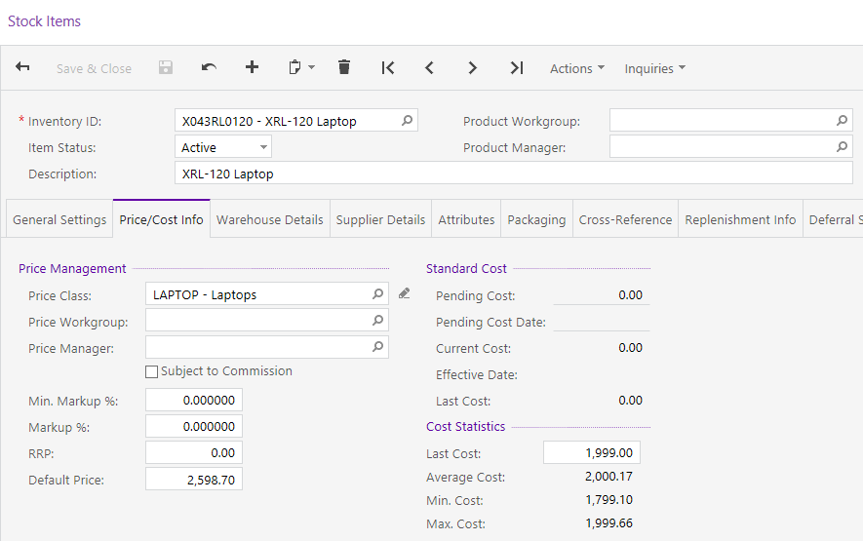
Figure: Stock Item

- Open the Sales Prices form (AR202000; Sales Orders > Profiles) and review the Price Type of BASE for the Laptops.
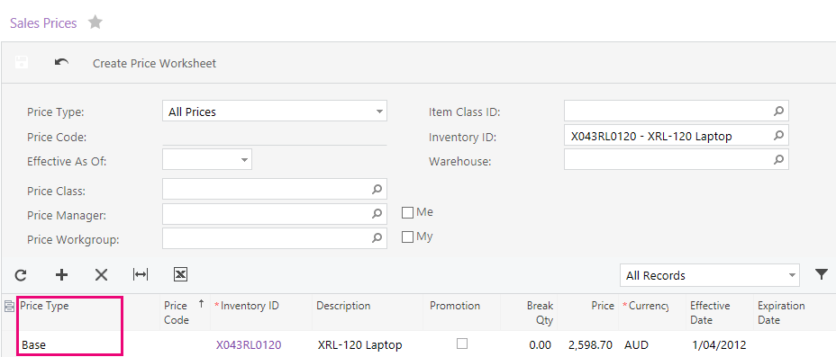
Figure: Sales Prices filtered for Price Type of Base
- Open the Customers form (AR303000) and locate your customer ABCSTUDIOS. On the Delivery Settings tab under Default Location Settings, is there a Price Class linked?
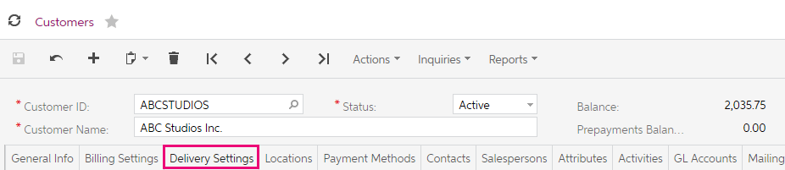
Figure: Customers – Delivery Settings tab
- Create a sales order – Order Type: SO, for Customer ID: ABCSTUDIOS for 1 x Inventory Item X043RL0120 and save the sales order with the Status of OPEN.
Which price did the sales order take?

- From the form toolbar, delete the sales order and go back to the customer ABCSTUDIOS. On the Delivery Settings tab, under the Default Location Settings, update the Price Class ID to A, then Save your changes.
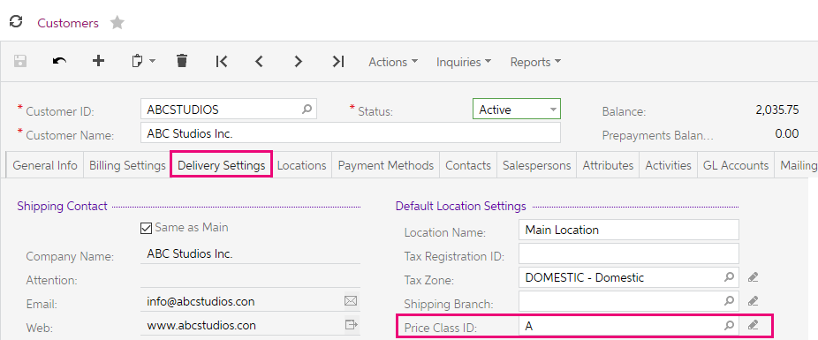
Figure: Price Class ID: A
- Open the Sales Prices form (AR202000; Sales Orders > Profiles) and search for the X043RL0120 stock item, then enter yesterday’s date as the Expiration Date on the current sales price for Customer Price Class A.
Enter the new Customer Price Class Type of Price Code: A for the XRL-120 Laptop with a Price of $2,400.00 then Save your changes.
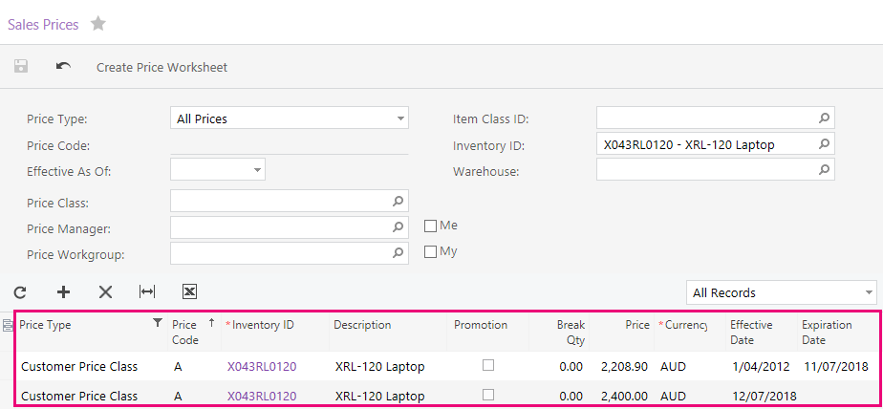
Figure: Customer Price Class for Xbox
- Create a Sales Order – Order Type: SO, for Inventory ID XBOX for Customer ABCSTUDIOS.
Which price did the sales order take?

Discounts
We are now going to look at two ways of using discounts in MYOB Advanced:
- Line-level discounts that apply to a document line: These discounts may be based on the line amount or quantity of the line, they can be a percentage or fixed amount. Line-level discounts can be applied to the price of item or extended price of the item (line amount), depending on the option selected on the Price/Discount Calculation tab of the Accounts Receivable Preferences (AR101000) form.
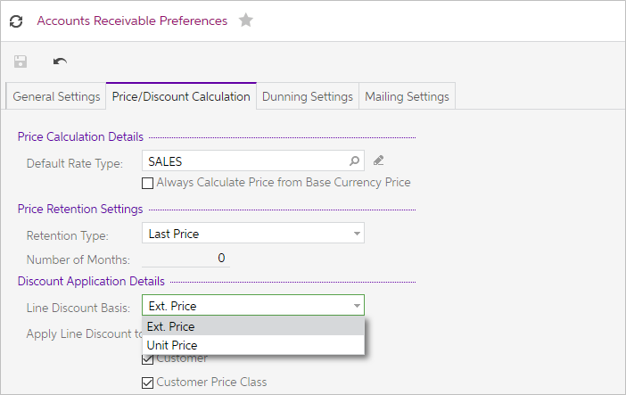
Figure: Accounts Receivable Preferences – Price/Discount Calculation
- Document-level discounts that apply to the document total: These discounts may be based on the document total, and they can be expressed as percentages or fixed amounts.

Activity 10
We are now going to create two Line Discount Codes (customer and inventory) for 10% and 20% respectively.
- Open the Discount Codes form (AP209000; Receivables > Preferences) and create 2 Discounts with the following details.
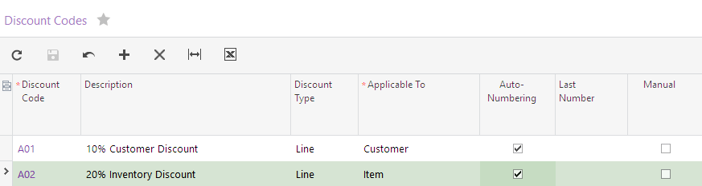
Figure: Discount Codes
- Open Discounts; Receivables > Profiles
- On the Discounts search form (AR2095PL); click on the add new record button on the form toolbar and enter the following discount for Discount Code A01 and Save your changes.
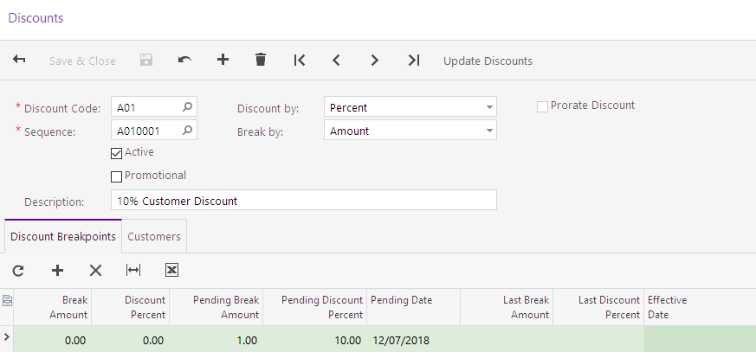
Figure: Discounts – Discount Breakpoints tab
- On the Customers tab add ABARTENDE.
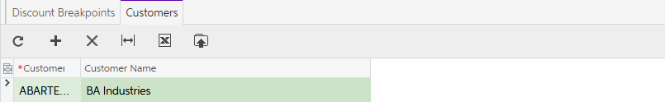
Figure: Discounts – Customers tab

- From the form toolbar select Update Discounts to apply the new discount rules. The values will move from the Pending to the Actual columns.
- Add another discount by selecting the Add New Record button on the form toolbar. Setup Discount Code A02 with the following details and Save your changes.
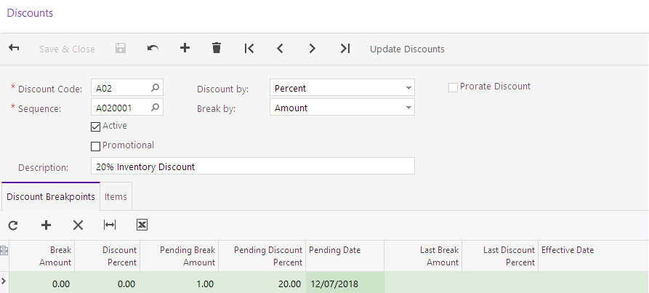
- On the Items tab add X043RL0120.
Figure: Discount
- From the form toolbar select Update Discounts to apply the new discount rules.
- Create a Sales Order – Order Type: SO, for Inventory ID XBOX for Customer ABARTENDE.

What is the discount % and discount amount?
What information do you see on the Discount Details tab?

