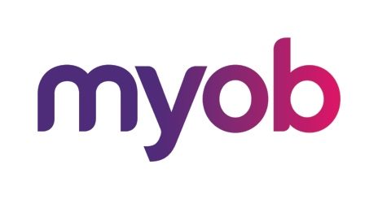
MYOB Advanced
AU-005 – Finance
July 2018
MYOB Technology Pty Ltd
Website: myob.com.au/myob.co.nz
ABN 13 086 760 198
Disclaimer
MYOB has carefully prepared this material but excludes (to the extent allowed by legislation) any direct or indirect liability arising from errors or omissions or from its use. Any case studies (including the application of particular accounting standards or legislation) are representative examples only, and will not directly apply to the user's own circumstances. They are not a substitute for professional advice. Users must check that third party materials, for example from the IRD and the ATO, are current at the time they are used.
Trademarks
MYOB®, MYOB Accountants Office®, MYOB AccountEdge®, MYOB AccountEdge® Network Edition, MYOB AccountRight™, MYOB AccountRight Standard™, MYOB AccountRight Plus™, MYOB AccountRight Premier™, MYOB AccountRight Enterprise™, MYOB Accounting™, MYOB Accounting Plus™, MYOB BusinessBasics™, MYOB CashBasics™, MYOB ClientConnect™, MYOB FirstEdge®, MYOB M-Powered®, MYOB M-Powered Services™, MYOB M-Powered Bank Statements™, MYOB M-Powered Invoices™, MYOB M-Powered MoneyController™, MYOB M-Powered Payments™, MYOB ODBC DeveloperPack™, MYOB ODBC Direct™, MYOB PowerPay®, MYOB Premier®, MYOB Premier Enterprise®, RetailManager®, Accountants Office®, AccountEdge®, Accounting Plus™, BusinessBasics™, ClientConnect™, FirstEdge®, M-Powered®, M-Powered Superannuation™, ODBC DeveloperPack™, ODBC Direct™, PowerPay® and Premier® are registered trademarks or trademarks of MYOB Technology Pty Ltd and their use is prohibited without prior consent. Ceedata, Solution 6 MAS and Xlon are registered trademarks or trademarks of Solution 6 Holdings Limited, a member of the MYOB group.
Adobe®, Acrobat®, Acrobat Reader®, Adobe Reader®, PDF™, and PostScript® are trademarks or registered trademarks of Adobe Systems Incorporated.
AddressBook, Apple®, iCal®, Macintosh®, and QuickTime® and the QuickTime logo are registered trademarks of Apple Inc. Mac and the Mac logo are trademarks of Apple Inc., used under licence. MobileMeSM is a service mark of Apple Inc.
Microsoft, Access, Excel, Internet Explorer, .Net Framework, Office, Outlook, Smart Tags, Windows and Word are registered trademarks or trademarks of Microsoft Corporation in the United States or other countries. Quicken® and QuickBooks® are registered trademarks of Intuit Inc. 4D Tools® is a registered trademark of 4D S.A. Bpay® is a registered trademark of Bpay Pty Ltd, ABN 69 079 137 518. CaseWare® is a registered trademark of CaseWare International Inc. FlexNet Connect® is a registered trademark of Flexera Software™ Inc. Google Maps™ card links included with permission. HandiLedger® is a registered trademark of HandiSoft Software Pty Ltd. POSTbillpay® is a registered trademark of the Australian Postal Corporation. SM2DGraphView Copyright 2002-2008 Snowmint Creative Solutions LLC snowmintcs.com/. Sentry Spelling Checker Engine for Windows, copyright Wintertree Software Inc. Brio Intelligence and Hyperion Intelligence are trademarks or registered trademarks of Hyperion Solutions Corporation. Crystal Reports® is a registered trademark of Crystal Decisions, Inc. in the United States or other countries. MasterCard® is a registered trademark of MasterCard International Inc. VISA® is a registered trademark of Visa International Service Association.
RightNow CX® is a registered trademark of RightNow Technologies Inc
Other products mentioned may be service marks, trademarks or registered trademarks of their respective owners.
© MYOB Technology Pty Ltd 2018. All rights reserved.
This material is intended only for MYOB Enterprise Solutions Business Partners and their customers. No part of this publication may be copied, reproduced, utilised, transmitted, or distributed in any form by any means—including photocopying, recording, mechanical, electronic or otherwise—by any other party without the prior written authorisation of MYOB Technology Pty Ltd.
Version 2018.1

Introduction to the MYOB Advanced User Interface 5
Completing the Training in the Modern UI 5
Navigating to Forms: Tips 9
Completing the Training in the Classic UI 11
Product Features 13
MYOB Advanced Business – Edition Comparison Chart 13
Accounting 13
Banking 13
Payables 14
Receivables 14
How’s my Business going? 15
What do I need to know? 16
Configuration 17
General Ledger Preferences 17
Activity 1 17
Other Setup features 18
Financial Year 18
Ledgers 18
Account Classes 18
Consolidation 18
Voucher Entry Codes 18
Profiles 18
Chart of Accounts 18
Activity 2 19
Subaccounts 19
Inter-branch Account Mapping 19
Transactions 20
Journal Transactions 20
Activity 3 20
Batch Status 21
Activity 4 21
Recurring Transactions 23
Activity 5 23
Budgets 25
Create and Budget and release the transaction 25
Activity 6 25
Currency Management 28
Create a New Currency 28
Activity 7 28
Currency Revaluation Process 29
Activity 8 29
Banking 31
Setup 31
Cash Management Preferences 31
Payment Methods 31
Entry Types 31
Payment Method Converter 31
Bank Transaction Rules 31
Cash Accounts 32
Create a Cash Account 32
Activity 9 32
Cash Transactions 35
Activity 10 35
Payables 37
Enter and process AP Invoice 37
Activity 11 37
Create and process EFT payment 39
Activity 12 39
Receivables 41
Create an AR Invoice and apply payment 41
Activity 13 41
Customer Statements 44
Activity 14 44
Bank Reconciliation 46
Activity 15 46
Taxes 48
Tax Reporting 49
Preparing the Tax Report 49
Release Tax Report 50
Print the GST Calculation Worksheet 50
Run the Business Activity Statement/GST Return 52
Tax Agency Supplier Transactions 54

Introduction to the MYOB Advanced User Interface
MYOB Advanced now offers two user interfaces:
- Modern, introduced in 2018.01, which is now used by default
- Classic, which is the user interface used in previous MYOB Advanced versions
The following sections describe the main aspects of working with MYOB Advanced user interface when you complete this course:
- Completing the Training in the Modern UI
- Completing the Training in the Classic UI
- Navigating to Forms: Tips

Completing the Training in the Modern UI
For completing the training, we recommend that you use the modern user interface, which provides an enhanced new look and easy navigation in the system. The following sections provide an overview of the modern UI and explain how to navigate in the system during the completion of the training.

To Navigate to a Form from a Quick Menu
Forms in the modern UI are grouped by workspaces, which are shown on the main menu on the left side of the screen. When you select a workspace, the system shows its Quick Menu, which has links to the most commonly used forms and reports of the workspace (see the screenshot below), listed under categories to further organise them. You can click a form name to navigate to it.
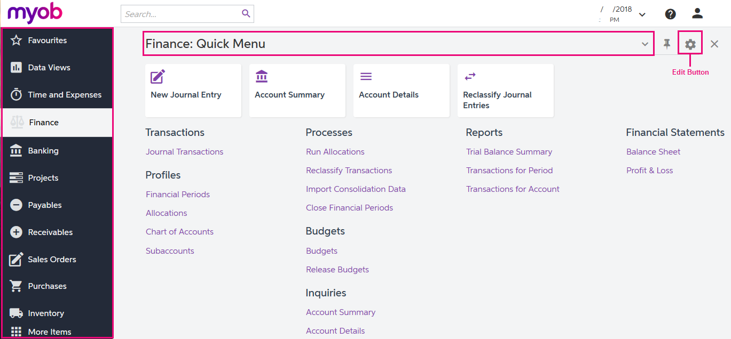
Figure: Navigating to a form from a Quick Menu

To View All Forms in a Workspace
To find any form of a workspace that is not shown on the Quick Menu, you can click the Quick Menu title bar to switch to All Items mode. In this mode, you can see the links to all forms that are included in the selected workspace (see the screenshot below).
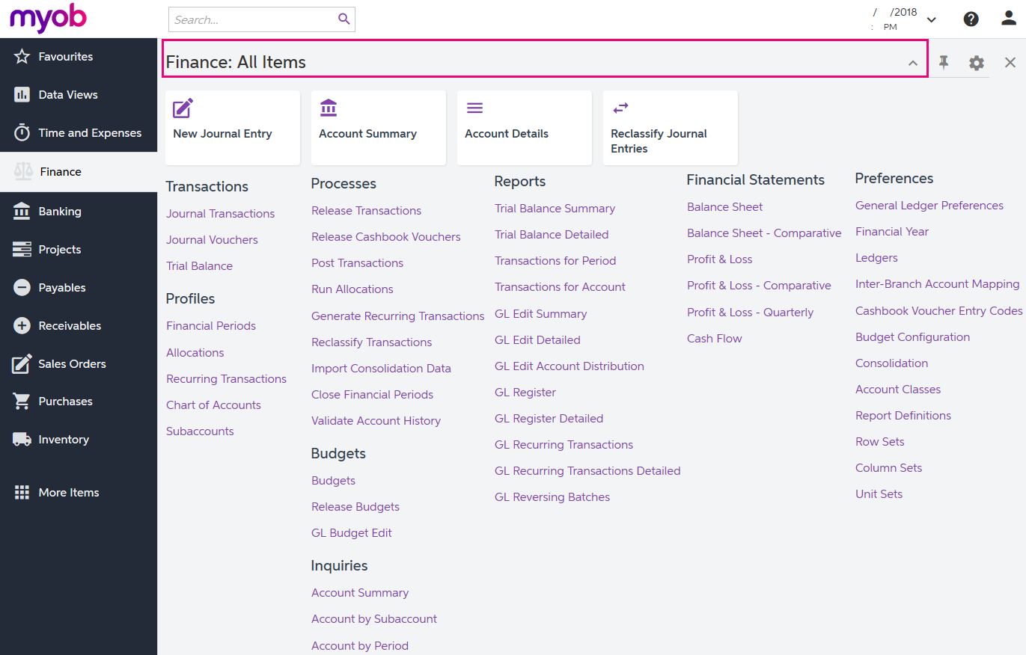
Figure: Displaying all items of the Finance workspace

To Add Forms to a Quick Menu
To add a form that currently is not shown on a Quick Menu of a workspace, open the needed workspace, and on the workspace title bar, click the Edit button (see the previous screenshot). In Configuration mode, select the check boxes next to the needed forms, and then click Exit to apply your changes and exit Configuration mode.
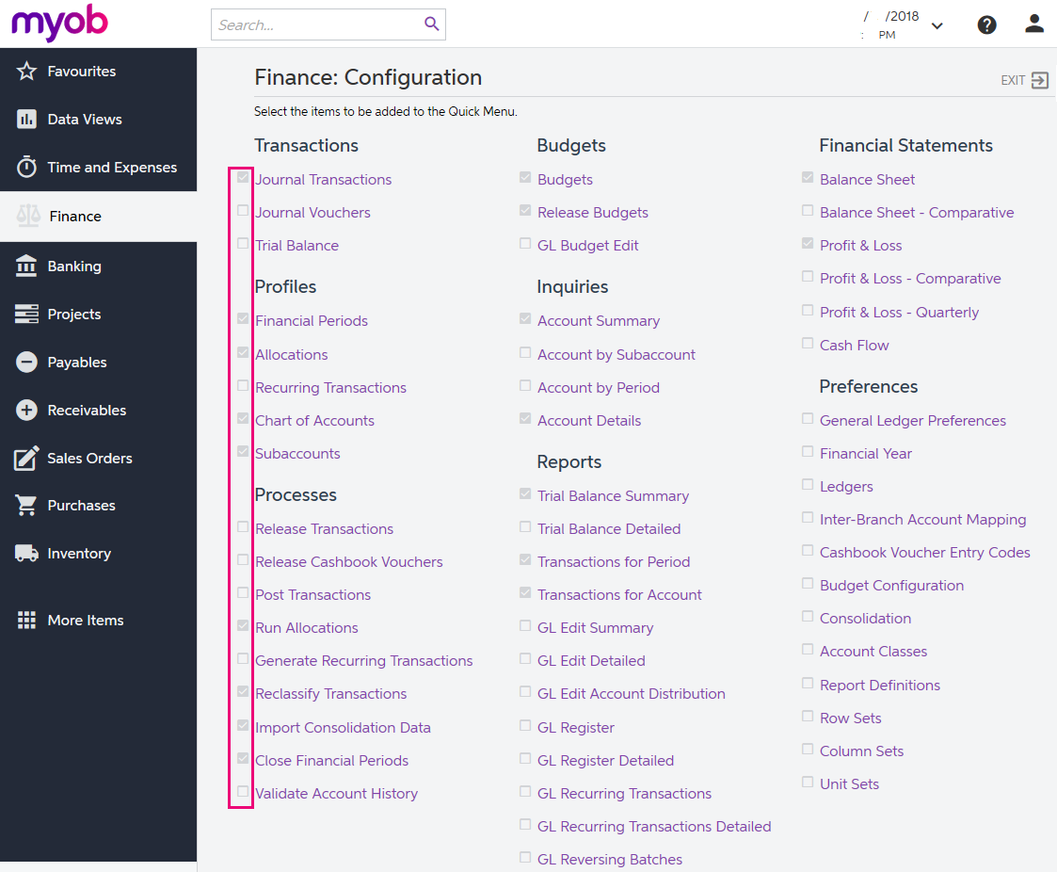
Figure: Adding forms to a Quick Menu
The full list of forms used during the completion of this training is provided below in this topic. We recommend that you be sure all these forms have been added to the applicable quick menus, to simplify navigation during the completion of the training.

To Review and Open Documents on Search Forms
Search forms provide a quick and easy way to review the list of records created on the applicable data entry forms. A search form is a generic inquiry that shows the summary information on the records entered on the entry form. Search forms are initially brought up instead of the corresponding entry forms when a user navigates to these forms in the Quick Menu.
For example, if you click Journal Transactions (under the Transactions category) on the Quick Menu of the Finance workspace, the system opens the Journal Transactions search form (GL3010PL), which shows the list of all transactions in the system (see the screenshot below). The search form may show tabs that filter the documents by their type or status.
To open the Journal Transactions entry form (GL301000) for entering a new batch of transactions from the Journal Transactions search form (GL3010PL), you need to click Add New Record button on the form toolbar.
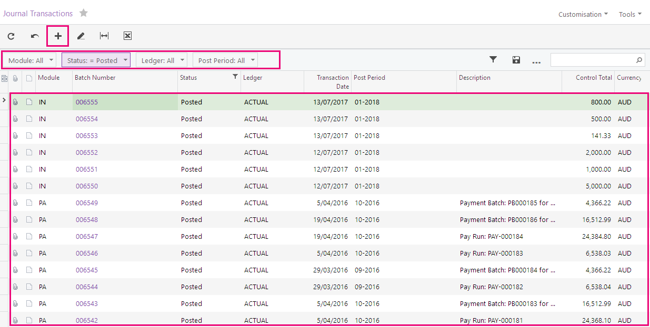
Figure: Viewing the Journal Transactions search form
If the training instructions ask you to open a document (such as a batch, a Payables bill, or a Receivables invoice), you can find this document on the appropriate search form and then click its reference number link to open this document on the data entry form. Alternatively, you can open the data entry form itself, select the module or document type (depending on the form), and in the Reference Nbr. box, click the selector icon and select the document by its reference number (see the screenshot below).
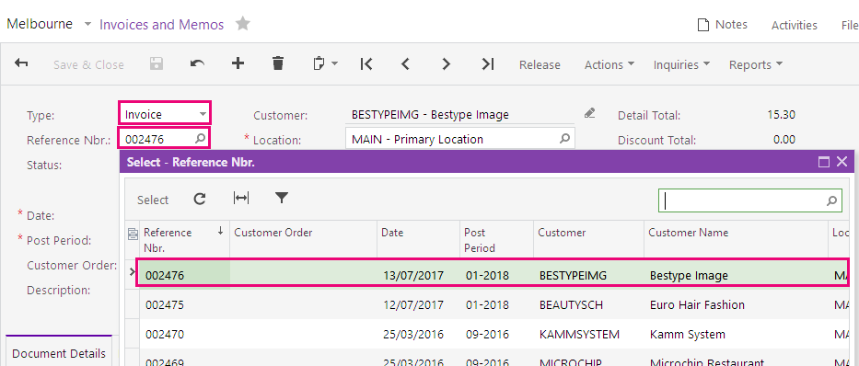
Figure: Opening a document by its reference number

Navigating to Forms: Tips
The following tips apply to the modern and classic user interfaces and will help you to quickly find and open any form.

How To Search for a Form by Its Title or ID
At any time, you can quickly search for a form by typing its title or ID in the Search box:
- In the modern UI, type the text in the Search box on the top of the screen (see the following screenshot). The system shows the search results in the Search window, which opens when you start typing the text in the Search box. Then on the Menu Items tab of the Search window, you click the link to open the needed form.
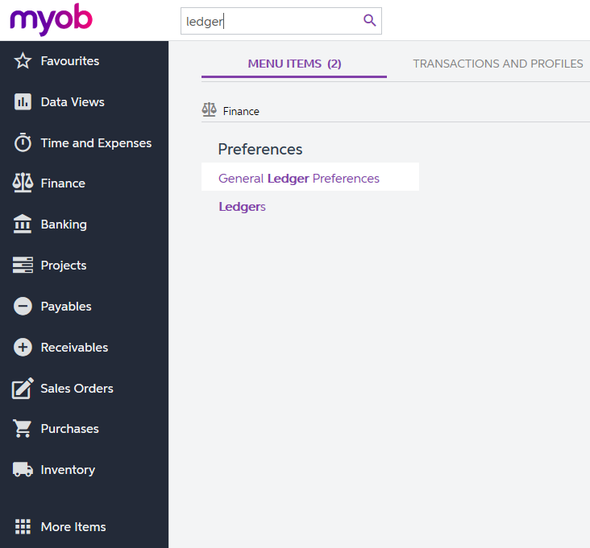
Figure: Searching for a form by title in the modern UI
- In the classic UI, type the text in the Search box at the top of the navigation pane (see the following screenshot). To navigate to the needed form, click it in the drop-down list with the search results.
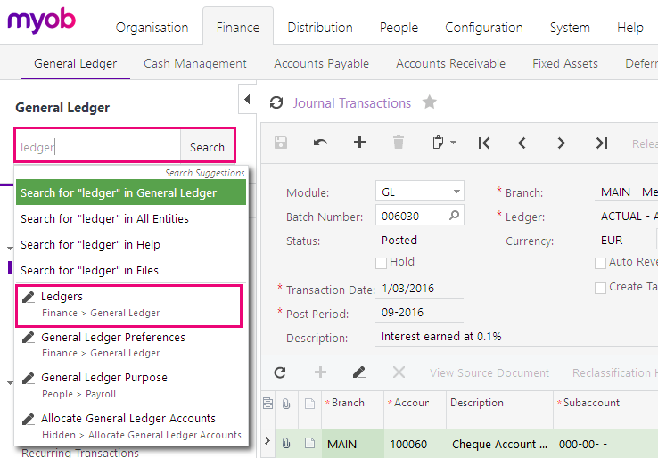
Figure: Searching for a form by its title in the classic UI

How To Navigate to Forms by Using the Form ID
In the training guide, each form is referred to by its ID. If you are not sure in which area a form is located, instead of searching for the form, you can simply open it by using its form ID. You can do this in both the modern UI and the classic UI as follows:
- In the browser's address bar, change the form ID of the currently opened form to the form ID of the needed form (see the screenshot below).
Figure: Entering the form ID
- Press Enter. The system navigates to the form.

Completing the Training in the Classic UI
The following sections provide a quick overview of the classic UI and explain how to navigate in the system during the completion of the training.

To Switch Back to the Classic UI
When you have created a new company and signed in to it, the modern user interface is enabled by default. If you need to switch back to the classic UI, do the following:
- In the top right corner, click the name of the current user, and click My Profile, as shown in the following screenshot.
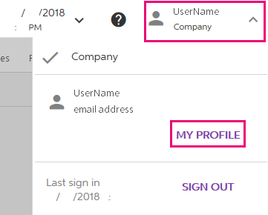
Figure: Opening the user profile
- On the User Profile form (SM203010), which opens, select the Show Classic UI by Default check box, and save your changes.
To switch back to the modern UI, again click the name of the current user in the top right corner and click Switch to Modern UI in the menu (see the screenshot below)
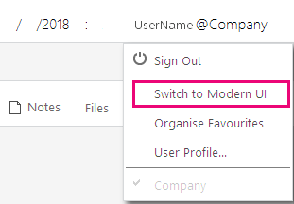
Figure: Switching to the modern UI

To Navigate to Forms in the Classic UI
To help learners to search for forms during the training completion in the classic UI, the paths to forms in this training guide are based on the classic UI. The main menu, at the top of the screen, shows suites and the modules of the selected suite. The navigation pane, located on the left side of the screen, shows the forms of the modules grouped by their functions. The path to a form is specified as follows in the training:
Form Title (Form ID; Suite > Module > Tab > Node)
For example, the form with the following path is shown in the screenshot below:
General Ledger Preferences form (GL102000; Finance > General Ledger > Configuration > Setup)
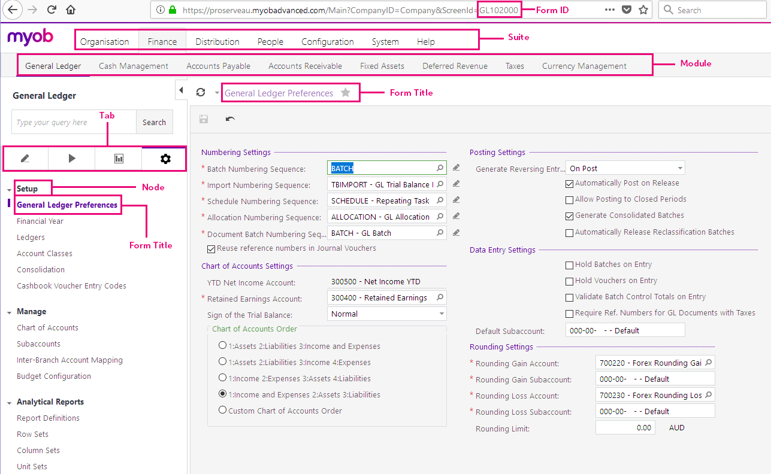
Figure: General Ledger Preferences form in the classic UI

Product Features
Not all features are available in all MYOB Advanced Business Editions, for example as you can see from the following comparison chart, Deferred Revenue Schedules are only available in Enterprise Edition.
Contact your Business Partner for more information on the different Editions or if you want to add more features to Advanced Business.

MYOB Advanced Business – Edition Comparison Chart

Accounting
Product Features | MYOB Advanced Business Edition
 | Standard | Plus | Enterprise
Ledgers |  |  | 
Invoice basis GST reporting |  |  | 
Multi-currency |  |  | 
Budgeting and Comparisons |  |  | 
Multi-Branch |  |  | 
Interbranch Transactions |  |  | 
Fixed Asset Management |  |  | 
Convert Ledger to Different Base Currency for Reporting/Consolidation |  |  | 
Allocation Revenue Schedules |  |  | 
Deferred Revenue Schedules |  |  | 

Banking
Product Features | MYOB Advanced Business Edition
 | Standard | Plus | Enterprise
Cashbook |  |  | 
Bank Reconciliation and Payment Processing |  |  | 
Cash Flow Reporting |  |  | 
Cash Flow Forecasting |  |  | 
Prompt Payment Discounts |  |  | 
Pre-Payments and Deposits |  |  | 
Payment Instalments |  |  | 

Payables
Product Features | MYOB Advanced Business Edition
 | Standard | Plus | Enterprise
Supplier Management |  |  | 
Recurring Invoices |  |  | 

Receivables
Product Features | MYOB Advanced Business Edition
 | Standard | Plus | Enterprise
Customer Management |  |  | 
Recurring Invoices |  |  | 
Head Office / Branch Relationships |  |  | 
Salesperson Commissions |  |  | 
Debt Collection |  |  | 

How’s my Business going?
The Finance module is the centre of MYOB Advanced and is where all financial information is collected for analysing, summarising, and reporting. It has the functionality for the following:
- Setting up the company’s financial structure through the chart of accounts and subaccounts
- Collecting information through transactions entered directly by users and posted from subledger modules
- Monitoring business performance through the module’s budgeting system
- Preparing data for generating various financial statements
- Preparing statutory returns to the ATO
When we release documents like a customer invoice or a purchase receipt, transactions are created and posted to the ledger. We can also enter Finance journals in the module. Transactions can be posted directly on release or we can set the preferences for manual updates.
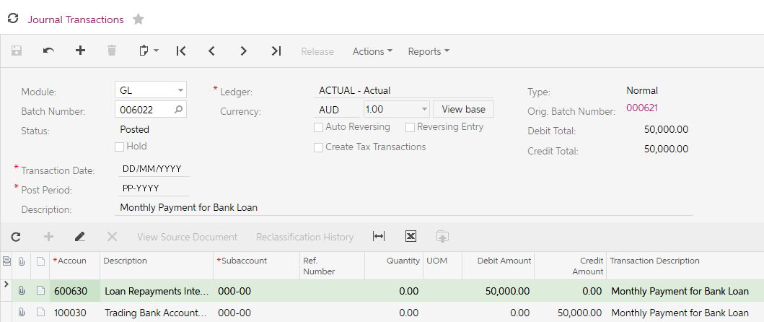
Figure: FINANCE Journal Transaction
As MYOB Advanced is highly configurable, the features and processes may differ for your business. Please refer to your Business Partner for details on any customisations they may have included in your implementation.

Finance batches are assigned the following batch types depending on where the transaction comes from.
- GL – Finance
- AP – Payables
- AR – Receivables
- CM – Currency Management
- CA – Banking
- IN – Inventory
- DR – Deferred Revenue (Enterprise edition only)
- FA – Fixed Assets
- PM – Project Accounting
- PR – Purchase Requisitions
- PA - Payroll
Your MYOB Advanced will be implemented by a consultant who is Certified to Implement MYOB Advanced Business. As mentioned previously, MYOB Advanced is highly configurable, this training covers the basic financial processes you need to know about the Finance.

What do I need to know?
Finance has a chart of accounts that provides a summary of business transactions. Information from the Ledger is used to review business performance, primarily in reports such as the Profit & Loss statement and the Balance Sheet.

Configuration

General Ledger Preferences
After review of your company’s needs, your implementing partner will go through and set the preferences for the Finance module. Preferences will include configuring the Financial Year, Chart of Accounts, Sub Accounts.
You should only make changes to any settings under Preferences after talking to your Business Partner.

Activity 1
- Go to the General Ledger Preferences form (GL301000; Finance > Preferences (Full Menu)), review the settings.
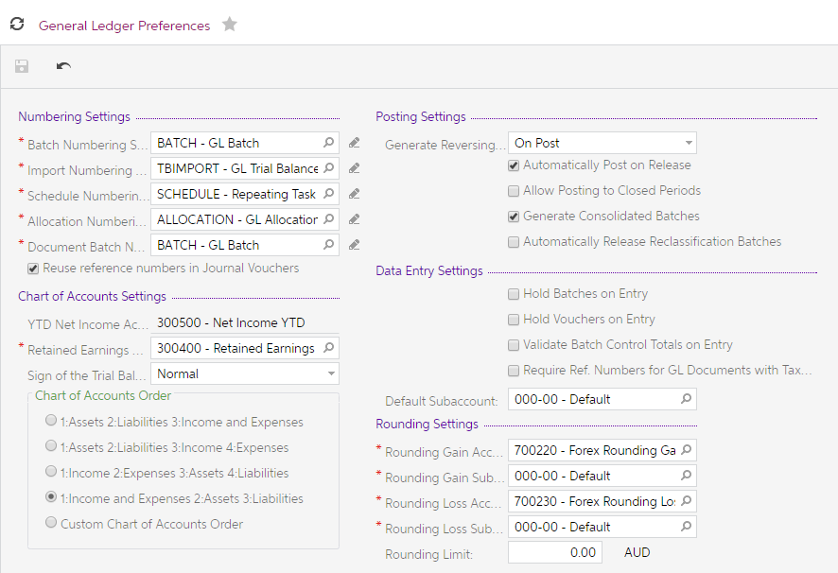
Figure: General Ledger Preferences
The Posting Settings is where we set up how the transactions will be posted e.g. if the Automatically Post on Release checkbox is ticked then once a journal has been released the transactions will update to the ledger. If the checkbox is not ticked then the journal will be posted manually using the Post Transactions on the processing tab.
Day to day management of the Ledger would usually not require any of the preferences to be changed. Occasionally you might need to tick the Allow Posting to Closed Periods. Should this be the case, remember to untick this feature once the posting has been completed.

Other Setup features

Financial Year
The financial year setup is one of the first tasks your implementing consultant will complete. Once this has been setup and financial periods generated you cannot change the settings.

Ledgers
There is one default posting ledger in MYOB Advanced and one Budget ledger. In the Enterprise Edition, you can also set up Statistical and Reporting ledgers. Statistical and Reporting ledgers are outside the scope of this training.

Account Classes
Account Classes are used to group Finance Accounts for sorting, filtering in reports and inquiries. If you add new Account Classes make sure you also add these classes to the Analytical Reports for the Profit & Loss Statement and/or Balance Sheet. When adding a new Finance account to the chart of accounts which requires a new Account Class, add the Account Class first.

Consolidation
Consolidation is an advanced feature in MYOB Advanced and involves combining transactions from subsidiaries to their parent company. Consolidation is outside the scope of this training.

Voucher Entry Codes
Finance allows you to enter Journal Vouchers, transactions entered on these vouches are defined in the Voucher Entry Codes. This topic is outside the scope of this training.

Profiles

Chart of Accounts
The Chart of Accounts is the cornerstone of any ERP system. It holds the Finance accounts defined in the system. MYOB Advanced supports four types of Finance accounts: asset, liability, income and expense.
You can manually enter new accounts or import a group of accounts using the file upload feature on the grid toolbar.
Figure: Grid toolbar

Activity 2
Your company has decided that they would like to split the reporting of salaries and wages into two expense accounts.
- Go to the Chart of Accounts form (GL202500; Finance > Profiles), modify the existing Salaries and Wages Expense account by highlighting the row and double click on the Description and update this as shown in the following screenshot. Then your changes.
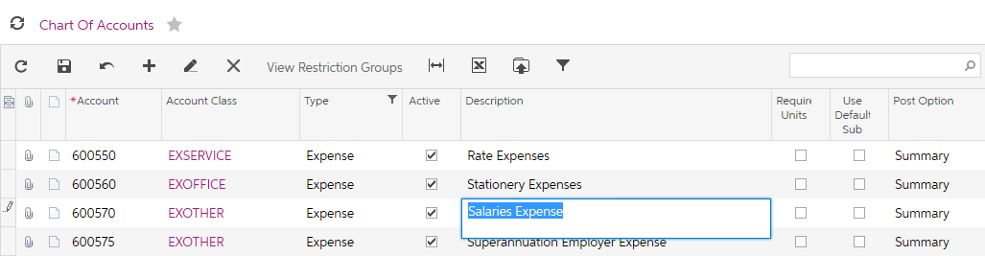
Figure: Modifying Description of a Finance account
- From the form toolbar click on the add icon, add a new account with the following details and then save your changes;
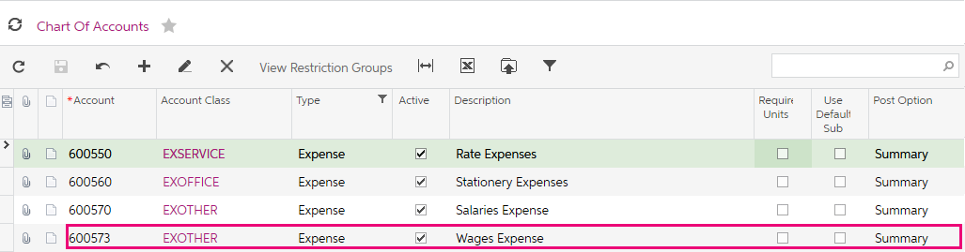
Figure: Adding a new account

Subaccounts
Subaccounts are a powerful feature of MYOB Advanced, they are used to detail transactions within an account for analysis. Your implementing consultant would have reviewed your company’s requirements and suggested the best structure for both your chart of accounts and subaccounts.
The same methods used to add Finance accounts can be used to add subaccounts; manually entering the new subaccount into the grid or using the file upload on the grid toolbar.

Inter-branch Account Mapping
This is an advanced feature of MYOB Advanced and is outside the scope of this training. For more information, see the help topics or contact your Business Partner.

Transactions

Journal Transactions
In the Finance module of MYOB Advanced, transactions are recorded in batches. A batch is a group of transactions that can be posted to the Ledger. The batch must include at least two journal entries. For each journal entry, the account and the debit or credit amount must be specified.
In processing entries on a day to day basis, you work with documents from the sub-ledgers (such as customer invoices from Receivables) and the batches are created so they can be posted to the Ledger.
To become familiar with the process of posting transactions, you will;
- Create and release batches,
- become familiar with batch statuses,
- see how to reverse a batch that has been incorrectly posted,
- create a batch for an accrual transaction, which will be automatically reversed in the next financial period, and
- create a recurring transaction for paying interest on a bank loan.

Activity 3
In Activity 2, you modified the Chart of Accounts so the Salaries and Wages would be reported in two expense accounts. You have analysed the Salaries account and found that $712,523.45 needs to be transferred from this account to the new Wages Expense Account.
- On the Finance menu, add a new Journal Transaction by clicking on the tile New Journal Entry. This will open the Journal Transactions form (GL301000; Finance > Transactions) and add a new journal with the following details and save .
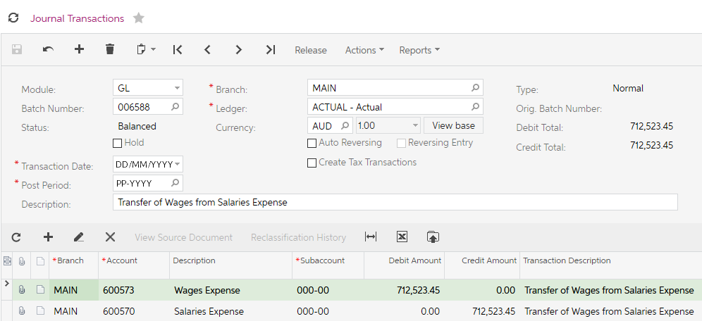
Figure: Finance Journal Batch
The journal batch now has a status of Balanced. The setup for Finance in our company allows the batch to be posted immediately once the batch is released.
- From the form toolbar click Release, the status changes to Posted and the batch becomes read only.

Batch Status
Finance Journal batches can have one of the following statuses.
- On Hold: The batch is being edited and can be saved without being balanced.
- Balanced: The batch is being edited and can be saved only if it is balanced.
- Unposted: The batch has been released but has not yet been posted. The unposted batch is read-only.
- Posted: The batch has been posted. The posted batch is read-only.
- Scheduled: The batch is a template for recurring batches. The scheduled batch itself isn't released and posted and can be edited as a template.
- Voided: The scheduled batch has been cancelled (removed from the schedule). The voided batch is read-only.

Activity 4
In Activity 3, you transferred $712,523.45 from the Salaries account to the new Wages Expense Account.
It was discovered that this journal did not need to be created and must be reversed.
- Open the Journal Transactions search form (GL3010PL; Finance > Transactions) and search for the journal created in Activity 3. Double click on the Batch Number to open the Journal.
- From the Actions dropdown select Reverse Batch.
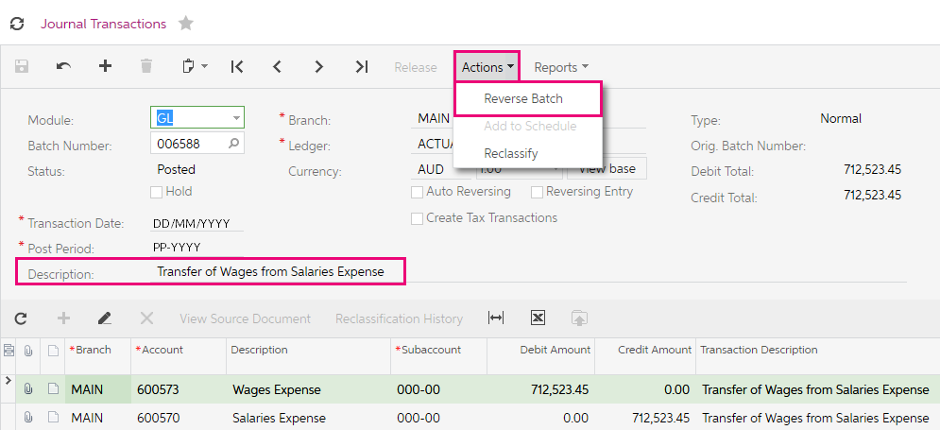
Figure: Reverse Batch function from Actions dropdown
A new batch will be created reversing all the entries on the original batch. The original batch number will be added to the summary section with a hyperlink to the batch number as shown in the screenshot below.
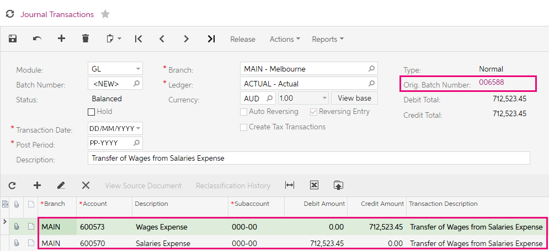
Figure: Reversed Batch
- Release the new batch and go to the original batch using the hyperlink.
The original batch now has the number of Reversing Batches: showing in the summary.
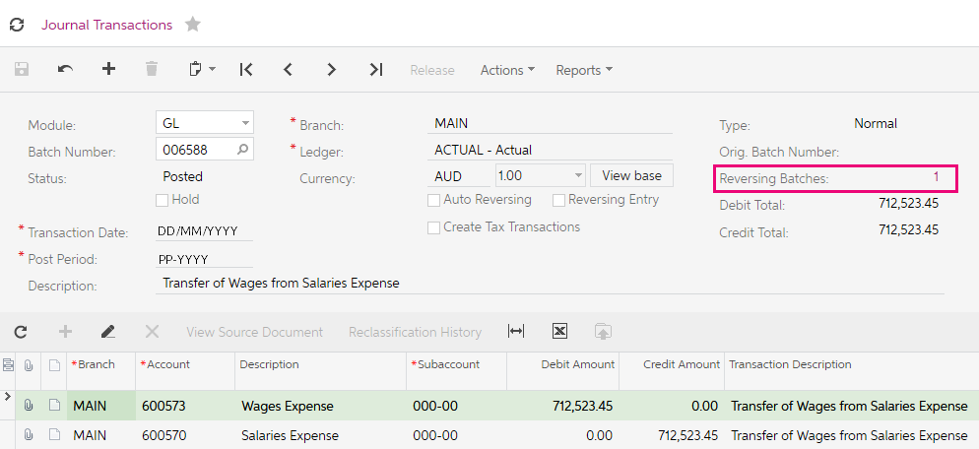
Figure: Original Batch with reversing batches added.

Recurring Transactions
Some Finance transactions, such as loan payments, depreciation-related transactions, repeat regularly. To automate the entering of recurring transactions, you can create schedules for them in the Finance module.
There are four steps in updating a recurring transaction;
- Create the recurring batch
- Create the Schedule
- Run the schedule
- Release the batch generated.

Activity 5
You have a loan repayment of $1650 per month which will continue for 12 months on the 15th of the month.

Create the Batch
- On the Finance menu, add a new Journal Transaction by clicking on the tile New Journal Entry. This will open the Journal Transactions form (GL301000; Finance > Transactions).
- Enter a new Finance Journal with the following details. Make sure the Hold checkbox is unticked (Balance status), then save your changes.
Hold: Cleared (sets the Balanced status for the batch)
Transaction Date: Today’s date.
Post Period: Today’s date’s Period
Description: Loan Repayment.
Credit entry: Account: 100010 - Cheque Account - AUD,
Subaccount: 000-00
Amount: $1650.00
Debit entry: Account: 200200 – Loans Payable,
Subaccount: 000-00
Amount: $1650.00
- From the Actions dropdown list, select Add to Schedule,
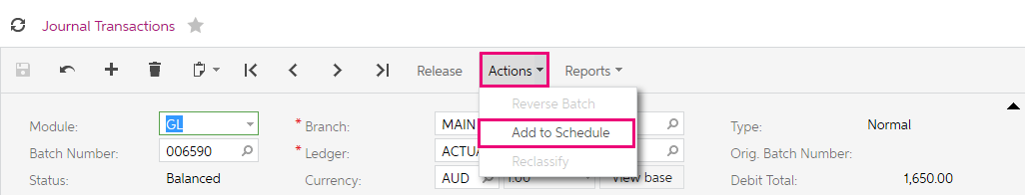
Figure: Add to Schedule from the Actions dropdown.

Create the Schedule
You will be taken to the Recurring Transactions form (GL233500). Update the form with the following details and save your changes.
- Start Date: Today’s Date
- Execution Limit (Times): 12
- Schedule Type: Monthly
- Monthly: Every 1 Month(s)
- On Day: 15
- Description: Loan Repayment

If you select the By Financial Period schedule type instead of Monthly, you specify the day within the financial period on which the batch should be generated. For example, you could select the End of Financial Period option button. You can also use the Weekly or Daily schedule type to generate more frequent batches.
If you clear the Never Expires check box, you can specify the Expiration Date of the schedule. After the last execution before this date, the schedule becomes inactive and you cannot generate batches with this schedule.
The Execution Limit number specifies the maximum number of execution times. The schedule can run fewer times if it expires before the limit is reached

Run the Schedule
To generate the batch to be posted to the next period, run the schedule as follows:
- On the Generate Recurring Transactions form (GL504000; Finance > Processes), specify the following selection criteria:
- Execution Date: 15th following today’s date.
- Stop After Number Of Executions: 1
- Tick the Loan Repayment schedule and then select Run from the form toolbar.
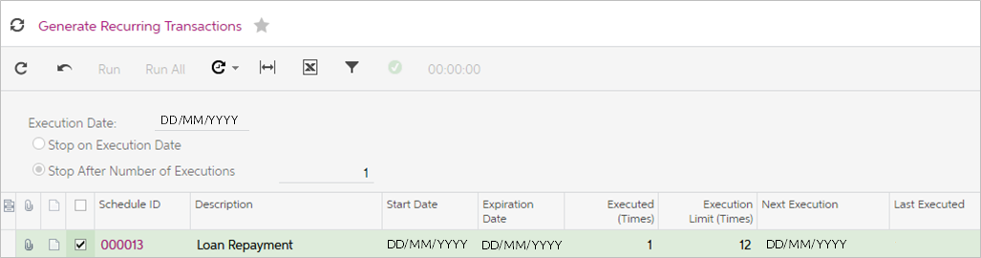
Figure: Successful execution of Loan Repayment recurring transaction.
Release the Batch.
If you click on the Schedule ID hyperlink in the row on the successful Generate Recurring Transactions form, you will be taken to the Recurring Transaction schedule screen. On the Generated Documents tab, you can see the Finance Journal batch that has been created.
Click on the Batch Number hyperlink to go directly to the batch.
The batch has a status of Balanced, this means the transactions have not been posted to the ledger.
From the form toolbar, Release the batch.

Budgets
A company budget generally consists of a set of interrelated budgets that the company’s top managers use for planning, financial analysis, and forecasting. In MYOB Advanced, you can create and maintain any number of budgets and budget scenarios (versions of a budget) for all branches, and you can compare budgets to actual data or to other budgets.
There are two types of budgets in MYOB advanced.
- A single-level budget is a list of budget articles, each of which is defined by an account-subaccount pair with the amount.
To update the single-level budget, you can
- enter the amounts manually,
- import them from a file, or
- calculate the amounts when you load budget articles from the actual ledger or another budget.
- A hierarchical budget (one that is based on the budget tree configured on the Budget Configuration form) includes budget articles of two types: leaves and nodes.
Hierarchical budgets are an advanced feature of MYOB Advanced and outside the scope of this training.

Create and Budget and release the transaction

Activity 6
You have been asked to create a budget which is based on the financials for the year 2015 for the Head Office which is Melbourne. The Executives of the company believe the budget figures need to be increased by 120% as the business has grown since this time.
Budget articles can be created by;
- Manually selecting an account and subaccount and typing the amount.
- Importing the list from an Excel spreadsheet.
- Loading the account-subaccount pairs from another ledger using the Preload Budget Articles Wizard.
As you have been asked to use the year 2015 with a multiplier to create the new Budget you have decided to use the wizard.
- Open the Ledgers form (GL201500; Finance > Preferences) and add a new Budget Ledger with the following details and save your changes.
- Ledger ID: AAABUDGET
- Description: A New Budget
- Balance Type: Budget
- Currency: AUD
- Consol. Branch: {blank}
- Branch Accounting: Unticked
- Is Consolidation Source: Unticked
- Open the Budgets form (GL302010; Finance > Budgets).
- Select the current Financial Year and then select Preload Articles from the form toolbar.
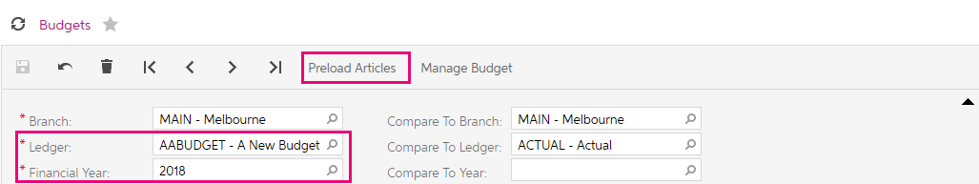
Figure: Budgets form.
- In the dialogue box that appears, update the information with the following details and then select Next.
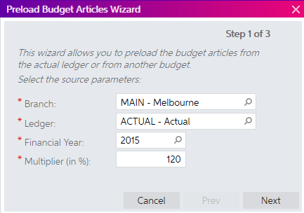
Figure: Budget Articles Wizard Step 1
- Another dialogue box will ask what information from the ledger is required for this Budget. Enter the following details and select Next.
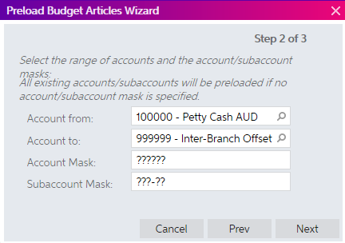
Figure: Budget Articles Wizard Step 2
- On the next wizard step, select to Update Existing Articles and Load Nonexistent Articles and then Finish.
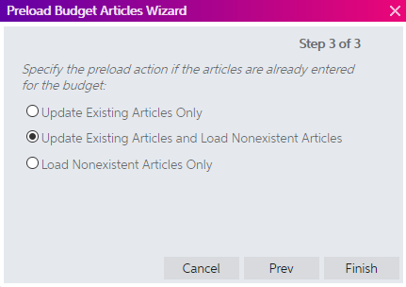
Figure: Budget Articles Wizard Step 3.
The Budget grid will be updated with the information entered in the Budget Wizard, as shown in the screenshot below.
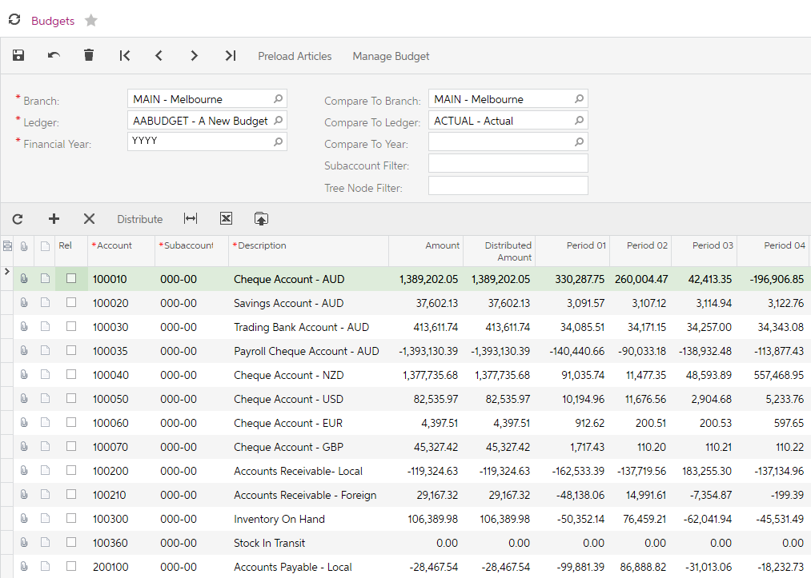
Figure: New Budget
- Make sure you save the changes to your budget.
- Open the Release Budgets form (GL505510; Finance > Budgets). From the form toolbar, select Release All. The budget is now available for reporting and inquiries.

Currency Management
The Currency Management module has functionality to use multiple currencies in MYOB Advanced. You can record foreign currency transactions throughout the Finance, Payables, Receivables, Sales Orders, Purchase Orders, and Banking modules. You can maintain lists of currencies, track exchange rate fluctuations, and do revaluations for currency-denominated accounts and produce documents in foreign currencies with automatic calculation of gains and losses resulting from exchange rate fluctuations.

Create a New Currency
You have a new supplier who wants to do business with you in their local currency, Japanese Yen.

Activity 7
- Open the Currencies form (CM202000); More Items > Financials > Currency Management > Profiles) and create a new currency with the following details and Save your changes.
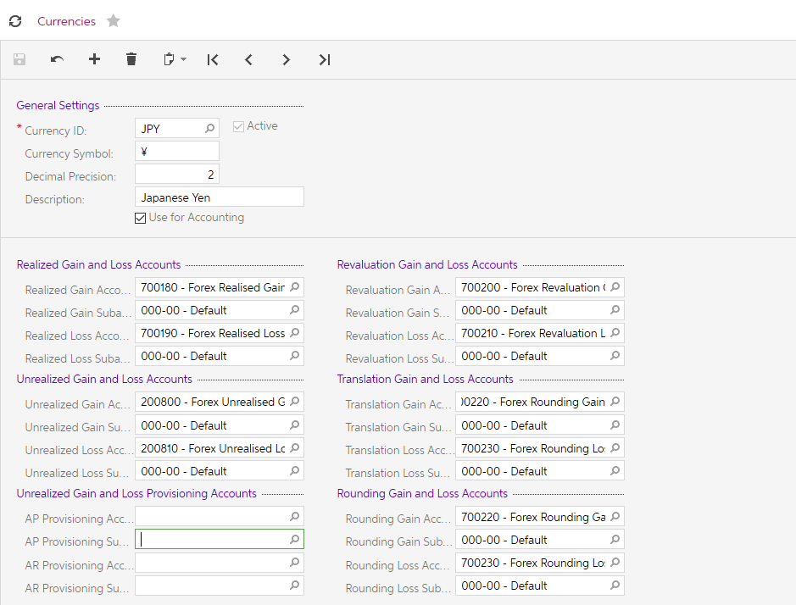
Figure: New currency
- Open the Currency Rates form (CM301000; More Items > Financials > Currency Management > Profiles).
- Update the To Currency: AUD with the following details and Save your changes.
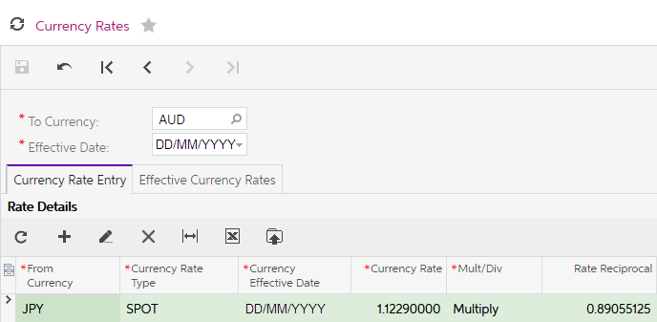
Figure: Currency Rate for Japanese Yen

Currency Revaluation Process
To revalue accounts that are maintained in a foreign currency, select a foreign currency to display all accounts maintained in this currency, select the specific accounts to be revalued, and provide a description for the revaluation. You can revalue the accounts at the end of each period as often as needed to accurately reflect your cash position.

Activity 8
Your company would like to revalue their Payables accounts so they have a better picture of the liability for these foreign currency balances.
Your first step is to update the currency rate
- Open the Currency Rates form (CM301000; More Items > Financials > Currency Management > Profiles).
- Update the To Currency: AUD with the following details and Save your changes.
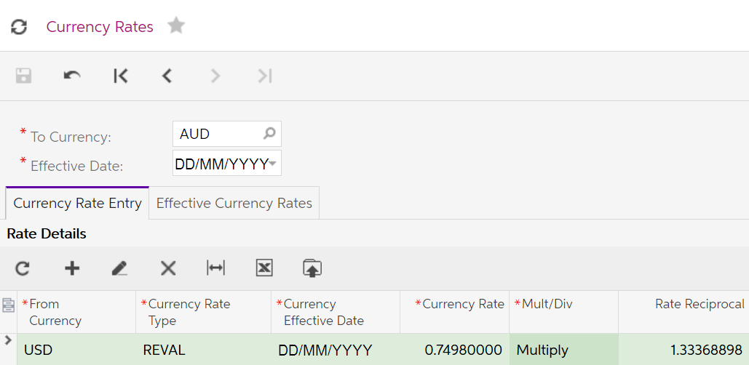
Figure: Reval Currency Rate update
- Open the Revalue AP Accounts form (CM504000; More Items > Financials > Currency Management > Processes).
- Update the Revalue AP Accounts form with the following details, select all the records and from the form toolbar, select Revalue.
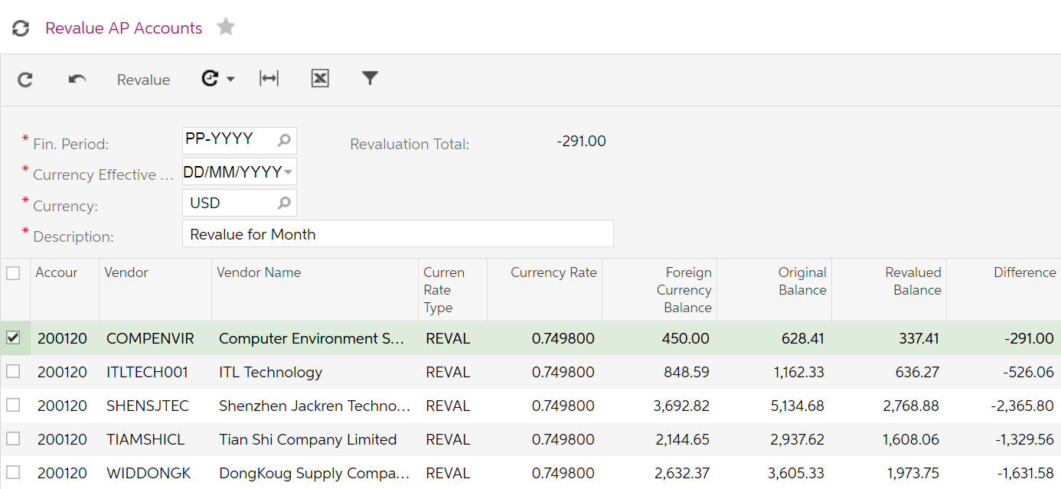
Figure: Revalue AP Accounts
You will be redirected to the Journal Transaction form to view the Finance journal transactions. If you want to see the Actual values of the currencies, click on View Base on the journal header.
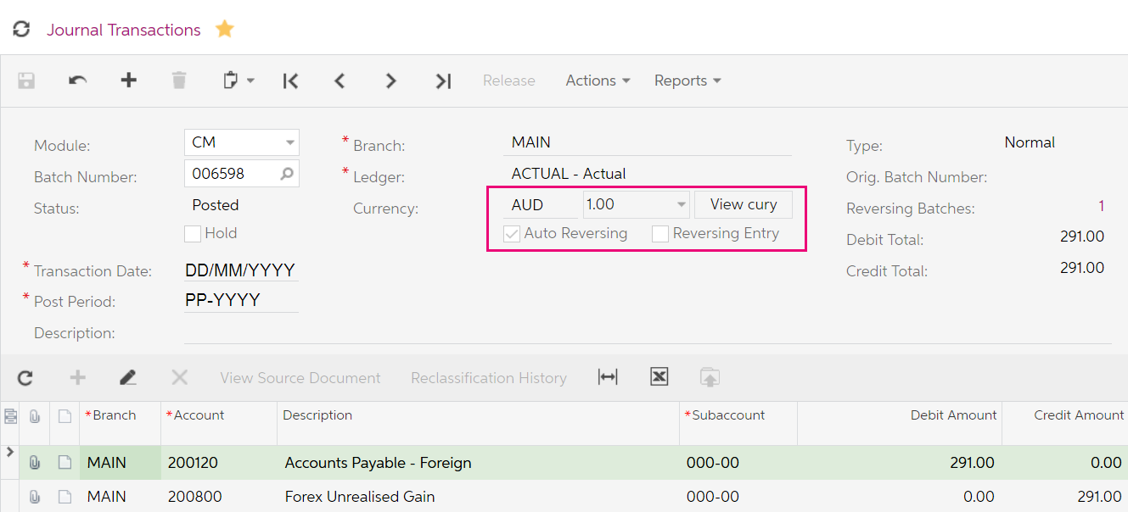
Figure: Journal Transaction from Revaluation – View Base selected

Banking
The Banking module of MYOB Advanced helps you manage cash flows and forecast your cash position at any time and in multiple currencies. By using the Banking module, you can track a wide range of cash transactions and perform bank reconciliations quickly and easily.

Setup

Cash Management Preferences
Every module in MYOB Advanced Finance, Distribution and People suites require the configuration of preferences. Preferences are usually configured by your implementing consultant after reviews of your business processes.
You should only make changes to the Cash Management Preferences after consulting with your Business Partner.

Payment Methods
Payment Methods are linked to cash accounts. MYOB Advanced has default payment methods, some of which hold the settings used when a bank transfer file is generated.
In MYOB Advanced you can use the same Payment Method for Receivables (Customers) and Payables (Suppliers).

Entry Types
While Payment Methods record the movement of cash through the Payables and Receivables modules, Entry Types are used to record the movement of cash transactions in the Banking module.
When adding an Entry Type, you specify which module is to be updated. There are three entry types to choose from;
- CA entry type is used for recording transactions that affect the balance of Finance accounts only. Transactions such as Bank Interest or Charges.
- AP entry type will record a prepayment in the Payables module, if the transactions is a disbursement; or a supplier refund in the Payables module, if the transaction is a receipt.
- AR entry type will record a payment in the Receivables module, if the transaction is a receipt; or a customer refund in the Receivables module, if the transaction is a disbursement.

Payment Method Converter
This topic is not part of the scope of our training.

Bank Transaction Rules
You can set rules to create new payments for imported bank transactions when matching documents are not found. This topic is not part of the scope of our training.

Cash Accounts
In the Banking module, you work with cash accounts. Cash accounts are used to keep records of the outgoing and incoming payments. You can create cash accounts that represent bank accounts, amounts of cash on hand, or amounts of cash in transit. The details of configuration depend on the type of cash account you need.
A cash account is always paired with a Finance account and if you have the multi-currency feature enabled, then the currency of the account must be entered on the Finance account before you can set up the cash account.
Cash Accounts and Payment Methods co-exist and there must be at least one payment method added to each Cash Account.

Create a Cash Account

Activity 9
- Open the Chart of Accounts form (GL202500; Finance > Profiles) and add a new Finance Account with the following details and save.
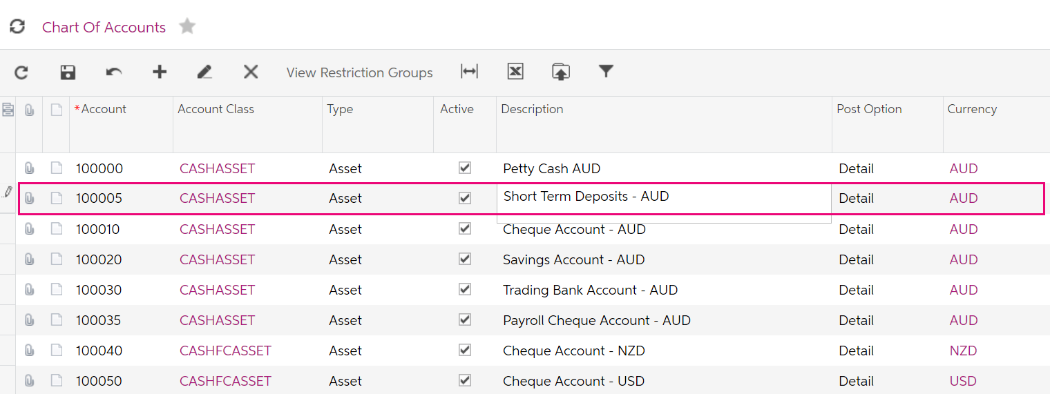
Figure: New Finance Account
- Open the Cash Accounts form (CA202000; Banking > Profiles) and enter a new cash account with the following details.
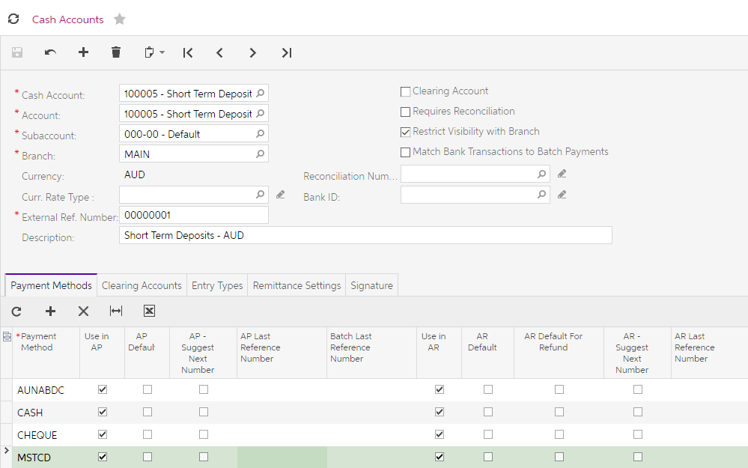
Figure: Cash Account Payment Methods tab
When a payment method is selected and the payment method has the Require Remittance Information for Cash Account ticked, you must add the details as shown on the Remittance Settings tab of the cash account. In the screenshot below, this is the bank account information that the funds will be taken from when the EFT file is created.
- On the Remittance Settings tab enter the following details.
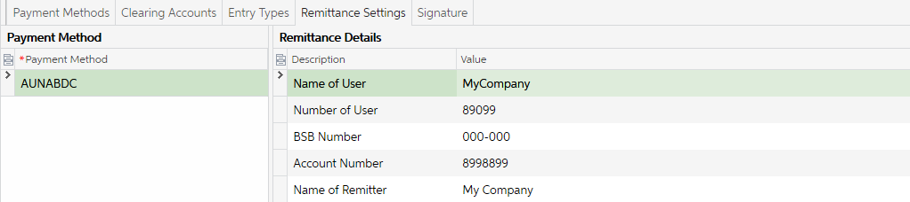
Figure: Cash Account Remittance Settings tab

This cash account will have transactions that need to be updated to the Finance. To make this easy we will add two Entry Types to the cash account so we can use the CA entry type.
- On the Entry Type tab, enter the following details when you have finished then save.
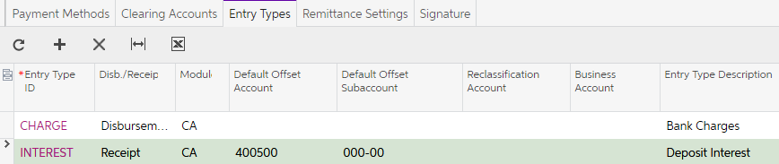
Figure: Entry Types on the Cash Account

Cash Transactions
Transactions are entered through the Banking module that affect cash, sometimes these transactions cannot be recorded in other MYOB Advanced modules. These transactions include cash entries, funds transfers, and transfer-related expenses. Such transactions do not involve customers or suppliers and affect balances of the Finance accounts only. These use the entry type of CA.
You can also enter transactions to affect the balances of customers (AR entry type) and/or suppliers (AP entry type).

Activity 10
You have two CA entry types to update, on the download of transactions of the short term deposit account there has been two bank entries, transfer of funds from the cheque account to the short term deposit account and interest received on the account.
- Open the Funds Transfer form (CA301000; Banking > Transactions) and enter a new Funds Transfer with the following details. Save and Release the transaction.
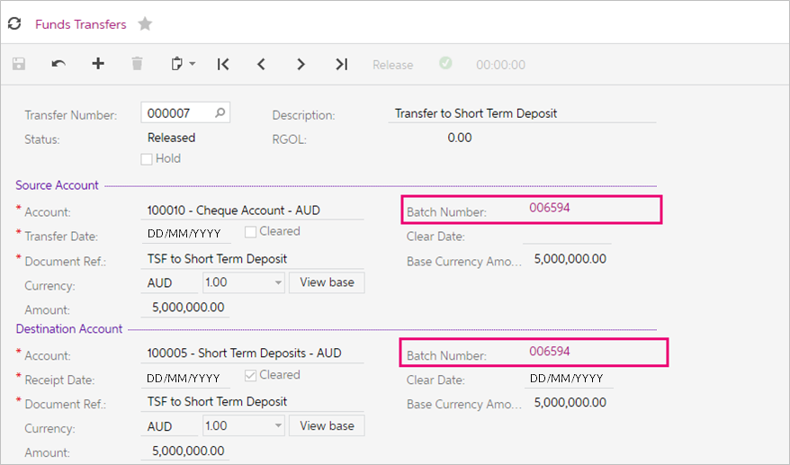
Figure: Funds Transfer between Cash Accounts
You can review the Finance entries from the Batch Number hyperlinks.

Activity 11
- Open the Transactions form (CA304000; Banking > Transactions) and enter a new Cash Entry with the following details. Save and then from the Actions dropdown list on the form toolbar, Release the transaction.
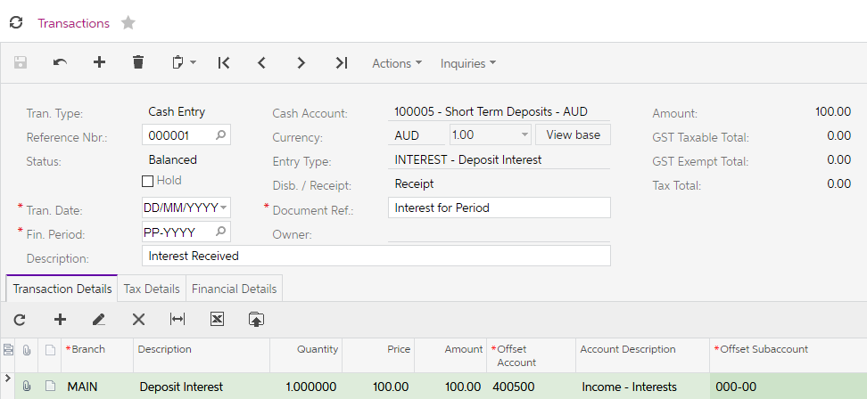
Figure: Interest received on Deposit
- From the Financial Details tab, click the Batch Number hyperlink to review the Finance Batch created.
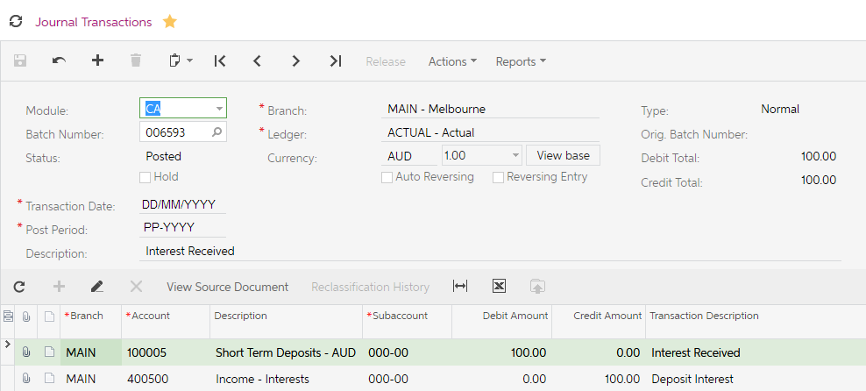
Figure: Finance journal updated from Banking transaction.

Payables
The Payables module allows you to manage your company’s suppliers for purchased or received goods and services. With this module, you can accumulate, store, and organise supplier information and documents. You can enter information quickly as the system allows default supplier information and automatic calculation of taxes, due dates, and cash discounts.
The Payables module also allows flexible payment options. In the Enterprise Edition, it lets you manage multiple instalments, prepayments, and credit and debit adjustments. Its set of comprehensive reports and inquiries, with extensive drill-down capabilities, gives you full visibility to the current state of Payables and historical supplier performance.
You may have already had some experience with the Payables module during your Purchasing training. During that training we looked at the preferences; the supplier classes and how to create a new supplier.
In this training, we will go over the process of raising an AP Bill and paying our suppliers using the batch processing feature.

Enter and process AP Invoice

Activity 11
You have received an invoice from your supplier Arktak Networks for some cable ties. Your company does not want to enter these ties as stock or non-stock items. When this is the case we can enter an AP Bill directly to the Finance module.
- Open the Bills and Adjustments form (AP301000; Payables > Transactions) and enter a new Bill with the following information, make sure the Due Date and Prompt Payment Date are both set to today’s date. Save and then Release the bill.
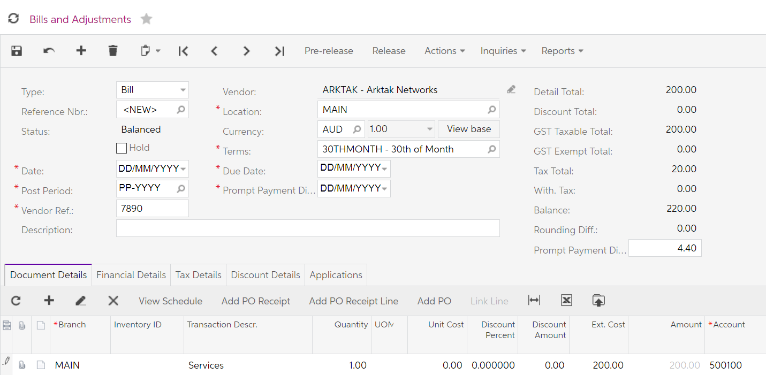
Figure: Bill for Arktak
- On the Financial Details tab, click on the Batch Nbr. Hyperlink to view the Finance transactions created when the Bill was released.
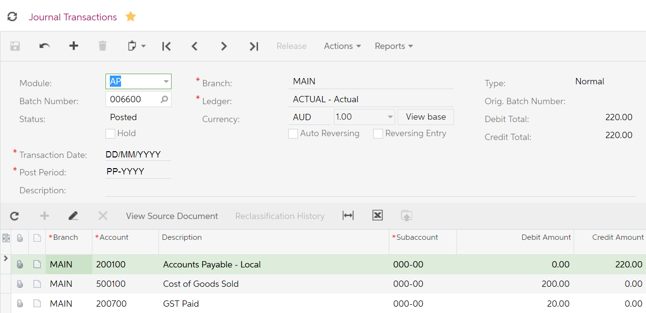
Figure: Journal Transaction from AP Bill release

Create and process EFT payment
Your company has decided to pay the Arktak bill entered previously.

Activity 12
- Open the Prepare Payments form (AP503000; Payables > Processes).
- Update the Prepare Payments form with the following information, select the Arktak networks bill entered today and from the form toolbar Process.
Partial payment can be updated by changing the value in the Amount Paid field.
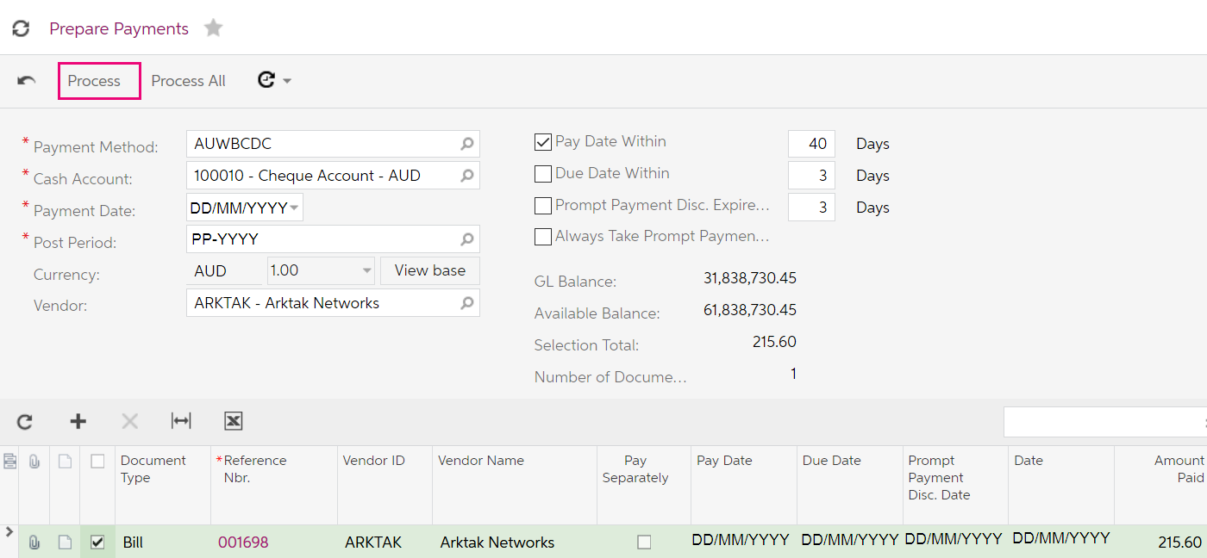
Figure: Prepare Payments with Bill marked for payment
You will be taken to the Process Payments/Print Cheques form (AP505000).
- From the form toolbar select Process All.
You will be taken to the Batch Payments form (AP305000)
- Enter Document Ref and Description; click on Release from the form toolbar. Once the process has been completed, Export the file that was created.
The EFT (ABA) file that was created will be automatically saved to your browser’s default download location.
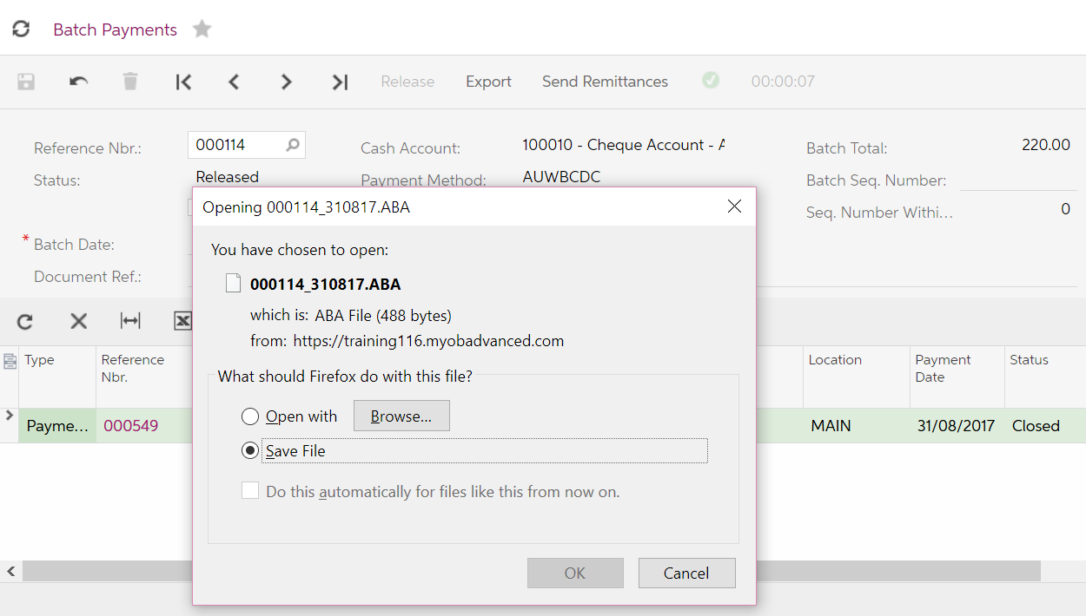
Figure: ABA file created from Batch Payments

Receivables
The Receivables module allows you to manage your customers. You can automate customer invoicing and payment collection. Default customer information on data entry and automatic calculation of taxes, salesperson commissions, discounts, and due dates will help you streamline the entire receivable process and could reduce input errors.
As was the case with Payables, you may have already had some experience with the Receivables module during your Sales Order training. During that training some of the topics covered were, preferences; the customer classes and how to create a new customer.
In this training, we will go over the process of raising an AR Invoice, sending out customer statements then we will process payments.

Create an AR Invoice and apply payment

Activity 13
Your customer ABC Studios Inc. wants to take some pictures of your warehouse to include in some storyboards. You have come to an arrangement with them that they will cover the costs of clearing the waste product that needs to be taken away.
- On the Receivables menu, add a new Invoice by clicking on the tile New Invoice. This will open the Invoices and Memos form (AR301000; Receivables > Transactions) and enter an Invoice with the following details, Save and then Release the document.
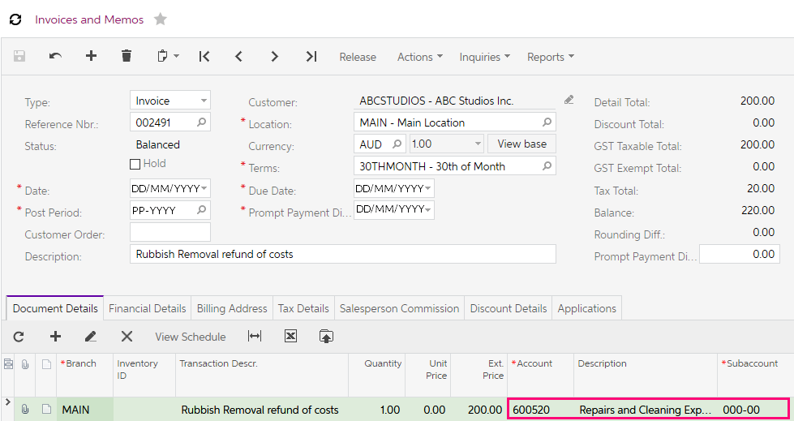
Figure: AR Invoice
- ABC Studios have paid the invoice straight away. From the Actions dropdown list select Enter Payment/Apply Memo.
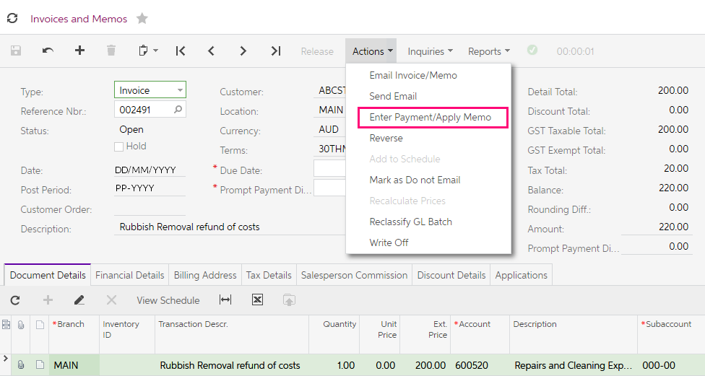
Figure: Enter Payment feature on Actions dropdown list
- You will be taken to the Payments form. You can see the Payment Amount has been updated with the total of the invoice. When you are happy the details are right, Release the payment. This will apply the payment to the invoice.
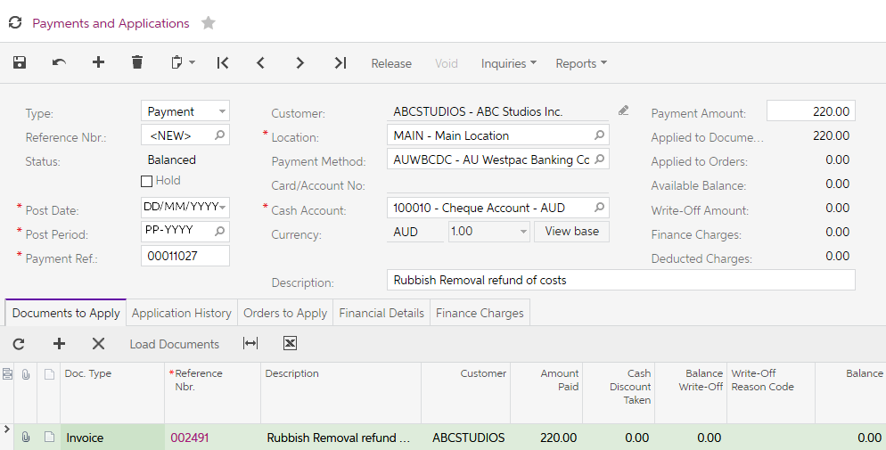
Figure: Payments and Applications form

You can also enter a payment directly on the Payments and Applications form. When a payment is entered directly to the form, on the Documents to Apply grid, click the Load Documents on the grid toolbar. A popup will display where you can filter documents to be selected. Once you have made your selections, click Load; the documents will be displayed in the grid.
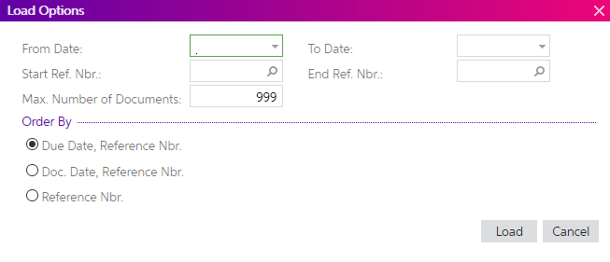
Figure: Load Options dialogue box

Customer Statements
MYOB Advanced allows you to setup statement cycles for your customers. Your implementing consultant will have identified and setup the statement cycles that work for your business.
Statement cycles are setup in the configuration area of the Receivables module. In a new site, there is one default cycle, End of the Month.
If you feel you need more statement cycles configured for your business please contact your Business Partner.

Activity 14
Your company sends out statements to customers at the end of the month. You have come to the end of the current month.
- Change the Business Date at the top of the MYOB Advanced screen to the last day of this month.
- How statements are sent to the customers and what type of statement will be sent, is controlled by the Print and Email Settings on the Billing Settings tab on the customer’s record.
If you wish to change the way (Email or Print) the statement is to be sent, this change must be made before processing in the Prepare Statements form (AR503000).
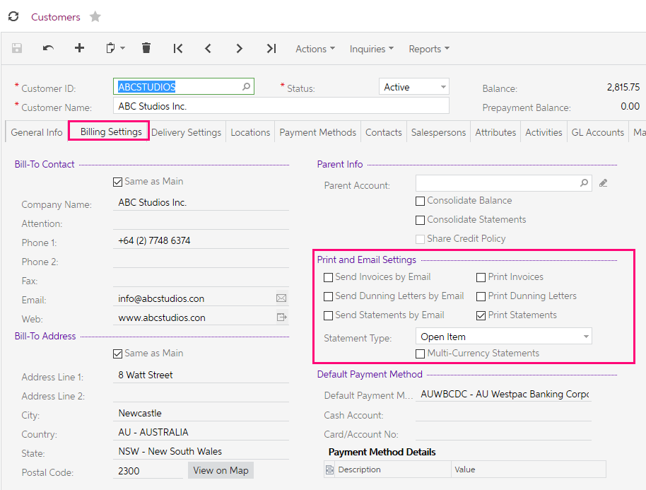
Figure: Print and Email Settings on Billing Settings tab

- Go to the Prepare Statements form (AR503000; Receivables > Processes) and tick the End of The Month statement cycle and click Process on the toolbar. You are now ready to print and/or email the customers who have the End of The Month statement cycle on the General Settings tab of their record.
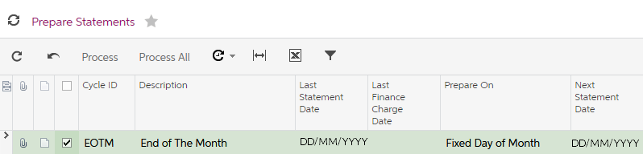
Figure: End of the Month Prepare Statements
- Go to the Print Statements form (AR503500); Receivables > Processes). Our customers have had Print Statement ticked on their records. In the Actions select Print Statements for the End of The Month statement cycle. Make sure the Statement Date is the End of the Month.
- When you are happy with your selections, Process or Process All the statements.
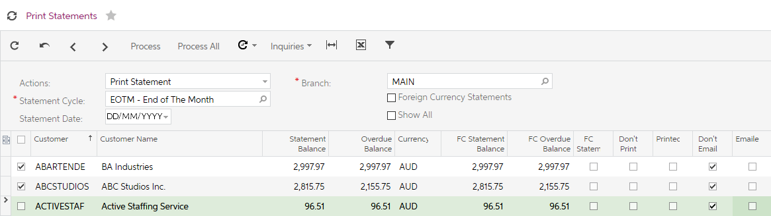
Figure: Print Statements for EOTM statement cycle.
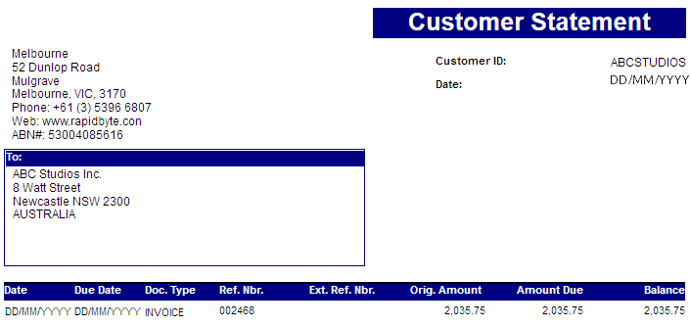
Figure: Customer Statement

Bank Reconciliation
To simplify reconciliation with bank statements, you can import multiple statements from Excel files or files in OFX format, and match transactions manually or automatically using the Bank Transaction Rules. Also, while performing reconciliation, you can apply payments to the documents.

Activity 15
You have downloaded the statement from the bank for the short term deposit account.
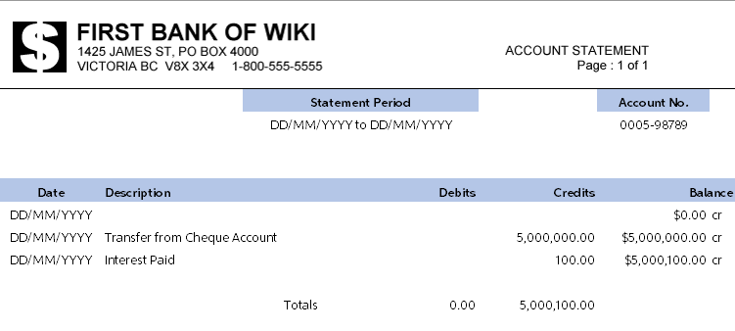
Figure: Bank Statement for Short Term Deposit Account.
- Open the Reconciliation Statements form (CA302000); Finance > Banking > Work Area Enter.
- Select Cash Account: 100005 – Short Term Deposits – AUD. You should still be at the last day of the month as you changed the Business Date previously.
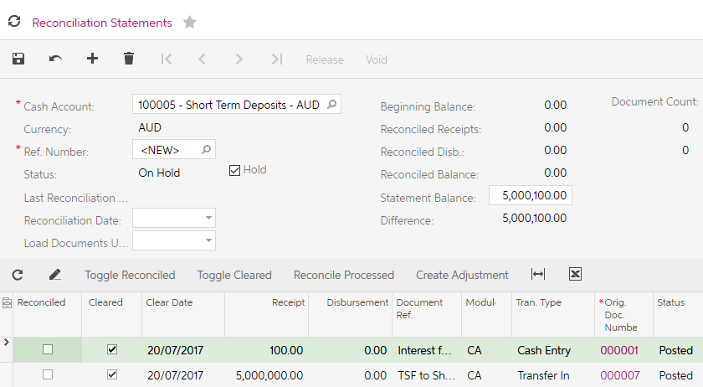
Figure: Reconciliation Statements form for account 100005
- In the Statement Balance: field enter in the final balance shown on the Bank Statement.
- In the Reconciled checkbox column, tick the entries that match those in MYOB Advanced from the Bank Statement.
You can also add transactions on the fly by selecting Create Adjustment on the grid toolbar. These transactions are called Quick Transaction.
Say you had a bank charge that you only saw once the bank statement was downloaded. Once you had clicked on the Create Adjustment the following dialogue box can be completed.
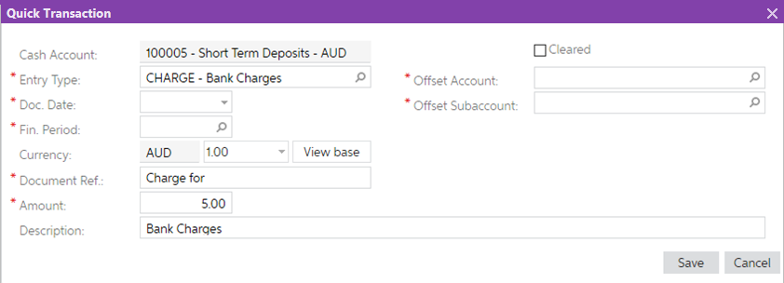
Figure: Quick Transaction example.

Taxes
The Taxes module allows calculation of tax amounts on each bill, invoice, and other similar documents created in MYOB Advanced. The Taxes module for Australia and New Zealand is preconfigured when a site is deployed. If an additional company is created in the Companies form (SM203530) the settings will be blank

Tax Agency
In an Australian site there will be some suppliers already in the Payables module. One of these suppliers is the Australian Tax Office (ATO). The ATO supplier has the Vendor is Tax Agency checkbox ticked on the General Info tab. Once ticked, a new tab Tax Agency Settings becomes available.
The Tax Agency Settings tab is where all the settings that will be used to update the Tax Report and record payments due to, or from the ATO are set up
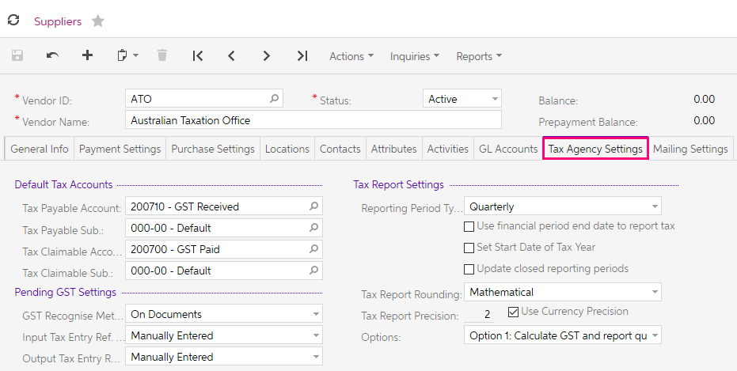
Figure: ATO Tax Agency Supplier
Some of the features of the ATO Supplier;
- Records all tax transactions.
- AP Invoices are generated when payment is due to the ATO; or an AP Debit memo is generated, when a refund is due from the ATO.
- When processing the BAS the reversing entries to GST Collected and GST paid account are created automatically.

Tax Reporting
Tax reporting to the Australian Tax Office uses the following process:
- Prepare the tax report
- Release the tax report
- Print the GST Calculation Worksheet
Once the tax report is released you cannot void, reverse or edit the report.

Preparing the Tax Report
- Open the Tax Report form (TX501000; More Items > Financials > Taxes > Processes).
In the tax report that is going to be prepared you will see the totals of the AP and AR transactions.
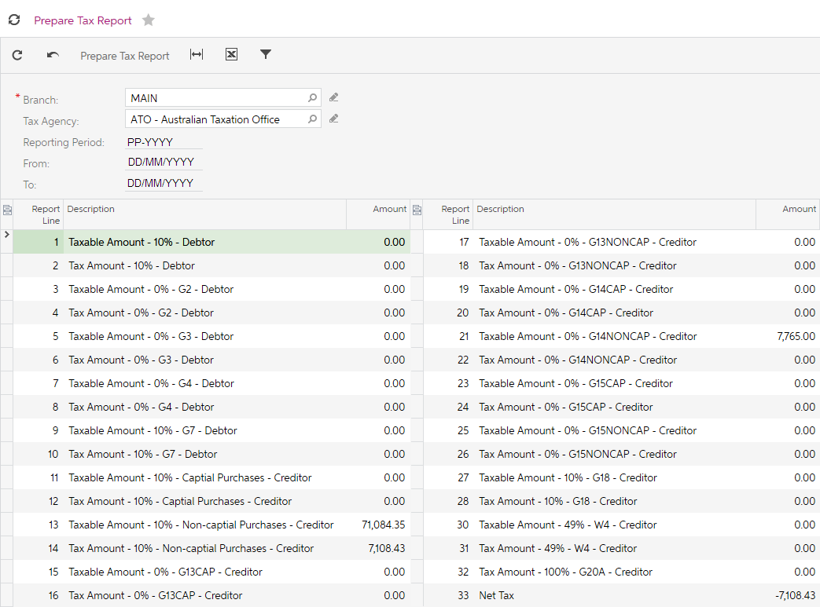
Figure: Prepare Tax Report example
- Once you are happy with the information that is showing on the Tax Report, select the Prepare Tax Report on the toolbar.

Release Tax Report
- The Release Tax Report form (TX502000; More Items > Financials > Taxes > Processes) will be displayed.
The Branch, Tax Agency and Reporting Period from the Prepare Tax Report will be updated to this form.
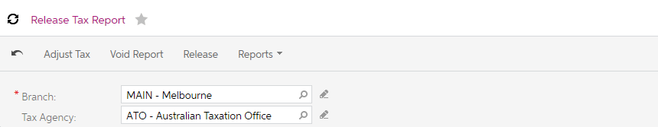
Figure: Release Tax Report form
On the form toolbar you will find the following options:
- Adjust Tax selecting this option will send you to the Tax Adjustments form (TX301000), where you can create a tax adjustment document that adjusts tax and taxable amount of the specified tax in the prepared tax report.
The option Adjust Tax is not used across Australia and New Zealand. Any adjustments to the tax to be reported must be made at the document level, Purchasing or Receivables.
- Void Report to be used if you would like to Void this report and go back to Prepare tax report option. You can only Void a report if it has not been released.
- Select Release to close the Tax Reporting period and update the BAS.

Print the GST Calculation Worksheet
- The next step is to print the GST Calculation Worksheet. Go to More Items > Financials > Taxes > Reports and open the GST Calculation worksheet for BAS form (MBTX6010).
- On this form, you need to select the Tax Agency and the Tax Reporting Period.
- The Business Activity Statement/GST Return report (MBTX6011; More Items > Financials > Taxes > Reports) will be displayed after you select Run Report.
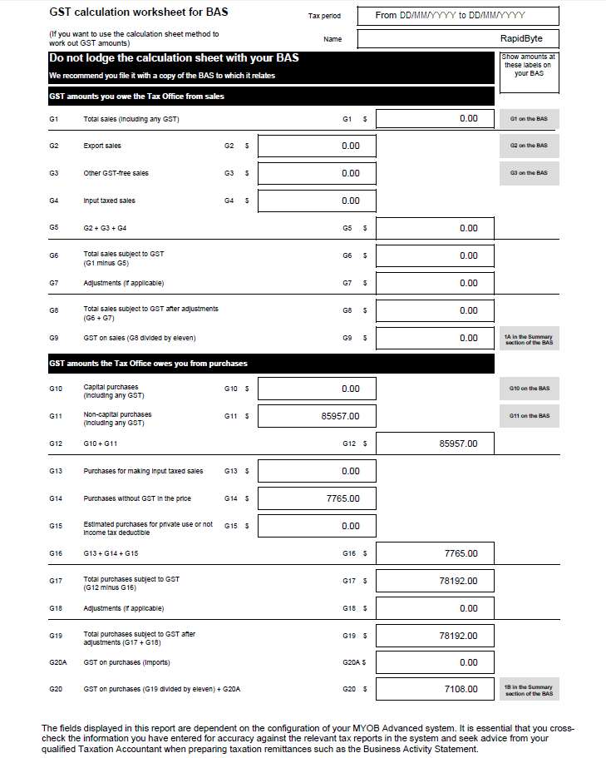
Figure: GST calculation worksheet for BAS example

Run the Business Activity Statement/GST Return
- The Business Activity Statement/GST Return report (MBTX6011; More Items > Financials > Taxes > Reports) can be accessed from the navigation menu or from the dropdown under the Reports button on the toolbar of the Release Tax Report form (TX502000).
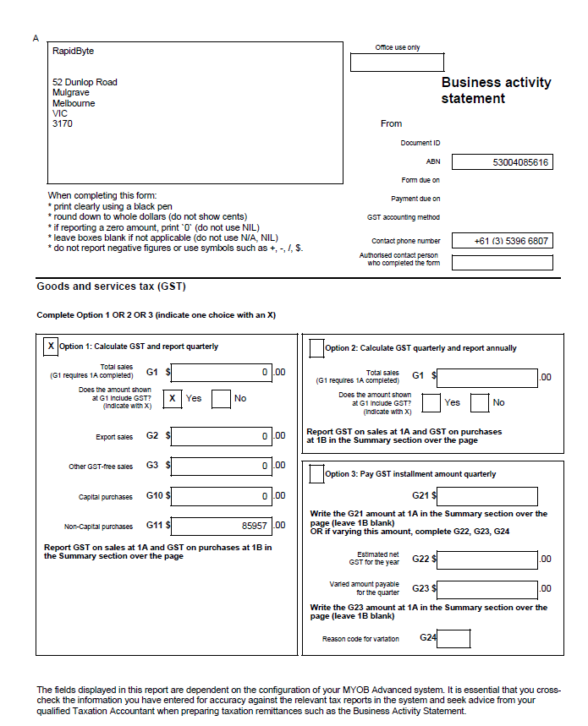
Figure: Business activity statement example page 1.

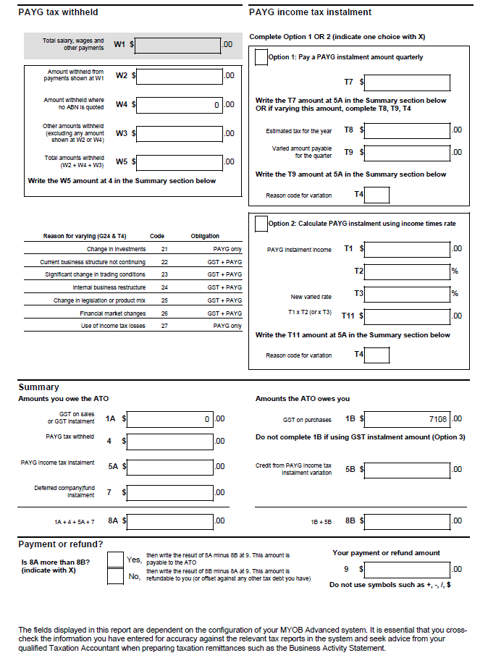
Figure: Business Activity statement example page 2.

Tax Agency Supplier Transactions
Once the Tax report has been released MYOB Advanced will automatically generate, in this scenario, a Bill against the Tax Agency supplier. Based on the GST calculations the business will receive a refund from the ATO.
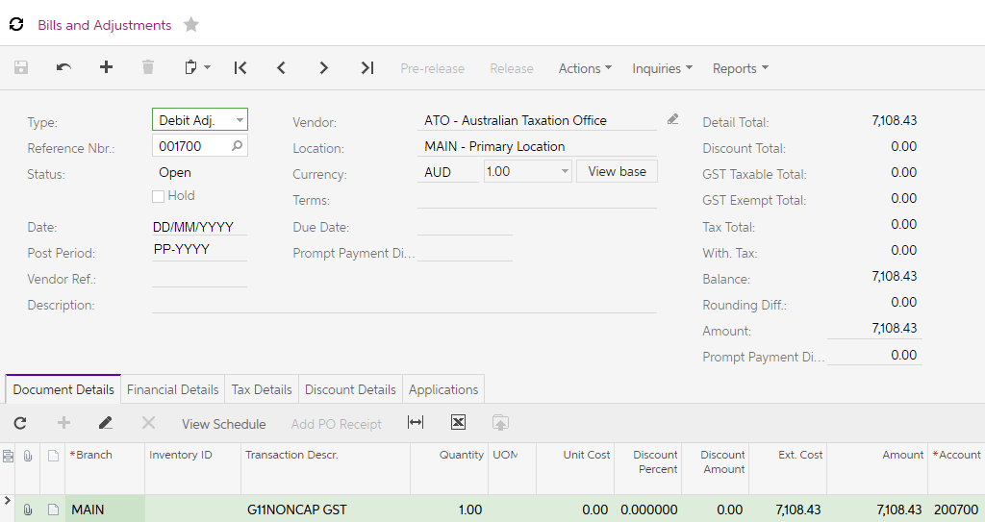
Figure: ATO Debit Adjustment example
Below is the debit adjustment Finance entry.
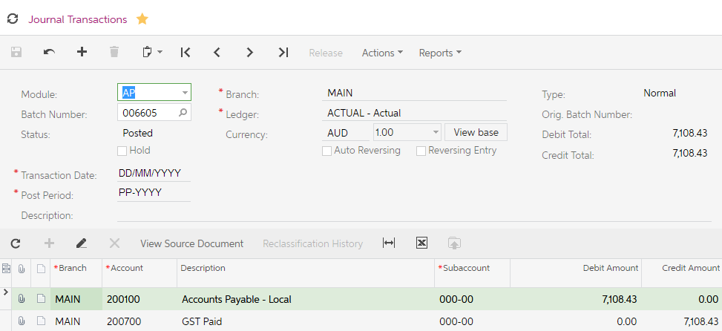
Figure: Finance journal transaction from release of Tax Report example.

