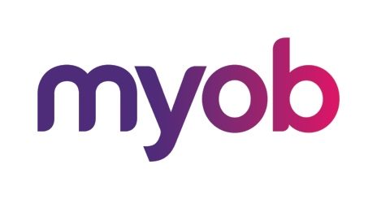
MYOB Advanced
AU-002 – Inventory Management
July 2018
MYOB Technology Pty Ltd
Website: myob.com.au/myob.co.nz
ABN 13 086 760 198
Disclaimer
MYOB has carefully prepared this material but excludes (to the extent allowed by legislation) any direct or indirect liability arising from errors or omissions or from its use. Any case studies (including the application of particular accounting standards or legislation) are representative examples only, and will not directly apply to the user's own circumstances. They are not a substitute for professional advice. Users must check that third party materials, for example from the IRD and the ATO, are current at the time they are used.
Trademarks
MYOB®, MYOB Accountants Office®, MYOB AccountEdge®, MYOB AccountEdge® Network Edition, MYOB AccountRight™, MYOB AccountRight Standard™, MYOB AccountRight Plus™, MYOB AccountRight Premier™, MYOB AccountRight Enterprise™, MYOB Accounting™, MYOB Accounting Plus™, MYOB BusinessBasics™, MYOB CashBasics™, MYOB ClientConnect™, MYOB FirstEdge®, MYOB M-Powered®, MYOB M-Powered Services™, MYOB M-Powered Bank Statements™, MYOB M-Powered Invoices™, MYOB M-Powered MoneyController™, MYOB M-Powered Payments™, MYOB ODBC DeveloperPack™, MYOB ODBC Direct™, MYOB PowerPay®, MYOB Premier®, MYOB Premier Enterprise®, RetailManager®, Accountants Office®, AccountEdge®, Accounting Plus™, BusinessBasics™, ClientConnect™, FirstEdge®, M-Powered®, M-Powered Superannuation™, ODBC DeveloperPack™, ODBC Direct™, PowerPay® and Premier® are registered trademarks or trademarks of MYOB Technology Pty Ltd and their use is prohibited without prior consent. Ceedata, Solution 6 MAS and Xlon are registered trademarks or trademarks of Solution 6 Holdings Limited, a member of the MYOB group.
Adobe®, Acrobat®, Acrobat Reader®, Adobe Reader®, PDF™, and PostScript® are trademarks or registered trademarks of Adobe Systems Incorporated.
AddressBook, Apple®, iCal®, Macintosh®, and QuickTime® and the QuickTime logo are registered trademarks of Apple Inc. Mac and the Mac logo are trademarks of Apple Inc., used under licence. MobileMeSM is a service mark of Apple Inc.
Microsoft, Access, Excel, Internet Explorer, .Net Framework, Office, Outlook, Smart Tags, Windows and Word are registered trademarks or trademarks of Microsoft Corporation in the United States or other countries. Quicken® and QuickBooks® are registered trademarks of Intuit Inc. 4D Tools® is a registered trademark of 4D S.A. Bpay® is a registered trademark of Bpay Pty Ltd, ABN 69 079 137 518. CaseWare® is a registered trademark of CaseWare International Inc. FlexNet Connect® is a registered trademark of Flexera Software™ Inc. Google Maps™ card links included with permission. HandiLedger® is a registered trademark of HandiSoft Software Pty Ltd. POSTbillpay® is a registered trademark of the Australian Postal Corporation. SM2DGraphView Copyright 2002-2008 Snowmint Creative Solutions LLC snowmintcs.com/. Sentry Spelling Checker Engine for Windows, copyright Wintertree Software Inc. Brio Intelligence and Hyperion Intelligence are trademarks or registered trademarks of Hyperion Solutions Corporation. Crystal Reports® is a registered trademark of Crystal Decisions, Inc. in the United States or other countries. MasterCard® is a registered trademark of MasterCard International Inc. VISA® is a registered trademark of Visa International Service Association.
RightNow CX® is a registered trademark of RightNow Technologies Inc
Other products mentioned may be service marks, trademarks or registered trademarks of their respective owners.
© MYOB Technology Pty Ltd 2018. All rights reserved.
This material is intended only for MYOB Enterprise Solutions Business Partners and their customers. No part of this publication may be copied, reproduced, utilised, transmitted, or distributed in any form by any means—including photocopying, recording, mechanical, electronic or otherwise—by any other party without the prior written authorisation of MYOB Technology Pty Ltd.
Version 2018.1

Introduction to the MYOB Advanced User Interface 5
Completing the Training in the Modern UI 5
Navigating to Forms: Tips 9
Completing the Training in the Classic UI 11
Product Features 13
MYOB Advanced Business – Edition Comparison Chart 13
Inventory 13
Why do I need to know Inventory Management? 14
Where do I start? 15
What do I need to know? 15
Setting Up Inventory – the basics 16
Inventory Preferences 16
Activity 1 – Inventory Preferences 16
Item Classes 17
Activity 2 – Item Classes 19
Replenishment Settings 20
Subitem/Restriction Groups 20
Attributes 20
Warehouse and Warehouse Locations 21
Multiple Warehouses 21
Multiple Warehouse Locations 21
Activity 3 – Add a Warehouse with Multiple Locations 22
Master Records 25
Stock Items 25
Warehouse Details tab 27
Activity 4 – Add 4 Stock Items 30
Non-Stock Items 35
Activity 5 – Add Non-Stock Items 39
Setting up Kits 40
Activity 6 – Add Kit Stock Item 40
Kit Specification 41
Activity 7 – Add Kit Specification 41
Working with Inventory 43
Inventory Transactions 43
Receipts 43
Activity 8 – Add and release Receipts 43
Issues 46
Activity 9 –Issues 46
Transfers 47
Activity 10 –Transfers 48
Adjustments 50
Activity 11 –Adjustments 50
Kit Assembly 51
Activity 12 –Kit Assembly 51
Review Stock Items 52
Financial Details 53
Stocktake (Physical Inventory) 55
Activity 13 – Physical Inventory Types 57
Activity 14 – Prepare Physical Count 57
Activity 15 –Data Entry & Completing PI 61
Activity 16 – Review Physical Inventory Updates (Stocktake) 63

Introduction to the MYOB Advanced User Interface
MYOB Advanced now offers two user interfaces:
- Modern, introduced in 2018.01, which is now used by default
- Classic, which is the user interface used in previous MYOB Advanced versions
The following sections describe the main aspects of working with MYOB Advanced user interface when you complete this course:
- Completing the Training in the Modern UI
- Completing the Training in the Classic UI
- Navigating to Forms: Tips

Completing the Training in the Modern UI
For completing the training, we recommend that you use the modern user interface, which provides an enhanced new look and easy navigation in the system. The following sections provide an overview of the modern UI and explain how to navigate in the system during the completion of the training.

To Navigate to a Form from a Quick Menu
Forms in the modern UI are grouped by workspaces, which are shown on the main menu on the left side of the screen. When you select a workspace, the system shows its Quick Menu, which has links to the most commonly used forms and reports of the workspace (see the screenshot below), listed under categories to further organise them. You can click a form name to navigate to it.
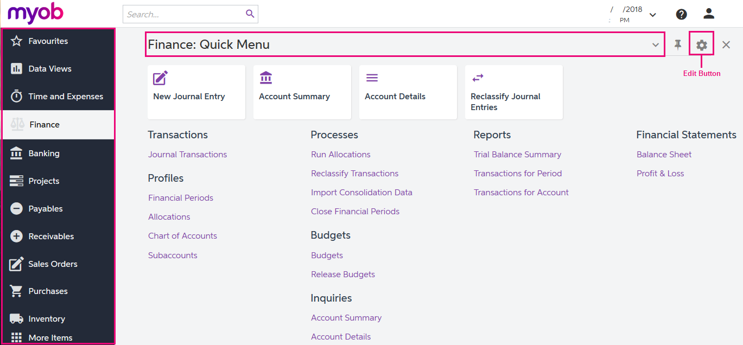
Figure: Navigating to a form from a Quick Menu

To View All Forms in a Workspace
To find any form of a workspace that is not shown on the Quick Menu, you can click the Quick Menu title bar to switch to All Items mode. In this mode, you can see the links to all forms that are included in the selected workspace (see the screenshot below).
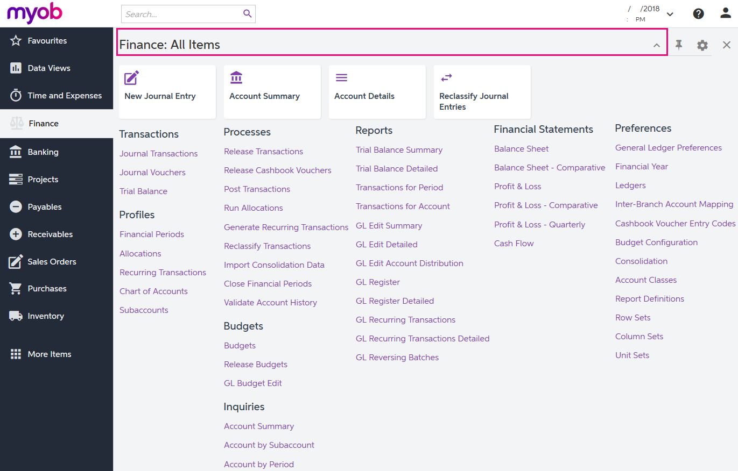
Figure: Displaying all items of the Finance workspace

To Add Forms to a Quick Menu
To add a form that currently is not shown on a Quick Menu of a workspace, open the needed workspace, and on the workspace title bar, click the Edit button (see the previous screenshot). In Configuration mode, select the check boxes next to the needed forms, and then click Exit to apply your changes and exit Configuration mode.
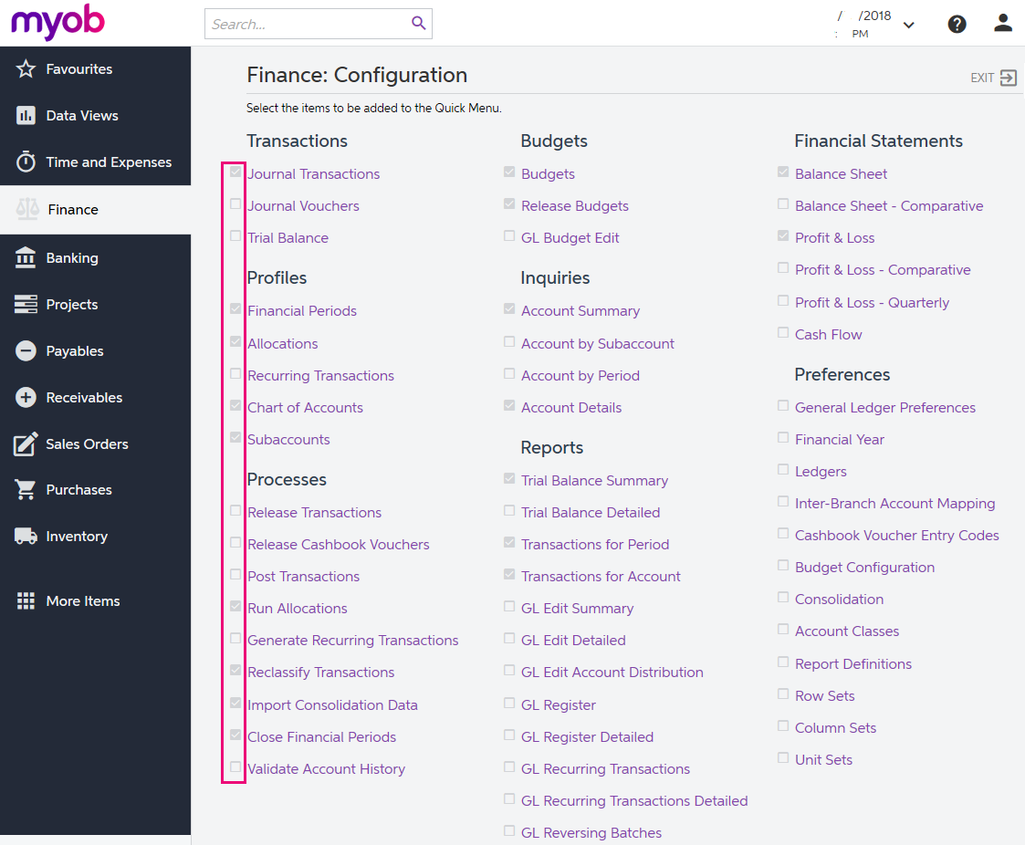
Figure: Adding forms to a Quick Menu
The full list of forms used during the completion of this training is provided below in this topic. We recommend that you be sure all these forms have been added to the applicable quick menus, to simplify navigation during the completion of the training.

To Review and Open Documents on Search Forms
Search forms provide a quick and easy way to review the list of records created on the applicable data entry forms. A search form is a generic inquiry that shows the summary information on the records entered on the entry form. Search forms are initially brought up instead of the corresponding entry forms when a user navigates to these forms in the Quick Menu.
For example, if you click Journal Transactions (under the Transactions category) on the Quick Menu of the Finance workspace, the system opens the Journal Transactions search form (GL3010PL), which shows the list of all transactions in the system (see the screenshot below). The search form may show tabs that filter the documents by their type or status.
To open the Journal Transactions entry form (GL301000) for entering a new batch of transactions from the Journal Transactions search form (GL3010PL), you need to click Add New Record button on the form toolbar.
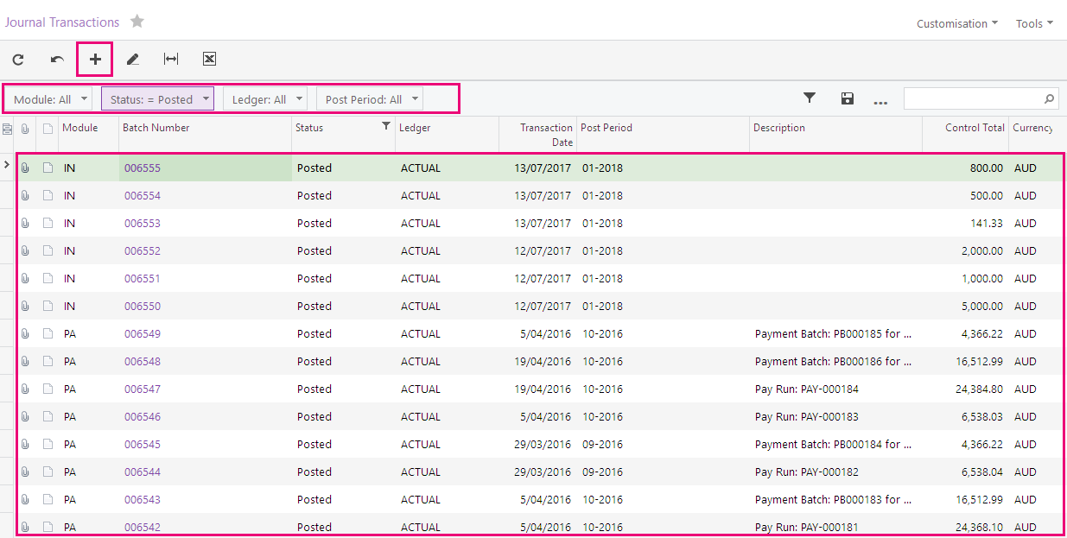
Figure: Viewing the Journal Transactions search form
If the training instructions ask you to open a document (such as a batch, a Payables bill, or a Receivables invoice), you can find this document on the appropriate search form and then click its reference number link to open this document on the data entry form. Alternatively, you can open the data entry form itself, select the module or document type (depending on the form), and in the Reference Nbr. box, click the selector icon and select the document by its reference number (see the screenshot below).
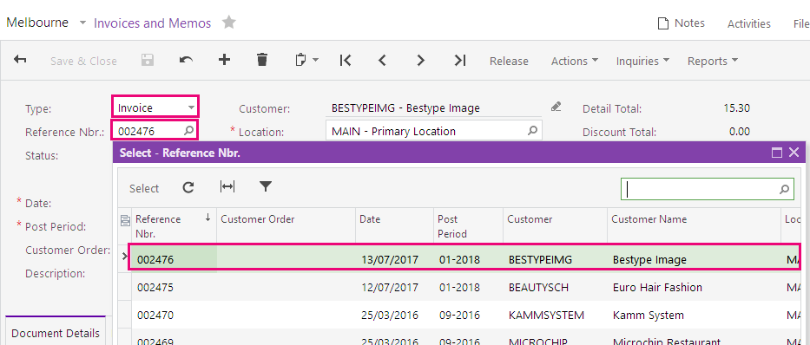
Figure: Opening a document by its reference number

Navigating to Forms: Tips
The following tips apply to the modern and classic user interfaces and will help you to quickly find and open any form.

How To Search for a Form by Its Title or ID
At any time, you can quickly search for a form by typing its title or ID in the Search box:
- In the modern UI, type the text in the Search box on the top of the screen (see the following screenshot). The system shows the search results in the Search window, which opens when you start typing the text in the Search box. Then on the Menu Items tab of the Search window, you click the link to open the needed form.
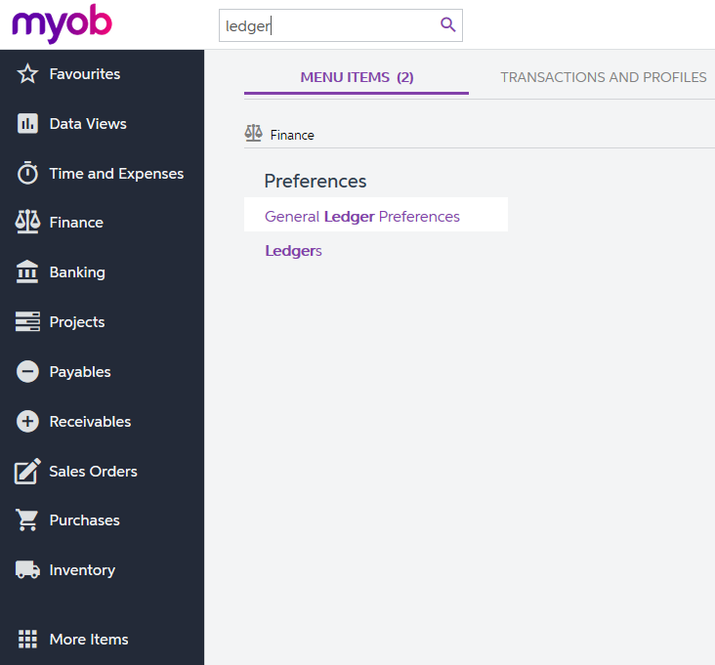
Figure: Searching for a form by title in the modern UI
- In the classic UI, type the text in the Search box at the top of the navigation pane (see the following screenshot). To navigate to the needed form, click it in the drop-down list with the search results.
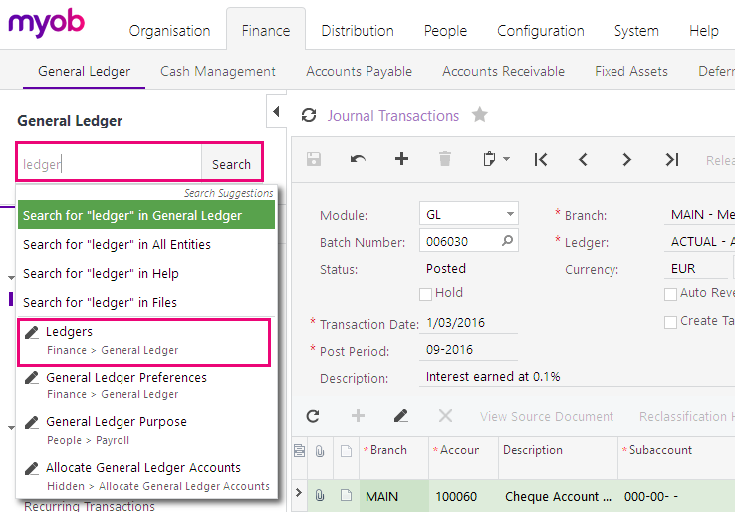
Figure: Searching for a form by its title in the classic UI

How To Navigate to Forms by Using the Form ID
In the training guide, each form is referred to by its ID. If you are not sure in which area a form is located, instead of searching for the form, you can simply open it by using its form ID. You can do this in both the modern UI and the classic UI as follows:
- In the browser's address bar, change the form ID of the currently opened form to the form ID of the needed form (see the screenshot below).
Figure: Entering the form ID
- Press Enter. The system navigates to the form.

Completing the Training in the Classic UI
The following sections provide a quick overview of the classic UI and explain how to navigate in the system during the completion of the training.

To Switch Back to the Classic UI
When you have created a new company and signed in to it, the modern user interface is enabled by default. If you need to switch back to the classic UI, do the following:
- In the top right corner, click the name of the current user, and click My Profile, as shown in the following screenshot.
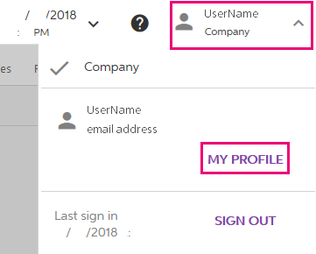
Figure: Opening the user profile
- On the User Profile form (SM203010), which opens, select the Show Classic UI by Default check box, and save your changes.
To switch back to the modern UI, again click the name of the current user in the top right corner and click Switch to Modern UI in the menu (see the screenshot below)
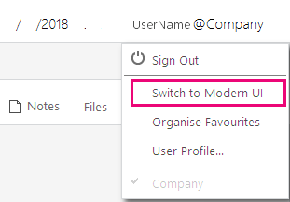
Figure: Switching to the modern UI

To Navigate to Forms in the Classic UI
To help learners to search for forms during the training completion in the classic UI, the paths to forms in this training guide are based on the classic UI. The main menu, at the top of the screen, shows suites and the modules of the selected suite. The navigation pane, located on the left side of the screen, shows the forms of the modules grouped by their functions. The path to a form is specified as follows in the training:
Form Title (Form ID; Suite > Module > Tab > Node)
For example, the form with the following path is shown in the screenshot below:
General Ledger Preferences form (GL102000; Finance > General Ledger > Configuration > Setup)
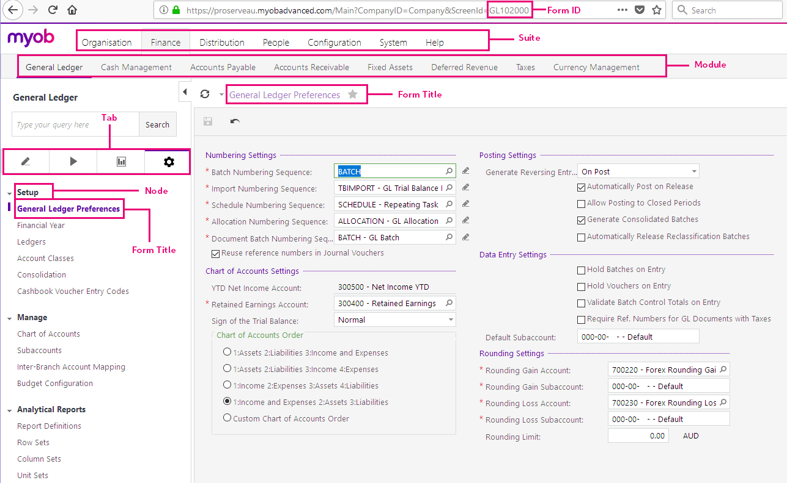
Figure: General Ledger Preferences form in the classic UI

Product Features
Not all features are available in all MYOB Advanced Business Editions, for example as you can see from the following comparison chart, Custom Sales Order Types are only available in Enterprise Edition.
Contact your Business Partner for more information on the different Editions or if you want to add more features to Advanced Business.

MYOB Advanced Business – Edition Comparison Chart

Inventory
Product Features | MYOB Advanced Business Edition
 | Standard | Plus | Enterprise
Inventory and Non-Inventory Item Management |  |  | 
Inventory Transfers, Issues and Receipts |  |  | 
Barcode Support |  |  | 
Unlimited Warehouses |  |  | 
Manage Inventory Cost by Warehouse |  |  | 
Warehouse Locations (Bins) |  |  | 
Multiple Units of Measure |  |  | 
Batch/Lot and Serial Tracking |  |  | 
Cross-reference Inventory Codes |  |  | 
Kit Assembly |  |  | 
Inventory Replenishment based on Reorder Points |  |  | 
Cost by Warehouse Location (Bin) |  |  | 
Inventory Replenishment based on Demand Forecasts |  |  | 
Advanced Inventory Segmentation Controls |  |  | 

Why do I need to know Inventory Management?
Ultimately you need to be able to add an inventory item when selling to a customer or purchasing stock from a supplier.
Let’s look at how we manage inventory in MYOB Advanced.
Inventory Items are split into stock and non-stock items.
Stock items are physically held in one or more warehouses. They can have a serial number or a lot (batch) number and you can even set a costing method for an individual stock code.
Non-stock items may include labour, services, or other charges; items that cannot be stocked in a warehouse. Or you may have items that don’t need to have their quantity tracked. Non-stock items will only have standard costs and base price information included in MYOB Advanced.
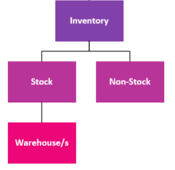
Figure: MYOB Advanced Inventory overview
Most businesses exist to provide goods and/or services to customers. Stock and Non-stock items are usually added to a sales order. When the sales order is converted to a shipment and the shipment is released the stock is then taken out of inventory and we are ready to re-stock these items with a purchase receipt to continue your business’ trade cycle.
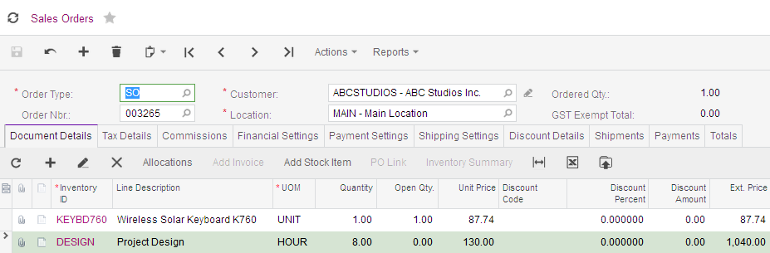
Figure: Sales Order showing Stock and Non-stock items
Before we can add Stock and Non-stock items to a sales order we need to update our inventory records with the goods and services we are going to sell to our customers.
In your training today, we are going to go over management of inventory. Selling goods and services and purchasing stock will be covered in other training sessions.
As MYOB Advanced is highly configurable, the features and processes may differ for your business. Please refer to your Business Partner for details on any customisations they may have included in your implementation.

Where do I start?
Your MYOB Advanced will be implemented by a consultant who is Certified to Implement MYOB Advanced Business. As mentioned previously, MYOB Advanced is highly configurable, this training covers the basic business processes you need to know to manage inventory.

What do I need to know?
Businesses need to add products, goods and services to their orders. We will start by looking at adding a stock and a non-stock item. If you would like to know any additional information, please see the help pages of MYOB Advanced. Or ask your Business Partner.
To get to the Help Articles in the Modern UI, just type in your text in the search box on the top of the screen and then click on the Help Articles link.
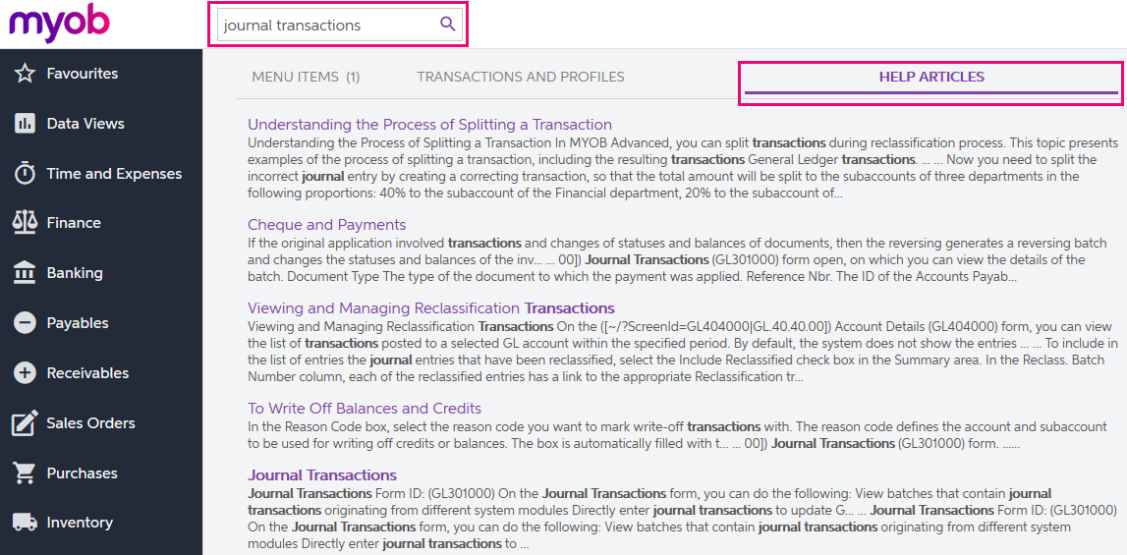
Figure: How to get to the screen help

Setting Up Inventory – the basics

Inventory Preferences
Your implementing partner will go through and set up your Inventory module based on the requirements of your business. Inventory Preferences, found under Inventory > Preferences in the Full Menu, allows defaults for managing inventory such as numbering and general ledger posting settings.
You should only make changes to any settings under preferences after talking to your Business Partner.

Activity 1 – Inventory Preferences
Go to the Inventory Preferences form (IN101000; Inventory > Preferences) and review the settings.
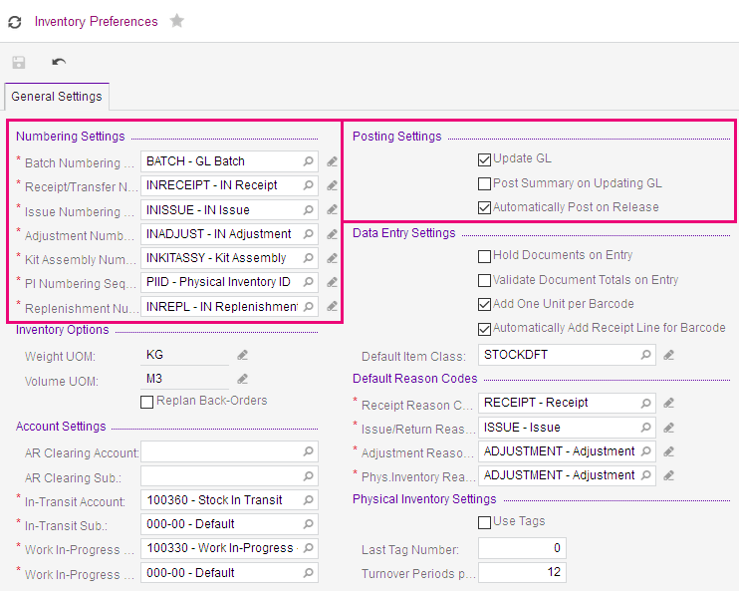
Figure: Inventory Preferences highlighting the Numbering sequences and posting settings

Item Classes
Each Inventory item is linked to an Item Class, this allows simplified order entry and the grouping of items on reports. The Item Class also defines values for calculating the cost and availability of inventory items. Item Classes are usually set up by your implementing partner.
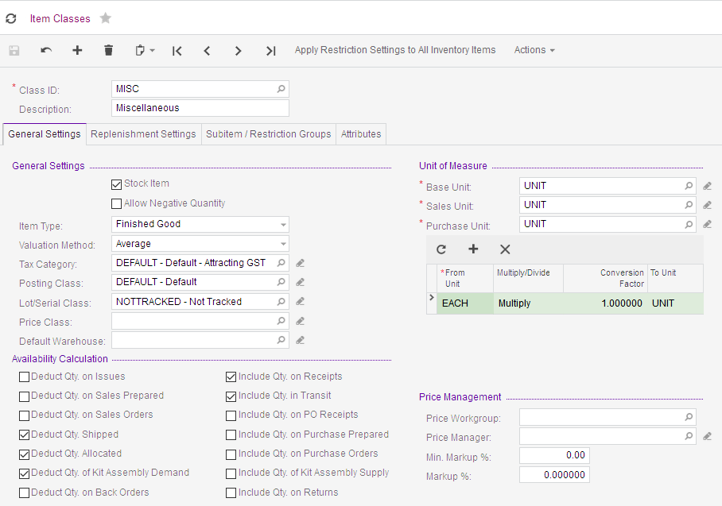
Figure: Item Class for stock items
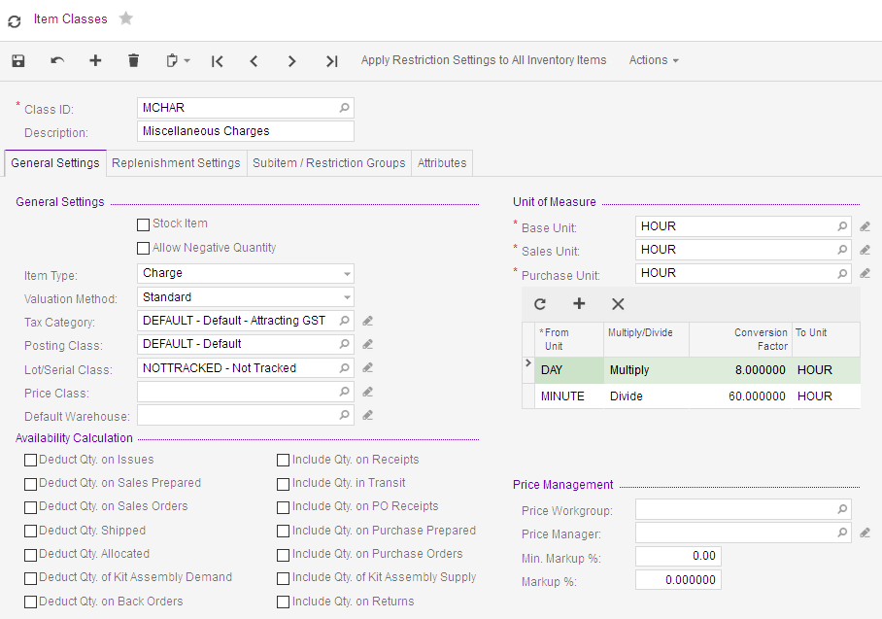
Figure: Item Class for Non-stock items

Activity 2 – Item Classes
- Go to the Item Classes form (IN101000; Inventory > Preferences.
- In the Class ID: field search for the MISC class.
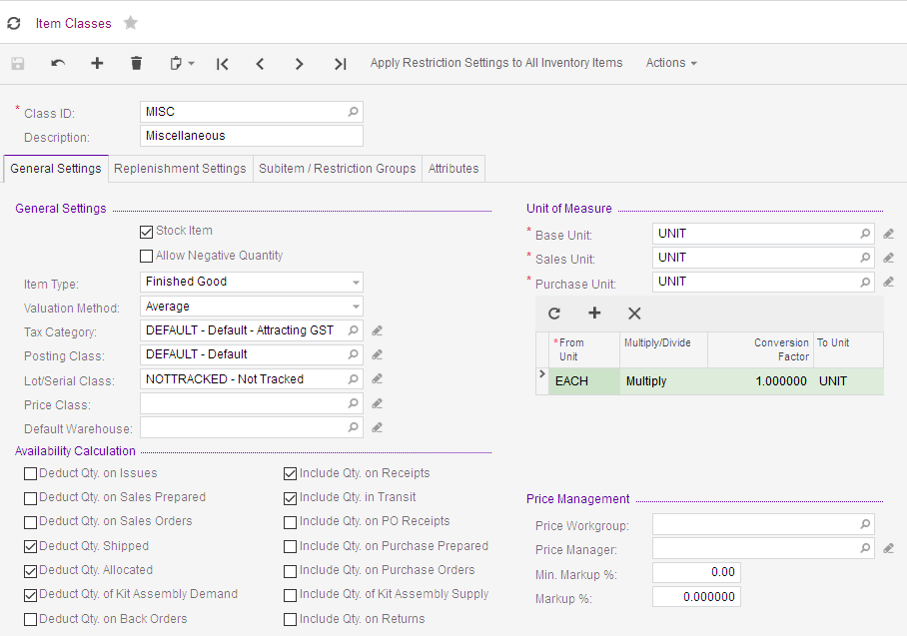
Figure: MISC Item Class

General Settings tab
The General Settings holds the basic settings of an item class.
In the General Settings section;
- Stock Item checkbox. If you want to track quantities, then this checkbox must be ticked.
- Allow Negative Quantity checkbox. Tick this checkbox if you want to allow your stock to go into a negative quantity.
- Valuation Method: you can choose between Standard, Average, FIFO (first in first out) or Specific.
- Posting Class: A posting class provides the default values for the purchase, sales, and inventory transactions of inventory items and defines how these transactions will be updated to the General Ledger.
- Lot/Serial Class: A lot/serial class is used to group inventory items with lot(batch) or serial numbers and to provide default settings for new items. This field is only shown if the Lot and Serial Tracking feature is enabled on the Enable /Disable Features form.
- The Availability Calculation is where you set the rules for calculating the availability of stock items. The on-hand quantities of items at your warehouses are automatically updated only after the documents that record inventory transactions are released and posted. On-hand quantities usually differ from available quantities because documents can be processed later: you can have items booked on on-hold sales orders, picked for shipping but not shipped, returned from customers before returns are created, received from suppliers with receipts not yet released.
- The Unit of Measure section is where, you specify a unit of measure to be used as default for items. If the Multiple Units of Measure feature is enabled, you can specify the unit of measure to be used as the stocking or base sales and purchase. Also, you can define conversion rules for those units.

Replenishment Settings
Outside the scope of this course. Refer to the online Help for details.

Subitem/Restriction Groups
Outside the scope of this course. Refer to the online Help for details.

Attributes
Outside the scope of this course. Refer to the online Help for details.

Warehouse and Warehouse Locations
Warehouses and warehouse locations can be set up in many ways in MYOB Advanced they can be fine-tuned to suit your business processes. You can use a single warehouse or configure multiple warehouses. Within each warehouse, you can define a single location or configure multiple locations.
To use multiple warehouses, the Multiple Warehouse feature must be enabled. To use Multiple Warehouse Locations that feature must also be enabled on the Enable/Disable Features form.
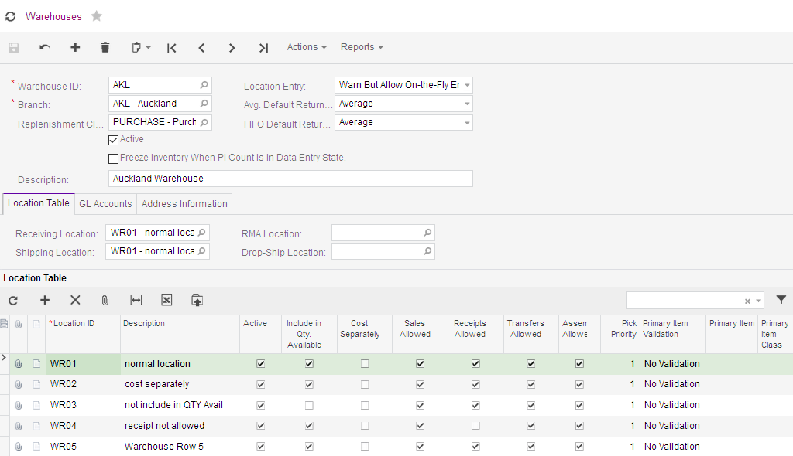
Figure: Warehouses form

Multiple Warehouses
In MYOB Advanced, a warehouse is not necessarily a physical building where inventory is stocked. You can divide a large storage space into multiple areas and define each area as a warehouse. A warehouse can even be virtual.

Multiple Warehouse Locations
With the Multiple Warehouse Locations feature enabled, you can configure multiple locations in each warehouse to best fit the logistics for your business. You can reserve specific locations for sales, receipts, or returns. Some locations may be used for assembly; in other locations, transfers may not be allowed. Different locations may have different primary items assigned, and you can setup validation for those items. Also, you can assign different pick priorities to items to more quickly empty certain locations while using others less frequently.
To create similar setup of locations in multiple warehouses, you can export the location table to an Excel file (in the .xlsx format) and import the settings from the file to the same or another warehouse. For details on importing the settings, refer to the help page in MYOB Advanced titled Integration with Excel.
By using the Location Entry setting on the Warehouses form, you can specify whether locations can be added only by using the Warehouses form or added On The Fly, as the users enter inventory documents. If the Allow On-the-Fly Entry option is selected, new locations entered on the fly during data entry will also appear in the warehouse’s location table (described in the following section) with default settings, which you can modify later if needed.

Activity 3 – Add a Warehouse with Multiple Locations
In MYOB Advanced you can usually copy a record and then paste the copied information to a new record. If you want to add a warehouse one of the easiest ways to do this is to copy an existing warehouse and then change details.
- Go to the Warehouses form (IN204000; Inventory > Profiles), then in the Warehouse ID: field search for the MLB warehouse.
- On the form toolbar, copy the warehouse by selecting the copy function under the clipboard icon .
- Now add a new warehouse by selecting the icon on the form toolbar.
- In the Class ID; type NEW
- Now go to the form toolbar and paste the MISC class details by selecting the paste function under the clipboard icon .
- Change the Description to New Warehouse.
- Save your new warehouse.
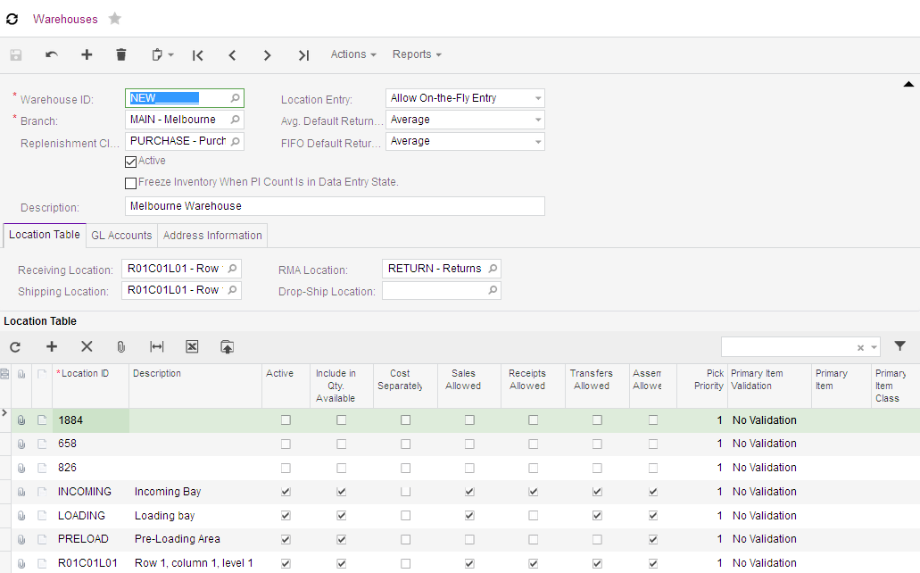
Figure: New warehouse

On the Warehouse form, some of the important fields are:
- Freeze Inventory When PI Count Is in Data Entry State.: You tick this checkbox if you want the inventory in the warehouse to be frozen during the physical counting and data entry stages of physical inventory (stocktake). If you don’t tick the checkbox, the inventory will be frozen only during the counting stage.
- Location Entry: This is an option that controls in MYOB Advanced where you can add warehouse locations.
You choose between 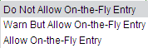.
  - Do Not Allow On-the-Fly Entry: This means that you can only add a location by adding a location on the Location Table on the Warehouses form. If you try to enter a location on an inventory document e.g. transfer, you will get the following error.
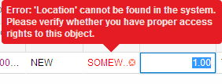
Figure: Error message when trying to add location on inventory documents with Do Not Allow On-the-Fly Entry selected.
  - Warn but allow On-The-Fly: You can enter new locations on any inventory document but a warning will display before the new location is added.
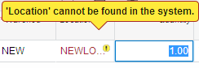
Figure: Warning message when adding a location on inventory documents with Warn but Allow On-the-Fly Entry selected.
  - Allow On-the-Fly Entry: You can enter new locations on any inventory document or on the Location Table on the Warehouse form.
On the Location Table tab, you can add new locations and modify existing ones. The tab includes a table that holds the list of locations and an area where you can select the receiving, drop-ship, shipping, and return material authorisation (RMA) locations. Some of the fields will not display if the feature is not enabled on the Enable/Disable Features form.
You can select whether you want the stock in a location to be included in the quantity available. Also on this tab you select whether to allow the location to be available for Sales, Receipts, Transfers and/or Assembly.

On the Warehouse Location tab;
Cost Separately: | Choose whether costs will be calculated separately from costs calculated at the system-level; i.e., for FIFO and specific valuation methods, separate cost layers will be created for this location if selected. You cannot tick this checkbox if this is the only location at the warehouse.  We recommend that you not change this option once it has been set.
Pick Priority: | The priority of this location when items are chosen. The 1 is the highest priority, 2 the next highest, etc.; 0 means that there isn’t any pick priority.
Primary Item Validation: | If you want to validate the primary item. Choose from one of the following options:  - No Validation: No validation is required.  - Primary Item Warning: Validation is required only for the primary item, if another item is being received, a warning will be displayed.  - Primary Item Error: Validation is required only for the primary item. The system generates an error if you try to save the purchase receipt if an item other than the primary item.  - Primary Item Class Warning: Validation is required for items of the primary item class. The system will display a warning if items of other than the primary item class are received.  - Primary Item Class Error: Validation is required for items from the primary item class. The system generates an error if you try to save the purchase receipt with items from non-primary item class.  Primary item validation is enforced only for received goods.

Master Records

Stock Items
Stock items are items purchased and re-sold to customers. Examples of stock items can include computers, cell phones, cables and auto parts. Stock items may have lot (batch) or serial numbers you can use to track them.
MYOB Advanced can automatically tracks stock items and maintains availability data: how many base units are on hand; how many are ordered from suppliers and how many are booked to sales orders and shipments. You can configure how exactly the availability data is calculated and this is updated as the item is received, invoiced, adjusted, or transferred.
Stock items are also tracked by their value and different valuation methods can be used. Typically, a stock item is an asset until it is sold, once sold its cost becomes an expense.
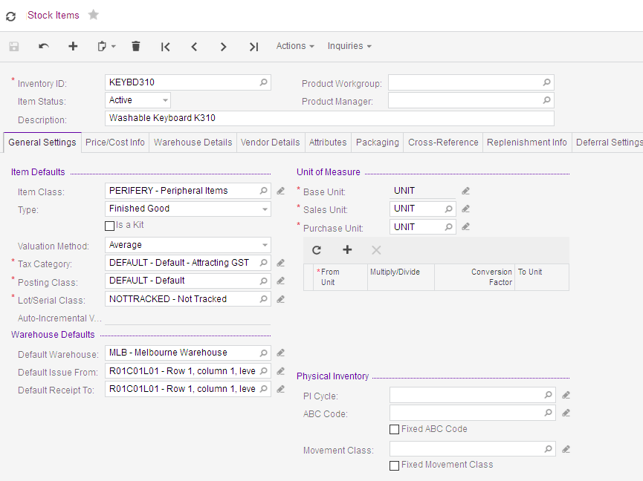
Figure: Stock Item showing the General Settings tab
On the Stock Item form;
Inventory ID: | At any time, you can change the stock item ID by selecting Change ID in Actions dropdown list on the toolbar.
Item Status | Choose from one of the following options:  Active: The item can be used in inventory transactions, such as issues and receipts.  No Sales: The item cannot be sold.  No Purchases: The item cannot be purchased.  No Request: The item cannot be used on requisition requests.  Inactive: No inventory transactions are allowed for the stock item  Marked for Deletion: The item is marked for deletion: No inventory transactions are allowed; the record will be kept in the database if any inventory transactions are related to it.

General Settings tab
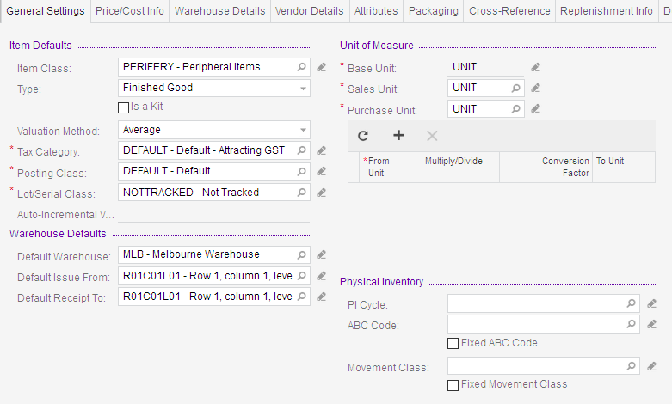
Figure: General Settings tab in Stock Item form
On the General Settings tab:
Type: | Select from one of the following options: Finished Good, Component Part, or Subassembly.
Is a Kit: | If this item is going to be a kit then tick this option. The components of the kit are added using the Kit Specifications (IN209500) form.
Valuation Method: | The method used for inventory valuation, this is the valuation method set up on the item class by default. You can change this to another valuation method from the following options:  - Average  - Standard  - FIFO  - Specific
 | Extreme care should be taken if you want to change any valuation method once you have started transacting on the stock item. Contact your implementing partner for advice.

Price/Cost info tab
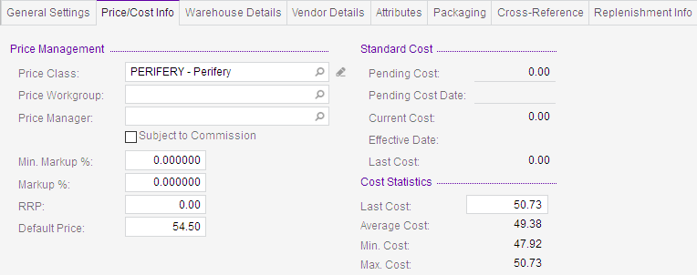
Figure: Price/Cost info tab in Stock Item form

Warehouse Details tab
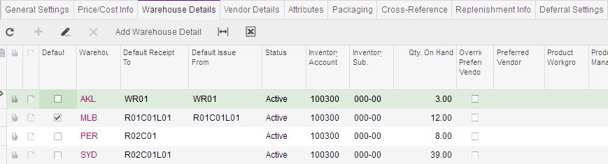
Figure: Warehouse Details tab in Stock Item form
Price Override: | Tick this checkbox if you want the price to be able to be overridden on inventory documents. (This option is also on the Price/Cost Information tab of the Item Warehouse Details form.)

Vendor Details Tab
Is outside the scope of this course.
This tab contains information about the vendor of the item and the vendor’s prices for the item.

Attributes Tab
Is outside the scope of this course.
You can use the Attributes tab to associate attributes with the non-stock item. You can select each attribute from the list of attributes defined in the system. To add a new attribute, use the Attributes (CS205000) form

Packaging Tab
On this tab, you add information about the item properties that can be used for packaging.
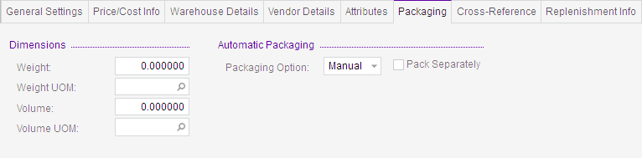
Figure: Packaging Tab in Stock Item form

Cross-Reference Tab
Is outside the scope of this course.
Use the Cross-Reference tab to maintain cross-references between the Inventory ID of the item used in your company and identifiers used by your vendors and customers.

Replenishment Info Tab
Is outside the scope of this course.
On this tab, you can specify replenishment settings and parameters that are used by default in warehouses with different replenishment classes.

Deferral Settings Tab
Is outside the scope of this course.
Use the Deferral Settings tab to specify how deferrals should be performed for this stock item when it is sold or purchased. If no deferral code is assigned to the item on this tab, no deferrals will be performed, and the revenue or expense will be recognised immediately.

Restriction Groups Tab
Is outside the scope of this course.
The Restriction Groups tab provides information about restriction groups the item is included in.

GL Accounts tab:
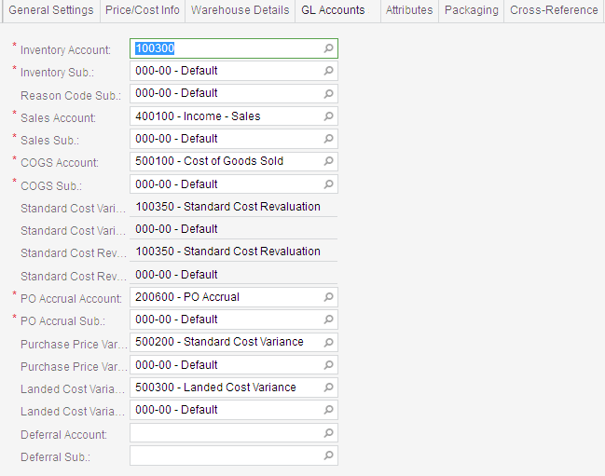
Figure: GL Accounts tab in Stock Item form
On the GL Accounts tab;
PO Accrual Account: | Is a liability account accruing amounts on purchase orders. Whenever receipts linked to purchase orders are released, the system updates transactions between the purchase order accrual account and the inventory account.
Purchase Price Variance Account: | Is an expense account recording any differences between the extended price on the purchase receipt and the extended price on Accounts Payable bill. This account is used if the item has any valuation method except for the standard cost valuation method.
Landed Cost Variance Account: | Is an expense account recording any differences in landed costs between the landed costs amounts on purchase receipts and the amounts on inventory receipts.

We are now going to add some stock items and use these in following activities of the training session.
In our previous activity, we added a new warehouse by copying an existing warehouse and its locations using the copy, paste function on the form toolbar. If you are adding Stock Items that are like ones that already exist, use this copy, past function and then make any changes necessary.

Activity 4 – Add 4 Stock Items
- Go to the Stock Items form (IN202500; Inventory > Profiles). Now add a new stock item by selecting the icon on the form toolbar with the following information and then Save your changes.
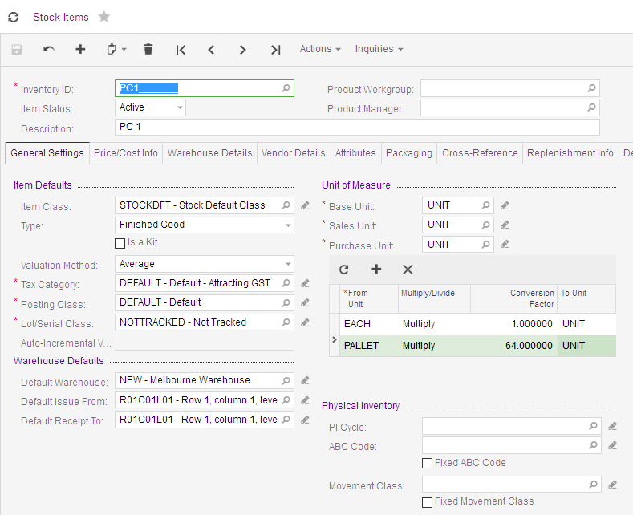
Figure: New Stock Item – General Settings tab
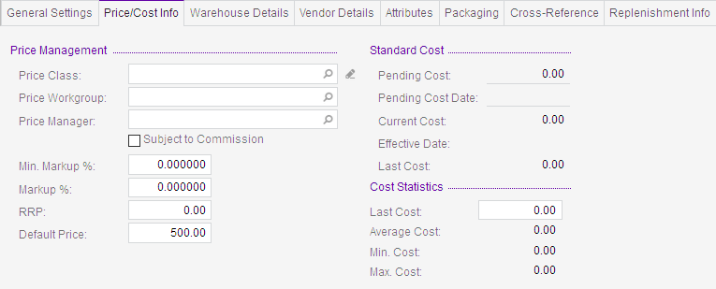
Figure: New Stock Item Price/Cost Info
By selecting the STOCKDFT – Stock Default Class as our Item Class: some of the default settings have been updated to our new stock item. We can change these settings for each stock item if this is needed.
- Now add a new stock item by selecting the icon on the form toolbar, type in MOUSE in the Inventory ID field, tab out of this field and update the new stock item using the following information, then Save your changes.
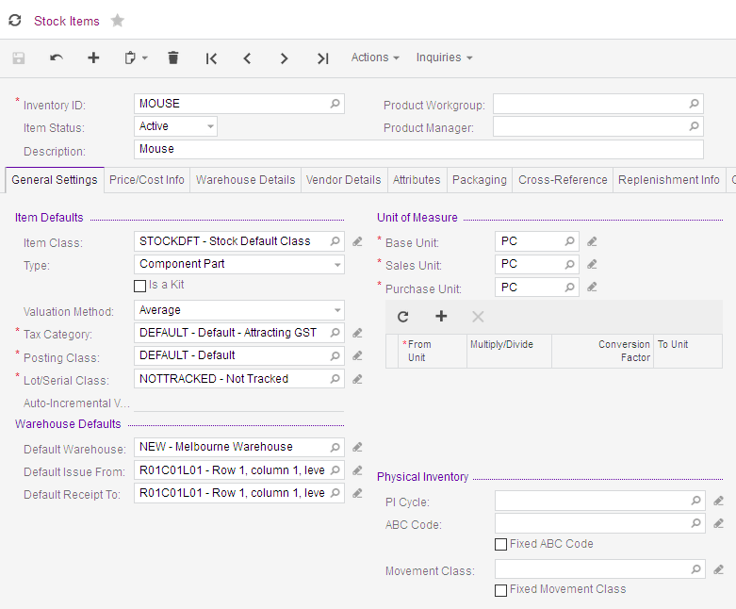
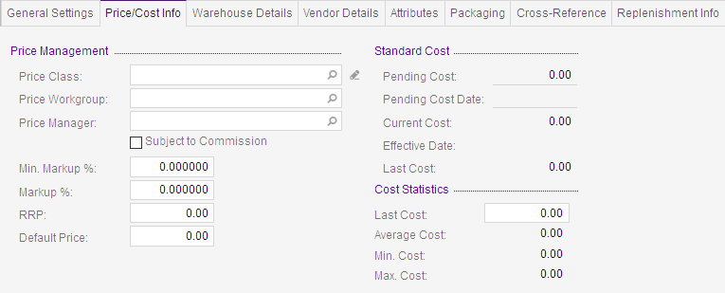
Figures: New Stock Item
- Now add another new stock item in the same way and update this new stock item with the following information and then Save your changes.
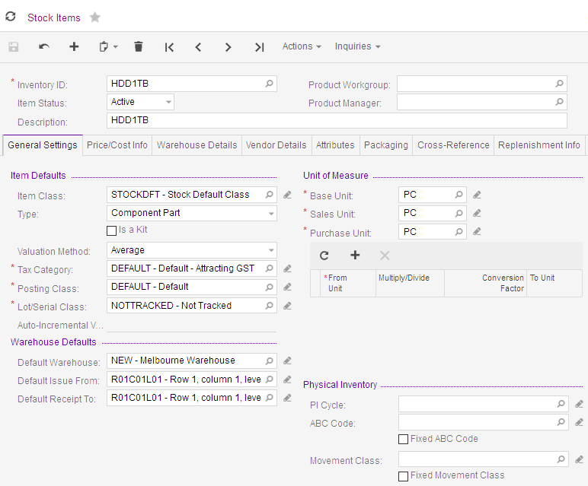
Figures: New stock item
- Now add another new stock item in the same way and update this new stock item with the following information and then Save your changes.
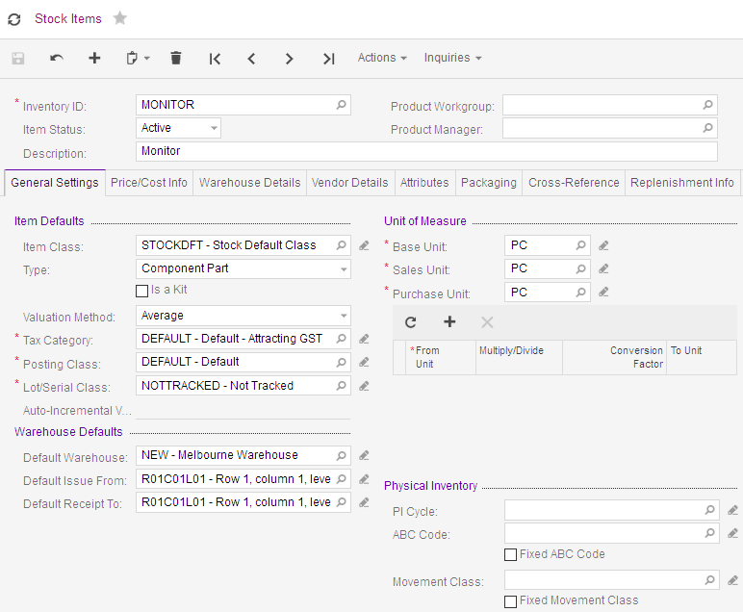
Figures: New stock item

Non-Stock Items
Non-stock items are typically non-physical goods, or items with very low values that might be hard to track. Examples might include labour and repair charge items, warranties, or small repair or installation parts.
Available quantities of non-stock items are not tracked by the system; they are treated as if they are available in any quantity at any time. A line on a sales order with a non-stock item cannot be back ordered.
Non-stock items can be purchased when they’re needed and on purchase their costs are recorded to expenses. On sale, their cost is rewritten from the expense accrual account to a more specific expense account.
Only standard cost valuation method applies to non-stock items.
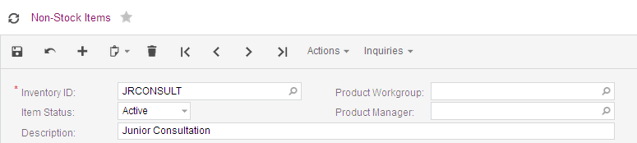
Figure: Non-Stock Item form header
Inventory ID: | Any time, you can change the non-stock item ID by selecting Change ID in Actions dropdown list on the toolbar.
Item Status: | Select from one of the following options:  Active: The item can be used in inventory documents, such as issues and receipts.  No Sales: The item cannot be sold.  No Purchases: The item cannot be purchased.  No Request: The item cannot be used on requisition requests.  Inactive: No inventory transactions are allowed for the non-stock item  Marked for Deletion: The item is marked for deletion: No inventory operations are allowed, but the record will be kept in the database if any inventory transactions are related to it.

General Settings tab
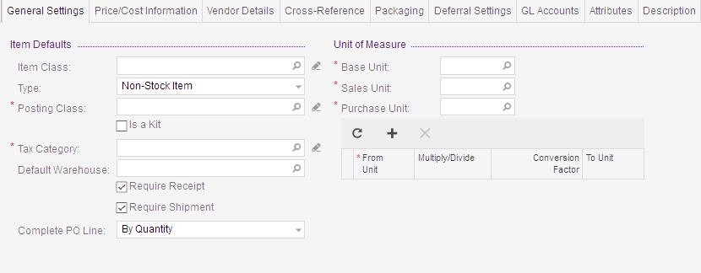
Figure: General Settings tab in Non-Stock Item form
Type: | Choose from one of the following options:  Non-Stock Item: A general type of non-stock items  Labor: Used as labour hour rates  Service: Used as service fees  Charge: Used as charge rates  Expense: Used to designate specific expenses
Is a Kit: | If this item is going to be a kit then tick this option. The components of the kit are added using the Kit Specifications (IN209500) form.
Require Receipt: | Tick this if you require a purchase receipt for this non-stock item. When ticked, the system will not generate any inventory transactions for the non-stock item.
Require Shipment: | Tick this if you require a Sales Orders receipt for this non-stock item. When ticked, the system will not generate any inventory transactions for the non-stock item.
Complete PO Line: | The rule used to automatically complete purchase order lines.  By Quantity: (The default option for items of Non-Stock type.) If the Require Receipt checkbox is ticked for the item, the order line is completed on release of a receipt if the item quantity on all receipts including the last one is equal to or exceeds the order line quantity. If the Require Receipt checkbox is cleared for this item, the line will be completed on release of a bill if the item quantity on all bills linked to the order line is equal to or exceeds the order line quantity.  By Amount: (The default option for items of Labour, Service, Charge, and Expense types.) If the Require Receipt checkbox is ticked for this item, the order line will be completed on release of a receipt if the amount on all receipts linked to the order line is equal to or greater than the order line amount. If the Require Receipt checkbox is cleared for this item, the order line will be completed on release of a bill if the amount on all the bills linked to the order line is equal to or greater than the order line amount.

Price/Cost info tab
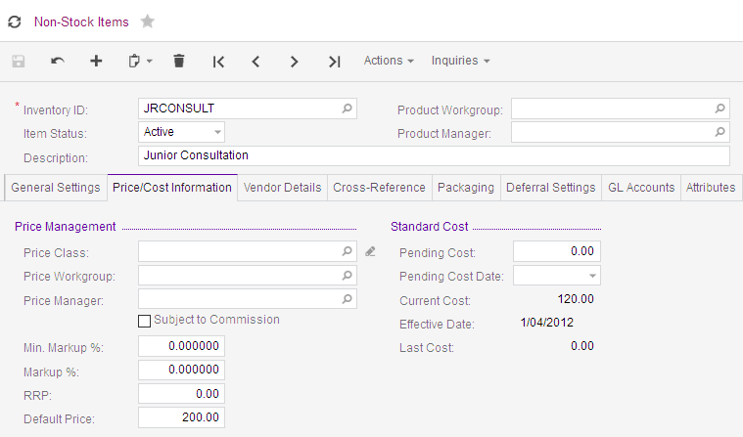
Figure: Price/Cost info tab in Non-Stock Item form

Vendor Details Tab
Is outside the scope of this course.
This tab contains information about the vendor of the item and the vendor’s prices for the item.

Attributes Tab
Is outside the scope of this course.
You can use the Attributes tab to associate attributes with the non-stock item. You can select each attribute from the list of attributes defined in the system. To add a new attribute, use the Attributes (CS205000) form

Packaging Tab
This tab contains information about the weight and volume of the base unit of this non-stock item if applicable.
Figure: Packaging Tab in Non-Stock Item form

Cross-Reference Tab
Is outside the scope of this course.
Use the Cross-Reference tab to maintain cross-references between the Inventory ID of the non-stock item used in your company and identifiers used by your vendors and customers.

Deferral Settings Tab
Is outside the scope of this course.
Use the Deferral Settings tab to specify how deferrals should be performed for this non-stock item when it is sold or purchased. If no deferral code is assigned to the item on this tab, no deferrals will be performed, and the revenue or expense will be recognised immediately. If a code is assigned to the item, revenue from its sales will be recognised according to the settings specified for the deferral code.

GL Accounts Tab
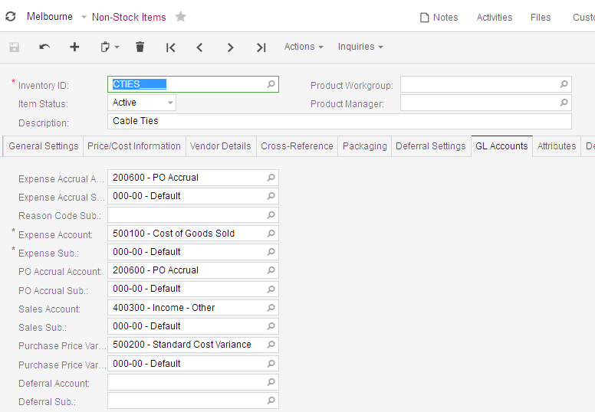
Figure: GL Accounts Tab in Non-Stock Item form
Expense Accrual Account: | For a Non-Stock item, that is part of a stock kit, this account will be used to accrue the costs (standard costs) in kit assembly.  For a Labor-type item, the account is used to accrue the cost of labour on projects (the account is credited on release of time cards).
Purchase Price Variance Account | The expense account to be to record differences between the extended price on the purchase receipt and the extended price on the Accounts Payable bill.

Activity 5 – Add Non-Stock Items
- Go to the Non-Stock Items form (IN202000; Inventory > Profiles). Now add a new non-stock item by selecting the icon on the form toolbar with the following information and then Save your changes.
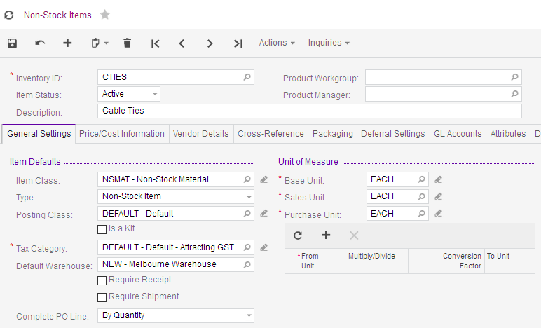
Figure: New Non-Stock Item General Settings tab
Figure: New Non-Stock Item GL Accounts tab

Setting up Kits
You enter the details of a kit on the Stock Items form (IN202500) or Non-Stock Items (IN202000). Tick the Is a Kit checkbox on the General Settings tab if this item is going to be a kit. Prices are set for kits in the same way as other items: You set multiple sales prices to kits by using the Sales Price Worksheets form (AR202010), you can set the default prices on per kit basis by using the Stock Items or Non-Stock Items forms.

Activity 6 – Add Kit Stock Item
- Go to the Stock Items form (IN202000) and add a new stock item making sure you tick the Is a Kit checkbox then save.
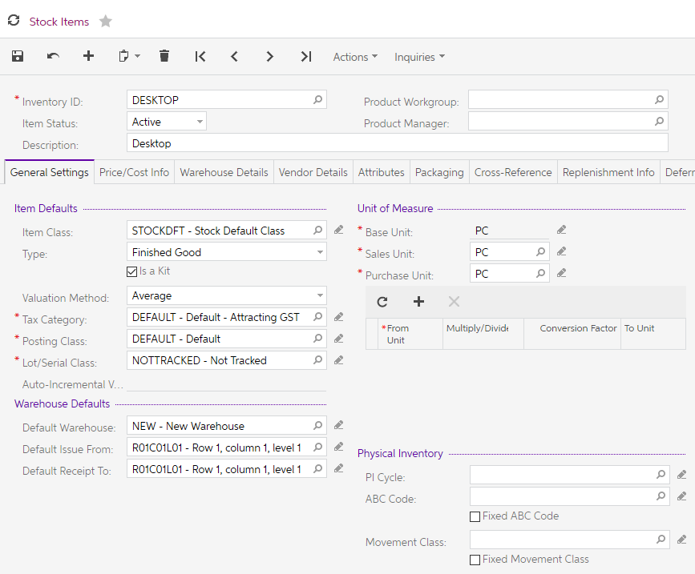
Figure: New Kit Stock Item

Kit Specification
All kits require a kit specification to be created. It is on the Kit Specification form (IN209500) where kits are defined. When a Kit is changed, you create a new revision which means that a previous assembly can always be disassembled.,
A kit specification can only for be created for an inventory item marked as a kit on the General Settings tab of the Stock Items (IN202500) or Non-Stock Items form (IN202000).
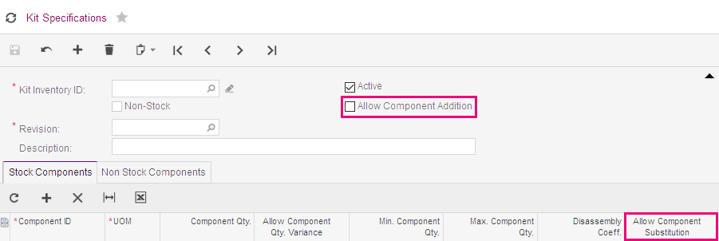
Figure: Kit Specification form
If the Allow Component Addition checkbox is ticked then other items can be added to the kit on assembly or shipping, also if the Allow Component Substitution checkbox is ticked you can swap another item for this one on assembly or shipping.

Activity 7 – Add Kit Specification
- Go to the Kit Specification form (IN202000; Inventory > Profiles) and add a new kit specification with the following information on the Stock Components tab. In the Revision field, you must type 001.
You manage revisions in kit specifications by updating the Revision: field manually.
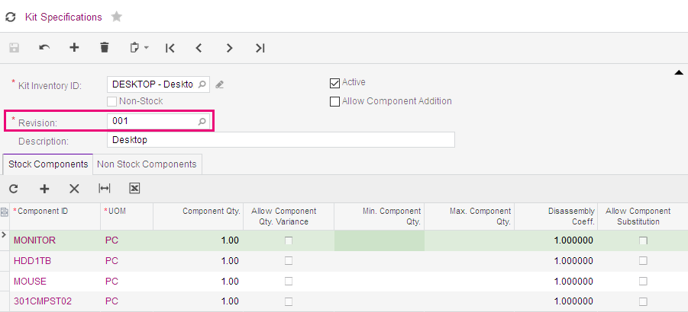
Figure: Kit Specification with Stock Components
- Now add the following information on the Non-Stock Components tab, then save.
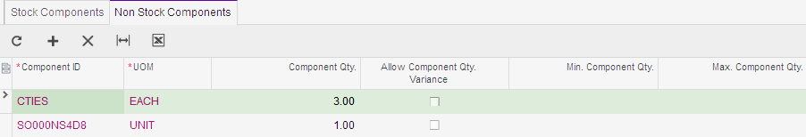
Figure: Non-Stock Components

Working with Inventory
In MYOB Advanced, inventory transactions are usually recorded on sales and purchasing documents and then processed through to customer invoices and supplier invoices (bills).
In our training, we will look at the sales order and purchase order processes in other training sessions. Now we will look at inventory transactions that are made in the Inventory module of the Distribution suite.

Inventory Transactions

Receipts
As mentioned, you would usually increase your stock quantities by receipting a purchase receipt in the Purchase Orders module.
In our training, we would like to increase the level of stock for our DESKTOP stock item using the kit function in MYOB Advanced. To do this, we will use Receipts in the work area of the Inventory module to update the stock levels of the components for the DESKTOP kit.

Activity 8 – Add and release Receipts
- Go to the Receipts form (IN301000; Inventory > Transactions) and add a new receipt with the following information (use valid dates).
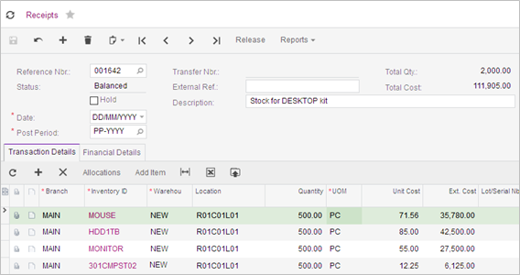
Figure: Receipt for Stock Items.
- In MYOB Advanced, transactions are finalised through multi-step processes. In Receipts, the document may be in one of the following status;
- On Hold – The receipt is a draft and can be edited.
- Balanced – The receipt has been validated and can be released.
- Released – The receipt has been released (finalised) and cannot be edited or deleted.
- On your new receipt, click on .on the form toolbar.
Releasing the receipt will update the stock quantities and cost based on the Stock Item settings.
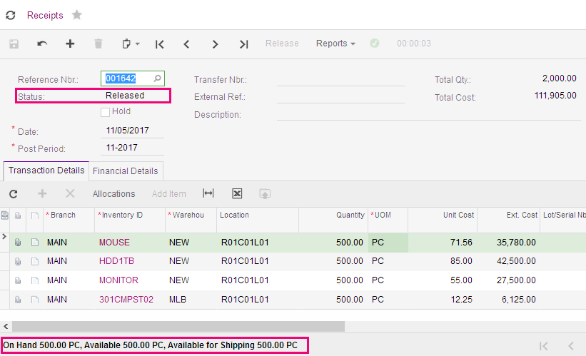
Figure: Receipts after being released.
- Click on the 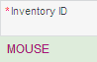 hyperlink to go to the stock record and select the Price/Cost Info tab.
The Cost Statistics have been updated when the receipt was released.
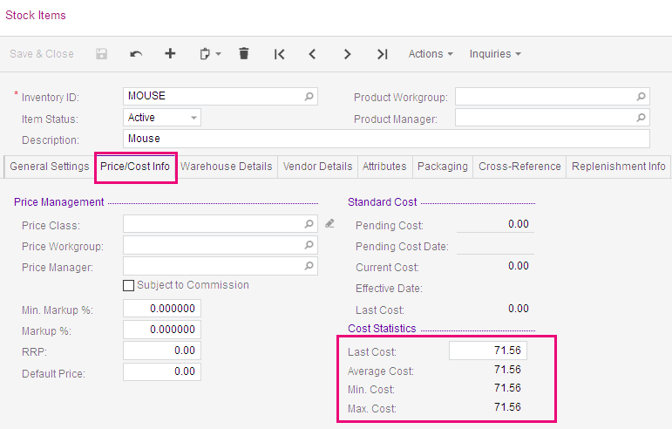
Figure: Stock Item showing updated cost statistics
- Now select the Warehouse Detail tab.
The Qty. On Hand for the NEW Warehouse has been updated when the receipt was released.
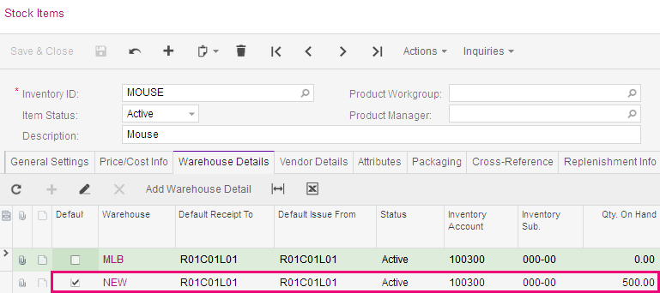
Figure: Stock Item showing updated stock quantities on the Warehouse Details tab

Issues
One way of decreasing your stock quantities is by creating and releasing an inventory issue. Usually a decrease in stock levels happens when sales orders, credit and debit memos and kit assembly documents are released.

Activity 9 –Issues
- Go to the Issues form (IN302000; Inventory > Transactions) and add a new issue with the following information (use valid dates).
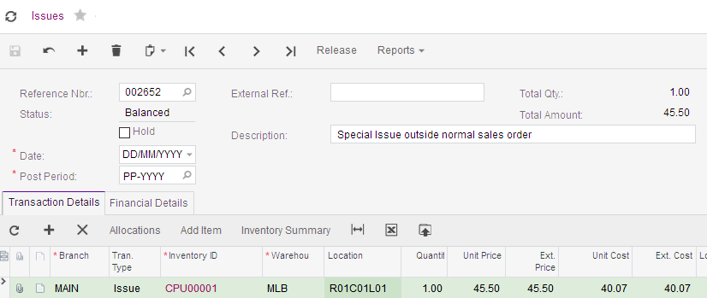
Figure: Direct Issue from Inventory module
- On your issue, click on .on the form toolbar.
- Click on the Inventory ID CPU00001 hyperlink on your Issue to go to the stock record and select Transaction Details from the Inquiries dropdown list on the form toolbar.
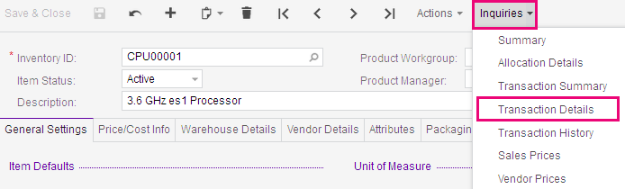
Figure: Location of the Transaction Details on the Stock Item form.
Release of the Issue has reduced the level of stock as shown in the screenshot below.
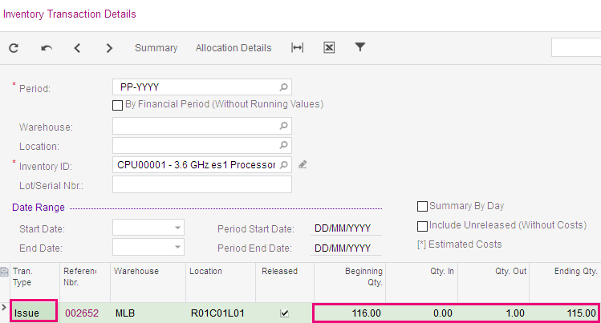
Figure: Inventory Transaction Details inquiry

Transfers
If you have more than one warehouse you might need to move stock from one warehouse/location to another warehouse/location. You can use an inventory transfer for this. In MYOB Advanced you can use two types of transfers;
- 1-Step transfer, which is the transfer between different warehouses and/or locations in one step.
- 2-Step transfer, is the transfer between different warehouses in two steps. 2-Step transfers are used where the warehouses are located some distance from each other so there is a delay between shipping and receiving the inventory.
In our training today, we will cover the 1-step transfer only as 2-Step transfers are outside the scope of our training.

Activity 10 –Transfers
- Go to the Transfers form (IN304000; Inventory > Transactions) and add a new transfer with the following information.
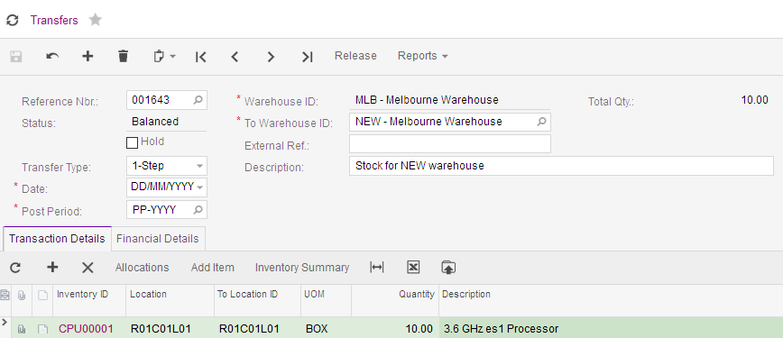
Figure: Transfer from MLB to NEW warehouse.
- On your transfer, click on .on the form toolbar.
- Click on the CPU00001 hyperlink to go to the stock record and select the Warehouse Detail tab.
The Qty. On Hand for both the MLB and the NEW Warehouse have been updated when the transfer was released.
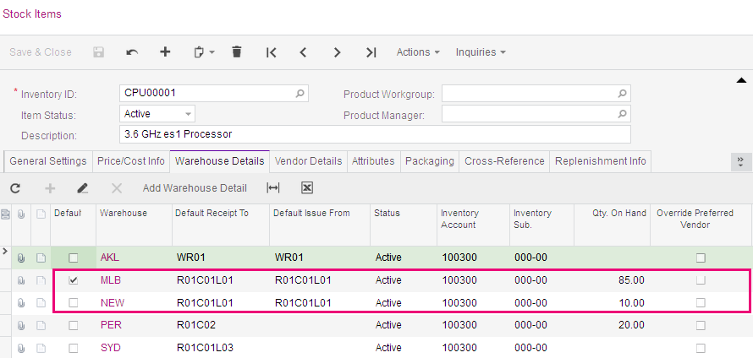
Figure: Stock Item showing updated stock quantities on the Warehouse Details tab
On the Warehouse Details tab note down the Qty. On Hand for the MLB warehouse (Qty may vary in your database).
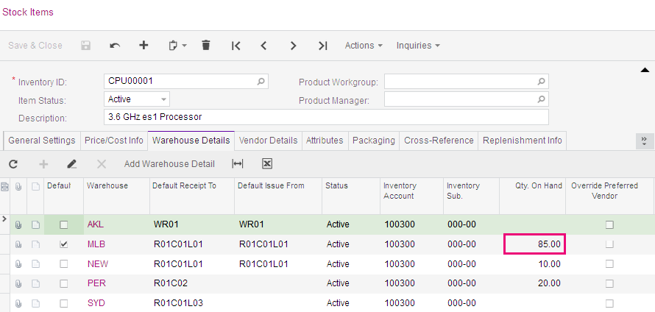
Figure: CPU00001 showing 85 items in MLB warehouse
When the transfer from the MLB to the NEW warehouse was released the issue was showing the items available.
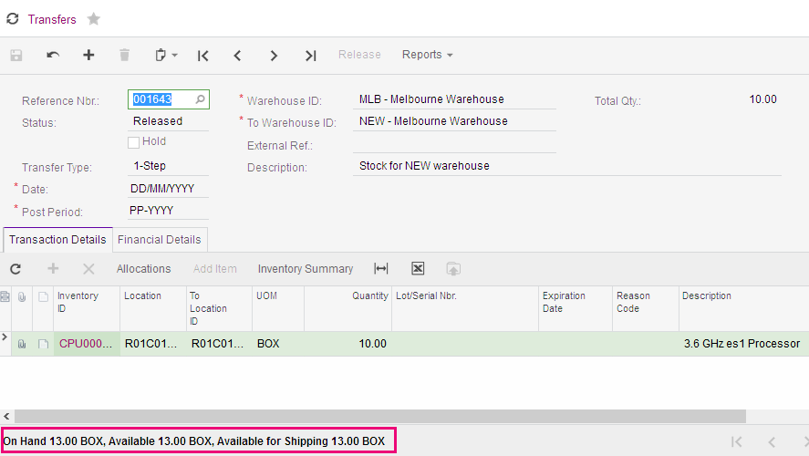
Figure: Transfer showing 13 items available
To find out why these figures differ click on the
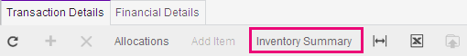 hyperlink on the grid toolbar. Then, clear the Location: field on the summary, you will be able to see the other 72 items located in R01C02L01 as shown below.
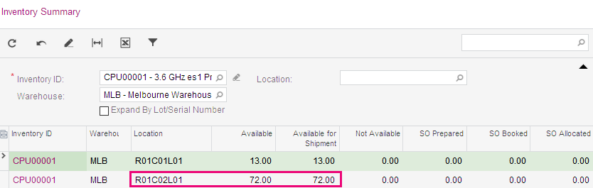
Figure: Inventory Summary showing location of all stock in MLB warehouse

Adjustments
From time to time you may “find” or “lose” stock in your warehouses. To update the stock levels to have the correct quantities an inventory adjustment can be entered.
A positive (+) adjustment will increase stock and a negative (-) adjustment will reduce stock.

Activity 11 –Adjustments
- Go to the Adjustments form (IN303000; Inventory > Transactions) and add a new adjustment with the following information.
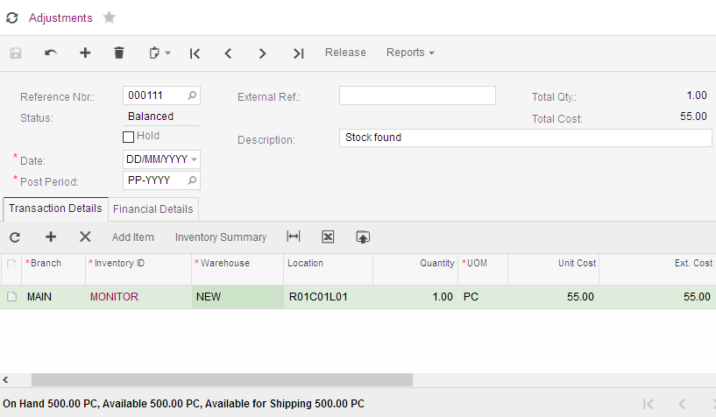
Figure: Adjustment increasing stock
- On your adjustment, click RELEASE on the form toolbar.

Kit Assembly
In our Master Record section, we setup a Kit Specification which is assembled from existing Stock and Non-Stock Items. We then added stock for the stock items of the kit using inventory receipts. Now we are going to assemble (build) some DESKTOP stock items to sell in the Sales Order training.
On the Kit Assembly form, we can produce (build) more kits or disassemble (dismantle) existing kits which have been built previously.

Activity 12 –Kit Assembly
- Go to the Kit Assembly form (IN307000; Inventory > Transactions) and add a new assembly with the following information.
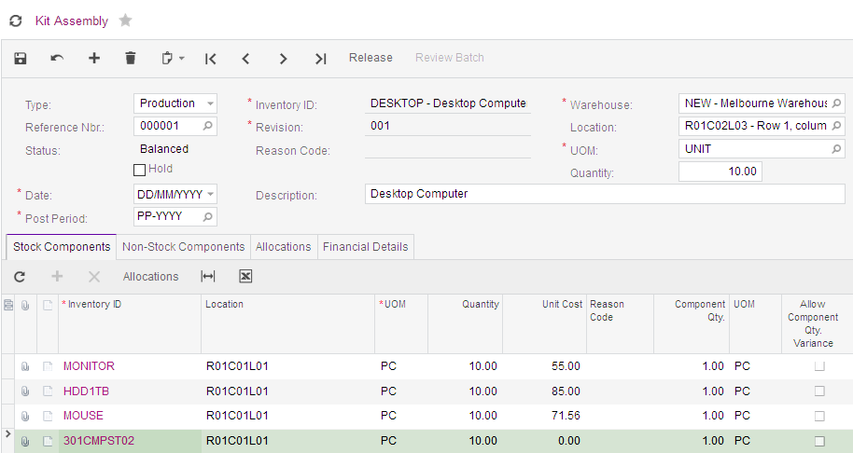
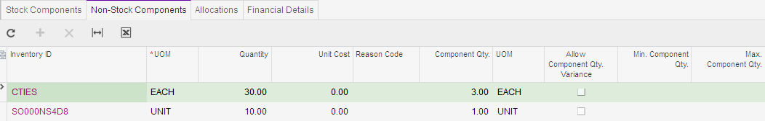
Figures: new assemble for Desktop stock item
- When you are happy with the details on the assembly form, click RELEASE on the form toolbar.

Review Stock Items
On the Stock Items form for DESKTOP the 10 new computers have been updated to the NEW warehouse.
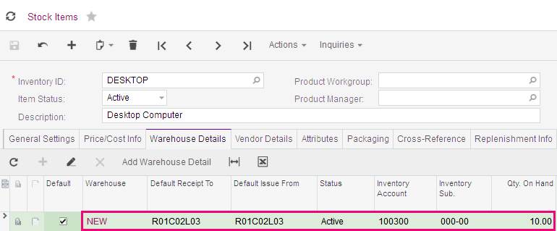
Figure: Qty. on Hand for the Desktops result from the Kit Assembly
On the Inventory Transaction History inquiry under Inventory > Inquiries, you can view all the transactions we have released for the MONITOR as seen in the following screenshot.
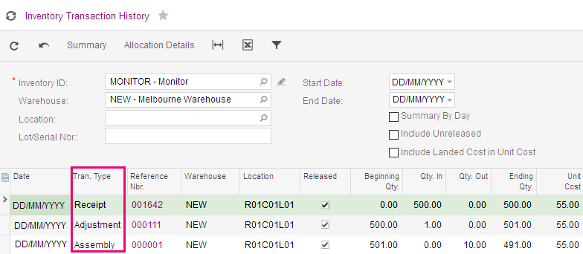
Figure: Inventory Transactions History for Monitor
The Receipt is from Activity 7; the Adjustment is from Activity 10 and the Assembly is from our last activity – Kit Assembly, Activity 11.

On the same inquiry if we select Inventory ID: CPU00001 and clear the Warehouse: field we can see the transactions from the Issue, from Activity 8 and both transactions created by the Transfer in Activity 9.
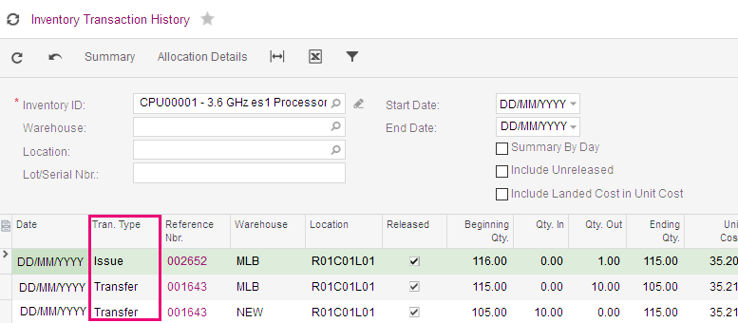
Figure: Inventory Transactions History for CPU00001

Financial Details
On every form in MYOB Advanced that will record a transaction to update the general ledger there is a Financial Details tab.
In the Inventory module, when Receipts, Issues, Kit Assembly, external Transfers and Adjustments are released, journal transaction batches are created and updated to the general ledger.
If a transfer for a 1-Step transfer is between locations in the same warehouse no batch is created.
To view the transactions details for that document, click on the Batch Nbr.: hyperlink as shown in the screenshot below.
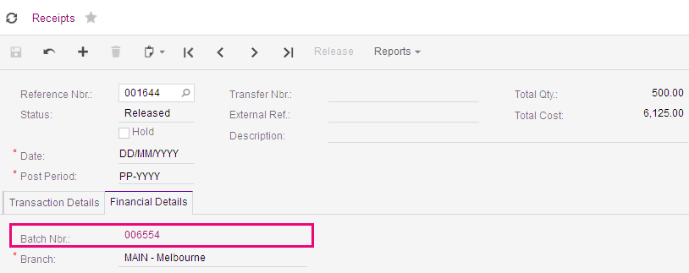
Figure: Hyperlink to general ledger journal for Receipt
The IN Journal Transaction dialogue box will appear with the details of the update to the general ledger.
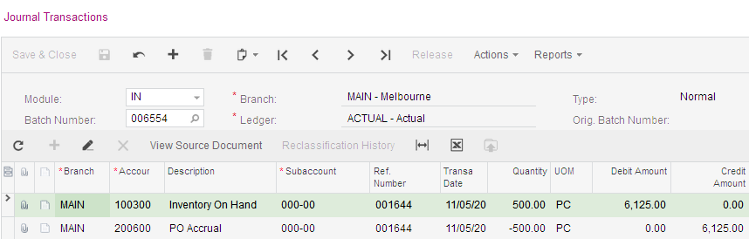
Figure: Journal Transaction created by Receipt 001644

Stocktake (Physical Inventory)
With MYOB Advanced, you can organise physical inventory counts (Stocktake) by cycles, ABC codes, movement classes, item classes, or stock items; you can even perform counts for randomly selected items. Nevertheless, you should occasionally undertake full inventory counts to maintain correct on-hand quantities.
On every repeat of a physical count, you complete the following steps as shown below.
- At the warehouse, organise goods to prepare for counting and complete data entry for warehouse activities (1 and 2 on the diagram).
- Prepare accurate book quantities in the system (3).
- Create the count review document of the needed physical inventory type (4) on the Physical Inventory Review form (IN305000) and pause the processing of inventory transactions in the system (6).
MYOB Advanced will not release inventory transactions starting from the moment after you have created a count review document and the document has the Counting in Progress status.
- At the same moment, freeze warehouse activities (5).
- At the warehouse, count the goods and register the physical quantities (7).
For example, the physical quantities can be recorded on the count sheets that you can print out from the system, or prepared in an Excel file.
- Resume warehouse activities (8) and resume the processing of inventory transactions in the system (9).
After the counting is complete, the processing of inventory transactions can be resumed because the book quantities are fixed in the count review document which is not affected with next processed transactions.
- Populate the physical quantities in the count review document (10).
Users can enter physical quantities by using the Physical Inventory Count form (IN305010). The quantities can also be entered manually or uploaded from Excel to the Physical Inventory Review form (IN305000).
- Process the count review document to finalise the result and generate the inventory adjustment (11).
- Review the generated inventory adjustment and make sure the adjustment is released and the GL transactions are posted (12).

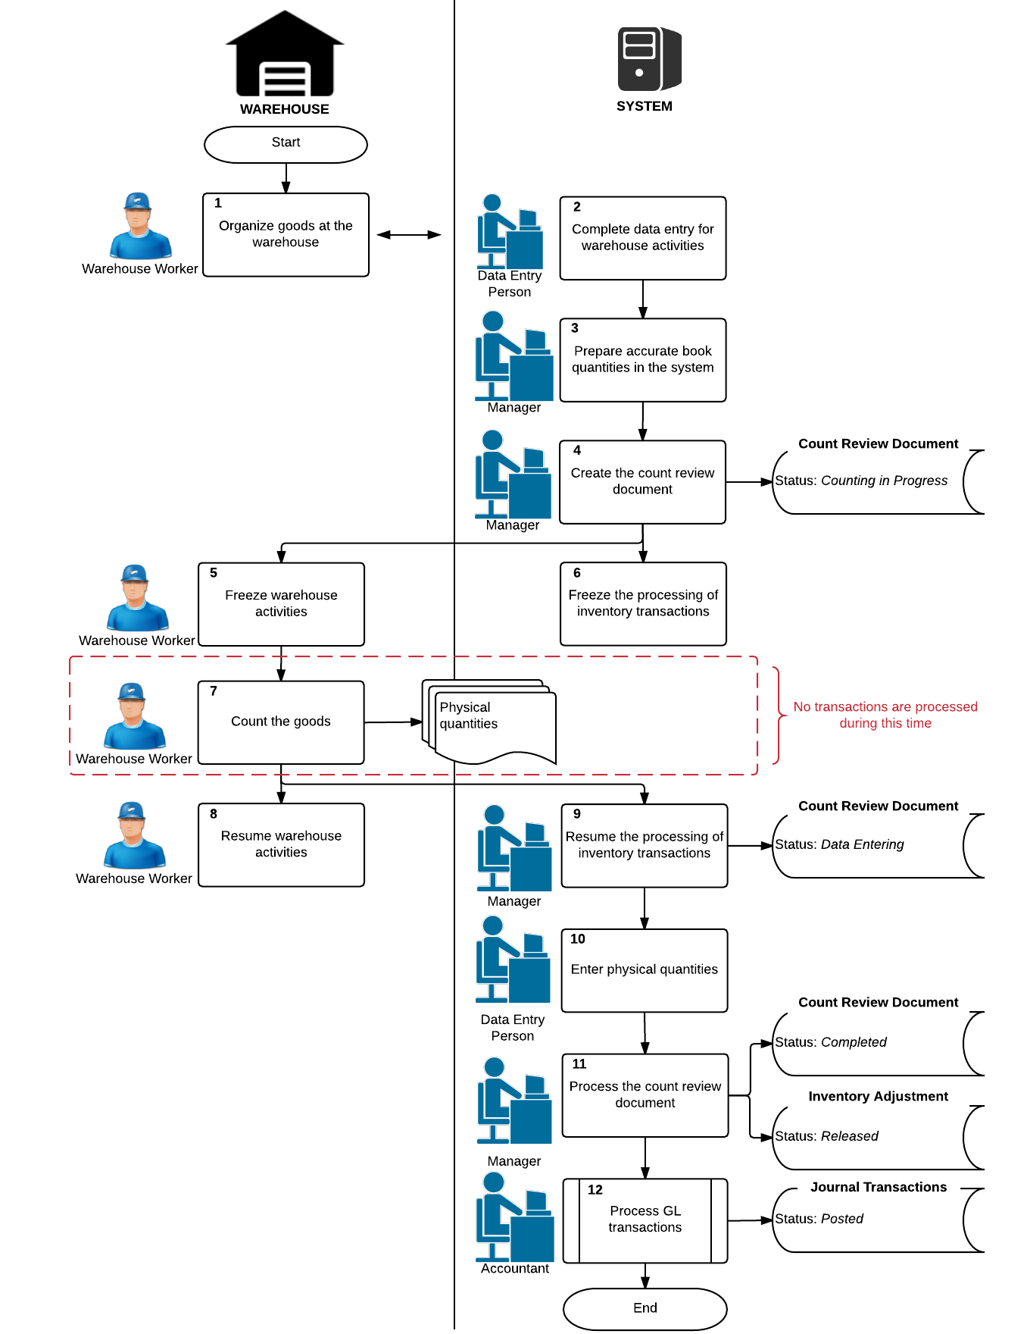
We need to set our Physical Inventory Types. The choices of Generation Method will change depending on your MYOB Advanced edition; Standard, Plus or Enterprise. We will go through the stocktake (physical inventory) process using the base method of Full Physical Inventory which will include all available items at the selected warehouse or location.

Activity 13 – Physical Inventory Types
- Go to the Physical Inventory Types form (IN208900; Inventory > Physical Inventory) and add a new type with the following information and save the record.
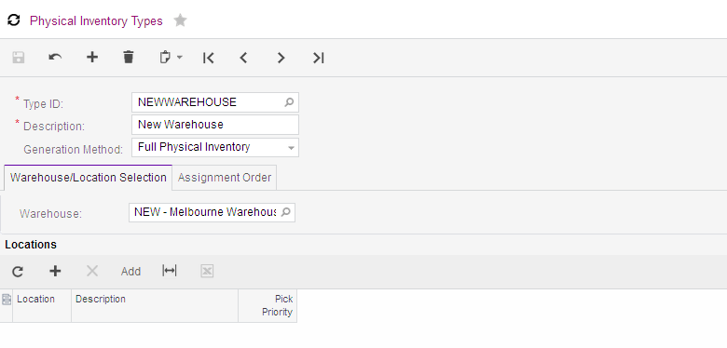
Figure: Physical Inventory Type with full count on one warehouse.

Activity 14 – Prepare Physical Count
For the first time in our training we are now going to work from the Processing tab on the navigation pane.
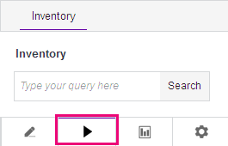
Figure: Inventory Processes tab
- Go to the Prepare Physical Count form (IN504000; Inventory > Physical Inventory).
- Prepare a new physical count with the following information. Once you select the Type ID: the other fields are updated automatically based on the NEWWAREHOUSE type we setup previously.
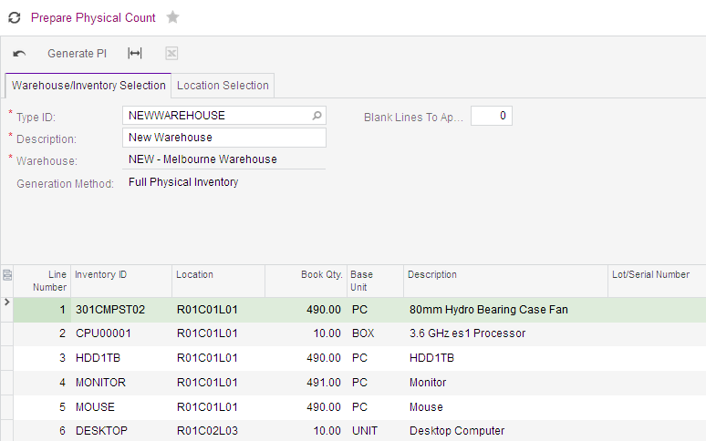
Figure: Full physical count on NEW warehouse.
The system produces the book quantity for physical counts as the diagram below shows. You organise goods at the warehouse and complete data entry to be able to count accurate physical quantities that match the book quantities.
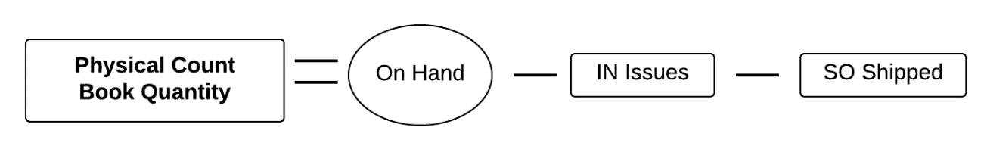
Figure: Book quantity for physical count
If, by some reason, you cannot complete the following transactions, you must exclude these items from the physical count:
- Items that have been received to the warehouse, but the receipts cannot be released.
- Items on unreleased inventory issues and not issued shipments, which haven't been removed from the warehouse.
You must exclude those items because they are not reflected in the book quantity that is printed in the count review document for comparison with the physical quantity.
- On the form toolbar, click . You will be taken to the Physical Inventory Review form (IN305000).
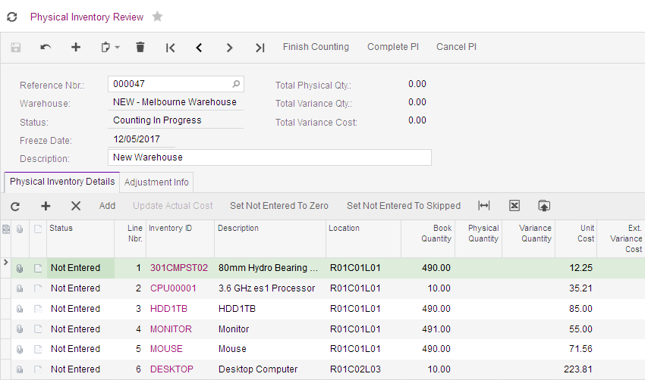
Figure: Physical inventory review
When you clicked MYOB Advanced,
  - Created the count review document with the book quantity of each Inventory ID for the NEW warehouse shown above.
If you notice that the review document is wrong, click .on the Physical Inventory Review form (IN305000) and start again.
  - Created the count sheets; Physical Count Sheets report (IN6205000).
  - Created count tags if required.
  - Stopped inventory transactions from being released for the warehouse being counted. The count review document’s status will be set at Counting In Progress.
On the Physical Inventory Review form, there are three actions on the toolbar.
Figure: Form toolbar of physical inventory review
: when selected will change the status of the document to Data Entering. This will allow inventory transactions to be released if the checkbox on the warehouse for Freeze Inventory When PI Count Is in Data Entry State is unticked.
: click this when you want to complete the data entry process. The status for this review will change to Completed, the stock will be updated and GL journals created to adjust the financial records.
: click this if at any time before you have completed the PI you wish to cancel the document.
There are two ways information from the count can be entered in MYOB Advanced;
- Physical Inventory Review form (IN305000) is used by one person entering quantities and this user can view book stock quantities and unit costs
- Physical Inventory Count form(IN305010) can be used by multiple users who are entering quantities at the same time. You can hide the book quantities on this form.
You shouldn’t update any Physical Inventory Review form (IN305000) while the Physical Inventory Count form (IN305010) is in use as this can cause errors.

Activity 15 –Data Entry & Completing PI
- On the Physical Inventory Review form (IN305000) enter the following quantities and save your changes.
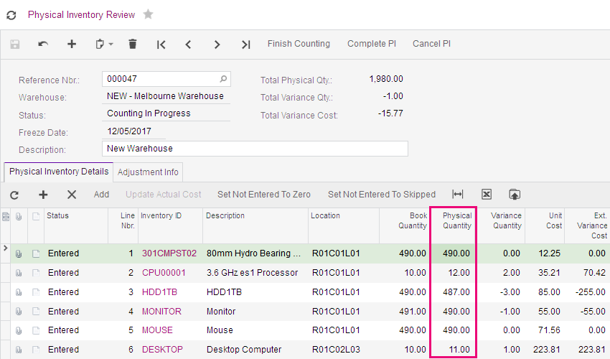
Figure: Physical inventory review with quantities updated
Special attention should be made to the and .
: Be careful of this setting as it will take any lines that have not had quantities entered and reduce the stock to zero.
: This setting will change each the line that has not had a quantity entered to a status of Skipped and the lines will not be processed.
- Now click :
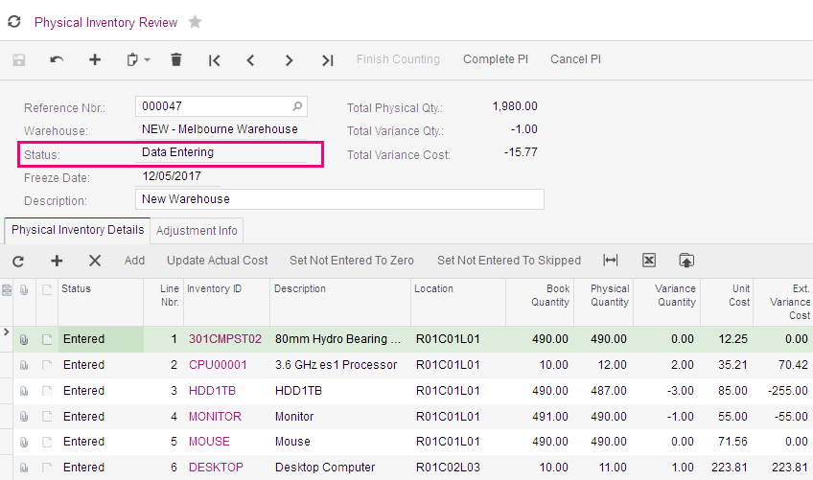
Figure: Physical Inventory Review after finished counting
- then .
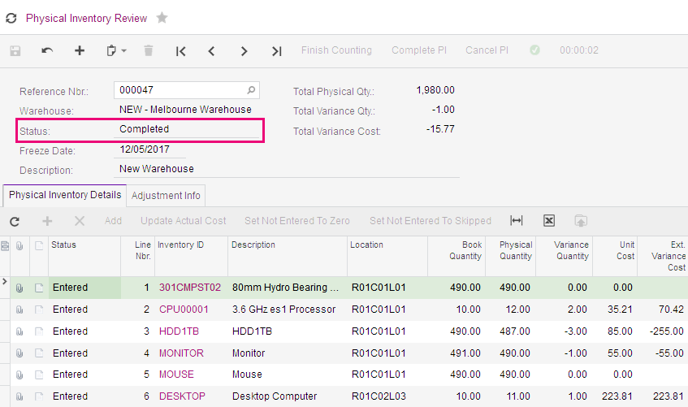
Figure: Physical Inventory Review completed

Activity 16 – Review Physical Inventory Updates (Stocktake)
- Go to the Adjustment Info tab on the Physical Inventory Review form (IN305000) and click on the hyperlink to the adjustment that was created when the review was completed.
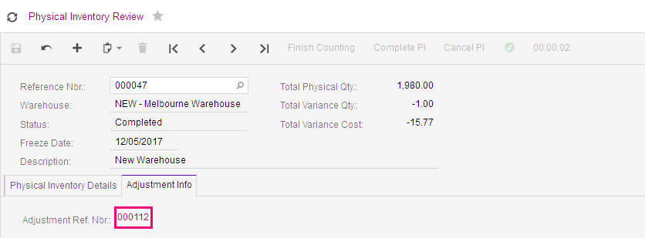
Figure: Adjustment Info tab with hyperlink.
The adjustment form with the details of the changes to stock will appear.
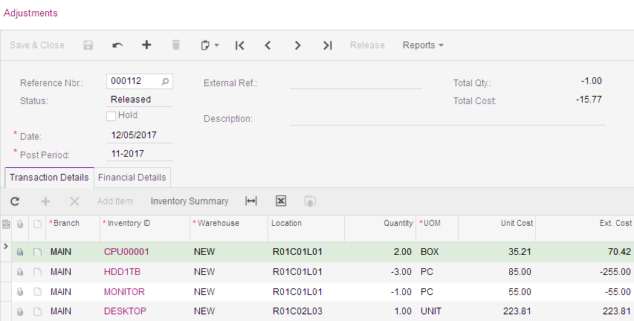
Figure: Adjustment created by completing physical inventory
- On the Financial Details tab, click on the Batch Nbr.: link to the general ledger batch created for the adjustment.
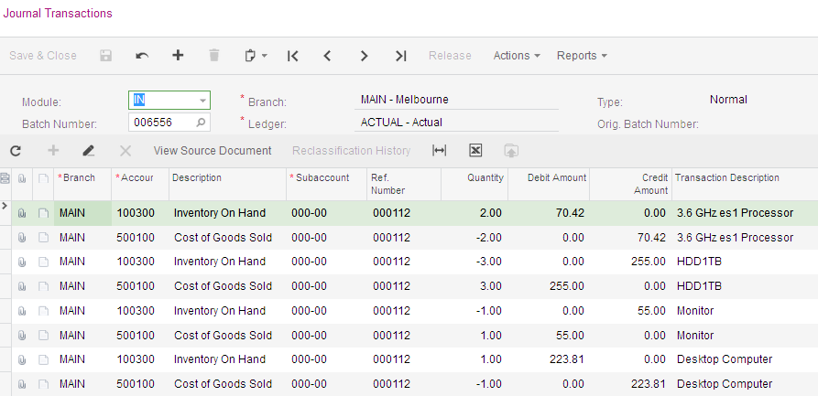
Figure: General ledger journals created by Physical Inventory complete

